MAHATMA GANDHI UNIVERSITY
NATIONAL SERVICE SCHEME
REPORT 2023-2024

A. PLANTATION
NO OF SAPLINGS PLANTED |  | PRODUCTION QUANTITY (KG) |  | AREA (CENT) | 10 | ESTIMATED VALUE (In Rupees)
B. BLOOD DONATION
TOTAL NO OF CAMPS CONDUCTED |  |  | 1 | TOTAL UNITS OF BLOOD DONATED(IN CAMPS &OTHER DONATIONS)
C. ORGANIZATION OF HEALTH / EYE / IMMUNIZATION CAMP
CAMP NAME |  |  | NO OF CAMPS CONDUCTED | CAMP NAME |  |  | NO OF CAMPS CONDUCTED
EYE CAMP |  |  |  | FITNESS DRIVE
IMMUNISATION CAMP |  |  |  | ORGAN DONATION AWARENESS
ANAEMIA AWARENESS PROGRAMMES |  |  | 1 | MEDICAL CAMP ( FOR WOMEN AND MOTHERS )
CANCER PREVENTION PROGRAMME |  |  | 2 | DENTAL CAMP
MENTAL HEALTH AWARENESS TRAINING |  |  |  | EAR CAMP
OMICRON AWARENESS PROGRAMME |  |  |  | IMMUNISATION DRIVE
NUTRITIONAL CAMP
COVID AWARENESS DRIVE |  |  |  | (if any other please specify)  CPR TRAINING SESSION |  |  | 1
D. AWARENESS PROGRAMMES / RALLIES /CAMPAIGNS ORGANISED
NAME OF THE PROGRAM CONDUCTED |  |  | NO OF PROGRAMS | OTHER AWARENESS PROGRAMMES |  |  | NO OF PROGRAMS
AIDS AWARENESS PROGRAMMES |  |  | 1 | 1.Drugs Awareness |  |  | 6
NO OF CLEANLINESS ACTIVITIES ORGANISED UNDER SWATCH BHARATH ABHIYAN |  |  |  | 2.Legal awareness |  |  | 1
ENVIRONMENTAL AWARENESS PROGRAMMES |  |  |  | 3.Paper pen making
Ujjwala Yojana |  |  |  | 4.Paper bag making
Pradhan Mantri Jandhan Yojana |  |  |  | 5.Cloth bag or mask making
Pradhan Mantri Jeevan Bima Yojana |  |  |  | 6.Ayurveda
Awareness on renewable energy |  |  |  | 7.Suicide prevention |  |  | 1
POCSO ACT RELATED PROGRAMMES |  |  |  | 8.Transgender
GENDER AWARNESS PROGRAMMES |  |  |  | 9.Organic farming
PROGRAMMES RELATED TO PERSON WITH DISABILITY |  |  |  | 10.Eco friendly products
PROGRAMMES RELATED TO PLASTIC FREE |  |  | 2 | 11.Aquaponics
ADULT LITERACY PROGRAMMES |  |  |  | 12.Swathhatha
PROGRAMMES RELATED TO GREEN VILLAGE |  |  |  | 13.Drug abuse
Work on digital literacy |  |  |  | 14.Youth day |  |  | 1
Work on Cashless India |  |  |  | 15.Road safety |  |  | 1
Swadesh darshan scheme- tourism promotion |  |  |  | 16.Age friendly
Sarva shiksha abhiyan |  |  |  | 17.Water conservation
Elite- language skill training |  |  |  | 18.Yoga
Khelo india – sports |  |  |  | 19.Energy conservation
Tribal youth exchange |  |  |  | 20.Gandhian values
ADIP Scheme- disability |  |  |  | 21.Plastic waste recycling |  |  | 2
SVEEP VOTING AWARENESS |  |  | 1 | 22.Fit india
(if any other please specify)  1, EDUCATION CAMPAIGN  2, AWARENESS ON VOTING |  |  | 1  1 | (if any other please specify)  1, PROTEST RALLY  2, HAR GHAR TIRANGA  3, DISASTER MANAGEMENT SESSION |  |  | 1  1  1
E. CREATION OF ASSETS
E1. NON DURABLE ASSET |  |  |  | E2. DURABLE ASSET
1.We care project contribution |  |  |  | Road construction
2.Repair and maintenance in adopted school |  |  |  | Reconstruction of houses
3.DISTRIBUTION OF STUDY MATERIALS |  |  |  | Artificial limb distribution
4.Cup of life |  |  |  | SNEHAVEEDU |  |  | 2
5.Abacus vedic maths training materials for the children |  |  |  | LIBRARY RENOVATION
6.Child care project |  |  |  | SNEHARAMAM |  |  | 1
7.Flood relief work |  |  |  | RENOVATION OF SCHOOL INFRASTRUCTURE
8.Placing of sandbags in chellanam |  |  |  | RENOVATION OF PONDS, WELLS, STREAMS.
9.Herbal garden in college |  |  |  | CONSTRUCTION OF KATCHA ROAD
10.Training Materials in Adopted School |  |  |  | LIBRARY BOOKS
11.Cultivation of Food Grains/Items |  |  |  | PUSTHAKATHANAL
12.Garden |  |  |  | FURNITURE MAKING
13.Cleaning Materials |  |  |  | LAND PURCHASED FOR SNEHAVEEDU
14.Merit cum needy scholarship |  |  |  | WHEELCHAIR
15.Paddy cultivation |  |  |  | DISTRIBUTION OF MOBILE /LAPTOPS AND OTHER GADGETS
16.Distribution of food for poor |  |  | 5 | COVID RELIEF MATERIALS
17. Covi care including Mask making, sanitizer, face shield etc… |  |  |  | HOME YARD POULTRY HOUSE
18.Fish Cultivation |  |  |  | RAIN SHELTER AND MINI POLY HOUSE FOR ORGANIC FARMING
19.Distribution of goods at chellanam and mundakayam |  |  |  | STEEL ALMIRAH
20.vegetable cultivation |  |  | 2 | WHITE CANE STICKS
21.Medical help for the poor |  |  |  | ELECTRIC/ELECTRONIC APPLIANCES FOR VISUALLY CHALLENGED
22. Fruits Cultivation |  |  |  | HEARING AID FOR DIFFERENTLY ABLED GIRLS
23. Distribution of Clothes |  |  |  | DRIP IRRIGATION SYSTEM WITH MOTOR PUMP
(if any other please specify) |  |  |  | CONSTRUCTION OF AUTOMATED FISH FARMING POND
 |  |  |  | (if any other please specify)
TOTAL ESTIMATED VALUE ( RS) |  |  |  | TOTAL ESTIMATED VALUE ( RS)
F. CLEANLINESS ACTIVITIES
SWACHH BHARAT |  |  |  | GREEN VILLAGE PROJECT
CLEAN INDIA PROJECT |  |  |  | MALINYAMUKTHA KERALAM |  |  | 1
SWACCHTHA HI SEVA  BEACH CLEAN-UP DRIVE |  |  | 1  3 | ‘REVIVE KOCHI’ |  |  | 1
G. CONTRIBUTION TO VARIOUS NATIONAL SCHEMES
PRADHAN MANTRI UJJWALA YOJANA
PRADHAN MANTRI SURAKSHA BEEMA YOJANA
PRADHAN MATRI JANDHAN YOJANA
SWATCH SAGAR SURAKSHIT SAGAR
(if any other please specify)
H. OTHER ACTIVITIES
NATURE STUDY CAMP WITH FOREST DEPARTMENT |  |  | 1 | ADULT LITERACY CAMPAIGN
NEHRU YUVAKENDRA - RELATED PROGRAMMES |  |  |  | DRUG RELATED PROGRAMMES
POLICE DEPARTMENT RELATED PROGRAMMES |  |  |  | AGRI PROGRAMMES (VEGETABLE GARDEN /ORGANIC FARMING )
PROGRAMME WITH SUCHITWA MISSION |  |  |  | MILLET YEAR PROGRAMME
PROGRAM IN ASSOCIATION WITH EXCISE DEPARTMENT |  |  |  | PROGRAM IN ASSOCIATION WITH SOCIAL JUSTICE DEPARTMENTS
PROGRAMME WITH SUCHITWA MISSION |  |  |  | (if any other please specify)  1, CELEBRATION AND REMEMBRANCE OF IMPORTANT DAYS  2, VOLUNTEERING DUTIES  3, CAMP AND ORIENTATION  4, FELICITATION CEREMONY  5, REGISTRATION AID |  |  | 16  2  2  1  1
I. NATIONAL LEVEL PROGRAMMES ORGANISED
SI N0 | NAME OF THE PROGRAMME |  | VENUE |  | DURATION | DATE | NO OF VOLUNTEERS PARTICIPATED
1
J. STATE LEVEL PROGRAMMES ORGANISED
SI N0 | NAME OF THE PROGRAMME |  | VENUE |  | DURATION | DATE | NO OF VOLUNTEERS PARTICIPATED
1
K. UNIVERSITY LEVEL PROGRAMMES PROJECTS
K1. SCHOOL ADOPTION
NAME OF SCHOOL ADOPTED | ST. JOSEPH’S SCHOOL, PANAMBUKKADU |  |  |  | NO OF PROGRAMMES CONDUCTED |  | 1
NO OF SAPLINGS PLANTED IN ADOPTED SCHOOL |  |  | ASSET CREATED ( In Rupees) |  |  | NO OF MEDICAL CAMPS CONDUCTED
K2. DISASTER MANAGEMENT TEAM ( MGU ON TEAM ON SPOT)
NO OF STUDENTS IN THE TEAM |  | 20
K3. SNEHAVEEDU
HOUSE COMPLETED 2023-24 |  |  | 2 | UNDER CONSTRUCTION |  |  | 1
K4. BIODIVERSITY PARK AT COLLEGE CAMPUS / ADOPTED SCHOOL
IS BIO DIVERSITY PARK MAINTAINED |  |  |  | BIO DIVERSITY PARK STARTED YEAR
K5. DRINKING WATER CONSERVATION
TOTAL NUMBER OF DRINKING WATER CONSERVATION PROJECT |  |  |  | TOTAL ESTIMATED COST FOR THE CONSTRUCTION AND MAINTENANCE.
K6. SUSTAINABLE REGIONAL TOURISM PROMOTION
NO: OF PROGRAMMES RELATED TO SUSTAINABLE REGIONAL TOURISM PROMOTION |  |  |  | NAME & ADDRESS OF TOURISM DESTINATION MAINTAINED
K7.PALLIATIVE CARE UNITS
PALLIATIVE CARE UNIT STARTED IN |  |  | 1 | NO OF PROGRAMMES CONDUCTED (2023-24) |  |  | 3
L. ANY OTHER UNIQUE PROGRAMMES ORGANISED
NO OF PROGRAMMES CONDUCTED |  | 14 | NAME OF PROGRAMMES CONDUCTED |  |  | 1, PROJECT ‘SHARP’  2, LAUNCH OF PROJECT ‘REFORM’  3, OPEN MIC  4, PROJECT ‘DISHA’  5, UTS APP PROMOTION ACTIVITIES  6, BODHI MEMORY WALK  7, THRIFT SALE- ‘SWEET REPEATS’ – FUNDRAISING ACTIVITY FOR ‘SNEHAVEEDU’  8, PROJECT ‘GOONJ IT’  9, CAKE CHALLENGE 4.0  10, 5TH WOMEN’S INTERNATIONAL FILM FEST VOLUNTEERING  11, SCREENING OF DOCUMENTARY ‘THE GREEN MAN’  12, KOCHI VOLUNTEER BANK INAUGURATION  13, HANDING OVER OF WHEELCHAIR  14, DISTRIBUTION OF BUTTERMILK

CATEGORY LIST
SI NO | CATEGORY NAME |  | CATEGORY NO
1 | PLANTATION |  | A
2 | BLOOD DONATION |  | B
3 | ORGANIZATION OF HEALTH / EYE / IMMUNIZATION CAMP |  | C
4 | AWARENESS PROGRAMMES / RALLIES /CAMPAIGNS ORGANISED |  | D
5 | CREATION OF ASSETS | NON DURABLE ASSET | E1
5 | CREATION OF ASSETS | DURABLE ASSET | E2
6 | CLEANLINESS ACTIVITIES |  | F
7 | CONTRIBUTION TO VARIOUS NATIONAL SCHEMES |  | G
8 | OTHER ACTIVITIES |  | H
9 | NATIONAL LEVEL PROGRAMMES ORGANISED |  | I
10 | STATE LEVEL PROGRAMMES ORGANISED |  | J
11 | UNIVERSITY LEVEL PROJECTS | SCHOOL ADOPTION | K1
11 | UNIVERSITY LEVEL PROJECTS | DISASTER MANAGEMENT TEAM ( MGU ON TEAM ON SPOT) | K2
11 | UNIVERSITY LEVEL PROJECTS | SNEHAVEEDU | K3
11 | UNIVERSITY LEVEL PROJECTS | BIODIVERSITY PARK AT COLLEGE CAMPUS / ADOPTED SCHOOL | K4
11 | UNIVERSITY LEVEL PROJECTS | DRINKING WATER CONSERVATION | K5
11 | UNIVERSITY LEVEL PROJECTS | SUSTAINABLE REGIONAL TOURISM PROMOTION | K6
11 | UNIVERSITY LEVEL PROJECTS | PALLIATIVE CARE UNITS | K7
12 | ANY OTHER UNIQUE PROGRAMMES ORGANISED |  | L

PROGRAMME CONDUCTED DURING THE YEAR 2023-24 ( DATE WISE FROM 1 APRIL 2023 TO 31 MARCH 2024)
SI NO | PROGRAMME NAME | DATE | VENUE | CATEGORY NO
1 | PLANT A SAPLING | 05/06/2023 | ST.TERESA’S COLLEGE, ERNAKULAM | A
2 | PROJECT ‘SHARP’ | 05/06/2023 – 15/06/2023 | M G ROAD METRO STATION | L
3 | LAUNCH OF PROJECT ‘REFORM’ | 08/06/2023 | ST.TERESA’S COLLEGE, ERNAKULAM | L
4 | CANON EDUCATION CAMPAIGN | 10/06/2023 | ST.TERESA’S COLLEGE, ERNAKULAM | D
5 | INTERNATIONAL YOGA DAY | 21/06/2023 | ST.TERESA’S COLLEGE, ERNAKULAM | H
6 | FOUNDATION LAYING CEREMONY OF SNEEHAVEEDU | 22/06/2023 | PUTHUVYPPU | K3
7 | OPEN MIC | 23/06/2023 | ST.TERESA’S COLLEGE, ERNAKULAM | L
8 | BLOOD DONATION CAMP | 24/06/2023 | GENERAL HOSPITAL ERNAKULAM | B
9 | VENDA (ANTI-NARCOTIC WEEK ACTIVITY) | 26/06/2023 – 30/06/2023 | ST.TERESA’S COLLEGE, ERNAKULAM | D
10 | DEEKSHARAMB | 10/07/2023 – 12/07/2023 | ST.TERESA’S COLLEGE, ERNAKULAM | H
11 | PROTEST RALLY | 26/07/2023 | HIGH COURT , ERNAKULAM | D
12 | KARGIL VIJAY DIWAS | 26/07/2023 | ST.TERESA’S COLLEGE, ERNAKULAM | H
13 | PROJECT ‘DISHA’ ORIENTATION | 27/07/2023 | ST.TERESA’S COLLEGE, ERNAKULAM | L
14 | DR. A P J ABDUL KALAM DEATH ANNIVERSARY | 27/07/2023 | ST.TERESA’S COLLEGE, ERNAKULAM | H
15 | HIROSHIMA DAY | 06/08/2023 | ST.TERESA’S COLLEGE, ERNAKULAM | H
16 | COMPETITION ON AIDS AWARENESS | 10/08/2023 | BHARATHA MATHA COLLEGE, THRIKKAKARA | D
17 | INTERNATIONAL YOUTH DAY | 12/08/2023 | ST.TERESA’S COLLEGE, ERNAKULAM | H
18 | WORLD ORGAN DONATION DAY | 13/08/2023 | ST.TERESA’S COLLEGE, ERNAKULAM | H
19 | INDEPENDENCE DAY CELEBRATION | 15/08/2023 | ST.TERESA’S COLLEGE, ERNAKULAM | H
20 | HAR GHAR TIRANGA | 15/08/2023 | ST.TERESA’S COLLEGE, ERNAKULAM | D
21 | SESSION ON BLOOD DONATION CAMP | 16/08/2023 | ST.TERESA’S COLLEGE, ERNAKULAM | D
22 | BLOOD DONATION CAMP | 18/08/2023 | ST.TERESA’S COLLEGE, ERNAKULAM | B
23 | TWO DAY RESIDENTIAL CAMP FOR NSS VOLUNTEERS | 18/08/2023 – 19/08/2023 | SACRED HEART COLLEGE, THEVARA | H
24 | ORIENTATION PROGRAM FOR FIRST YEAR VOLUNTEERS | 24/08/2023 – 26/08/2023 | ST.TERESA’S COLLEGE, ERNAKULAM | H
25 | TEACHERS DAY CELEBRATION | 05/09/2023 | ST.TERESA’S COLLEGE, ERNAKULAM | H
26 | SESSION COMMEMORATING WORLD SUICIDE PREVENTION DAY | 08/09/2023 | ST.TERESA’S COLLEGE, ERNAKULAM | D
26 | PLANTATION DRIVE | 16/09/2023 | ST.TERESA’S COLLEGE, ERNAKULAM | A
27 | ANTI-DRUG AWARENESS CAMPAIGN | 22/09/2023 | COCHIN SPORTS ARENA, EDAPALLY | D
28 | NSS DAY | 24/09/2023 | ONLINE MODE | H
29 | FUNDRAISING CAMPAIGN | 28/09/2023 | ST. TERESA'S COLLEGE, ERNAKULAM | D
30 | ROAD SAFETY AWARENESS DRIVE | 29/09/2023 | ST. TERESA'S COLLEGE, ERNAKULAM | D
31 | SWACHHATA HI SEVA | 01/10/2023 | ST. TERESA'S COLLEGE, ERNAKULAM | F
32 | ANTI DRUG AWARENESS PROGRAM | 02/10/2023 | ST. TERESA'S COLLEGE, ERNAKULAM | D
33 | GANDHI JAYANTHI | 02/10/2023 | ONLINE MODE | H
34 | KARUTHAL | 03/10/2023 | GENERAL HOSPITAL, ERNAKULAM | E
35 | POSHAKARAMAM | 04/10/2023 | ST. JOSEPH SCHOOL, PANAMBUKAD (ADOPTED SCHOOL) | A
36 | SESSION ON LEGAL TUTALAGE AND NSS WEEK VALEDICTORY FUNCTION | 09/10/2023 | ST. TERESA'S COLLEGE, ERNAKULAM | D
37 | UTS APP PROMOTION IN SOUTH RAILWAY STATION | 10/10/2023 | SOUTH RAILWAY STATION | L
38 | WORLD HOSPICE AND PALLIATIVE CARE DAY CELEBRATION | 14/10/2023 | ST. TERESA'S COLLEGE, ERNAKULAM | K7
39 | BODHI MEMORY WALK | 17/10/2024 | DARBAR HALL, ERNAKULAM | L
40 | MALINYA MUKTHA KERALAM CAMPAIGN | 20/10/2023 | GENERAL HOSPITAL, ERNAKULAM | F
41 | REVIVE KOCHI | 27/10/2023 -  28/10/2023 | MARINE DRIVE | F
42 | ANTI DRUG AWARENESS SESSION | 27/10/2023 | MAHARAJAS COLLEGE, ERNAKULAM | D
43 | UTS APP PROMOTION IN SOUTH RAILWAY STATION | 30/10/2023 | SOUTH RAILWAY STATION, ERNAKULAM | L
44 | NATIONAL UNITY DAY | 01/11/2023 | ST. TERESA'S COLLEGE, ERNAKULAM | H
45 | UTS APP PROMOTION IN SOUTH RAILWAY STATION | 01/11/2023 | SOUTH RAILWAY STATION, ERNAKULAM | L
46 | UTS APP PROMOTION IN SOUTH RAILWAY STATION | 02/11/2023 | SOUTH RAILWAY STATION, ERNAKULAM | L
47 | UTS APP PROMOTION IN SOUTH RAILWAY STATION | 06/11/2023 | SOUTH RAILWAY STATION, ERNAKULAM | L
48 | KARUTHAL | 08/11/2023 | GENERAL HOSPITAL, ERNAKULAM | E
49 | UTS APP PROMOTION IN SOUTH RAILWAY STATION | 08/11/2023 | SOUTH RAILWAY STATION, ERNAKULAM | L
50 | SWEET REPEATS - THRIFT SALE | 09/11/2023 -  10/11/2023 | ST. TERESA'S COLLEGE, ERNAKULAM | L
51 | BEACH CLEAN-UP DRIVE | 10/11/2023 | FORT KOCHI BEACH | F
52 | THE INTERNATIONAL DAY OF DIFFERENTLY ABLED | 02/12/2023 | PARISH HALL, EDAPALLY CHURCH | H
53 | PROJECT GOONJ IT | 06/12/2023 | ST. TERESA'S COLLEGE, ERNAKULAM | L
54 | PLANTATION DRIVE | 13/12/2023 | ST. TERESA'S PROVINCIAL HOUSE,KAKKANAD | A
55 | KARUTHAL | 14/12/2023 | GENERAL HOSPITAL, ERNAKULAM | E
56 | HANDING OVER CEREMONY OF SNEHVEEDU PROJECT | 16/12/2023 | ELOOR | K3
57 | DISASTER MANAGEMENT TRAINING | 16/12/2023 | SACRED HEART COLLEGE, THEVARA | K2
58 | CAKE CHALLENGE 4.0 | 19/12/2023 | ST. TERESA'S COLLEGE, ERNAKULAM | L
59 | FELICITATION CEREMONY FOR JILUMOL | 05/01/2024 | ST. TERESA'S COLLEGE, ERNAKULAM | H
60 | BEACH CLEAN -UP | 07/01/2024 | FORT KOCHI BEACH | F
61 | REGISTRATION: MY BHARAT | 08/01/2024 | ST. TERESA'S COLLEGE, ERNAKULAM | H
62 | PALLIATIVE CARE SESSION | 10/01/2024 | ST. TERESA'S COLLEGE, ERNAKULAM | K7
63 | NATIONAL YOUTH DAY | 12/01/2024 | ONLINE | H
64 | PALLIATIVE CARE VISIT | 12/01/2024 | JEREMIAH PALLIATIVE CARE | K7
65 | KARUTHAL | 18/01/2024 | GENERAL HOSPITAL, ERNAKULAM | E
66 | SWASTHYA: ΑΝΑΕΜΙΑ SCREENING AND AWARENESS SESSION | 22/01/2024 | ST. TERESA'S COLLEGE, ERNAKULAM | C
67 | AWARENESS SESSION ON BLOOD CANCER AND BLOOD STEM CELL | 23/01/2024 | ST. TERESA'S COLLEGE, ERNAKULAM | C
68 | NATIONAL GIRL CHILD DAY | 24/01/2024 | VYTILA MOBILITY HUB | H
69 | ANTI-DRUG MEET | 25/01/2024 | ERNAKULAM SUBHASH PARK | D
70 | REPUBLIC DAY | 26/01/2024 | ST. TERESA'S COLLEGE, ERNAKULAM | H
71 | BREAST AND CERVICAL CANCER AWARENESS SESSION | 31/01/2024 | ST. TERESA'S COLLEGE, ERNAKULAM | C
72 | FALCON BEACH CLEAN- UP | 11/02/2024 | FALCON BEACH | F
73 | KEY HANDING CEREMONY OF 'SNEHAVEEDU' | 11/02/2024 | PUTHUVYPPE | K3
74 | 5TH WOMEN’S INTERNATIONAL FILM FEST | 10/02/2024 -  13/02/2024 | SARITHA AND SAVITHA THEATRE | L
75 | CPR TRAINING SESSION | 13/02/2024 | ST. TERESA'S COLLEGE, ERNAKULAM | C
76 | BODHA POURNAMI | 13/02/2024 | BTH HOTEL | D
77 | NATURE CAMP | 16/02/2024 -  17/02/2024 | ATHIRAPPILLY- VAZHACHAL | H
78 | SCREENING OF THE DOCUMENTARY 'THE GREEN MAN' | 19/02/2024 | ST. TERESA'S COLLEGE, ERNAKULAM | L
79 | UYIRPPU KALAJATHA | 19/02/2024 -  21/02/2024 | 14 CONSTITUENCIES | D
80 | KOCHIN VOLUNTEER BANK  INAUGURATION | 21/02/2024 | ST. TERESA'S COLLEGE, ERNAKULAM | L
81 | AWARD CEREMONY  - APPRECIATION AWARD | 22/02/2024 |  | H
82 | SNEHAVEEDU PLOT VISIT | 26/02/2024 | ALANGAD, PARAVOOR | K3
83 | KALOLSAVAM VOLUNTEERING DUTY | 26/02/2024 -  03/03/2024 | KOTTAYAM | H
84 | SNEHARAMAM | 01/03/2024 | ST.TERESA’S COLLEGE, ERNAKULAM | E
85 | HANDING OVER OF WHEELCHAIR | 29/02/2024 | ST. TERESA'S COLLEGE, ERNAKULAM | L
86 | CYCLE RALLY | 07/03/2024 | PALARIVATTOM TO JLN STADIUM | D
87 | AWARENESS SESSION AND DISTRIBUTION OF CERTIFICATES | 07/03/2024 | ST. TERESA'S COLLEGE, ERNAKULAM | D
88 | INTERNATIONAL WOMENS DAY CELEBRATION | 07/03/2024 | ST. TERESA'S COLLEGE, ERNAKULAM | H
89 | KARUTHAL POTHICHORU DISTRIBUTION | 12/03/2024 | GENERAL HOSPITAL, ERNAKULAM | E
90 | TRAINING SESSION ON REGISTRATION FOR VOTER'S ID | 12/03/2024 | ERNAKULAM COLLECTORATE | D
91 | ELECTION AWARENESS PROGRAM, VOTER REGISTRATION DRIVE, AND ELECTION OF SVEEP AMBASSADOR | 13/03/2024 | ST. TERESA'S COLLEGE, ERNAKULAM | D
92 | DISTRIBUTION BUTTERMILK | 14/03/2024 -  15/03/2024 .  18/03/2024- 20/03/2024, 25/03/2024, 22/03/2024, 27/03/2024 | BUS STAND, ERNAKULAM | L
93 | VOTER AWARENESS COMPETITION | 18/03/2024 | ERNAKULAM (KAKKANAD) COLLECTORATE | D
94 | ELECTION DUTY | 26/04/2023 | ST.TERESA’S SCHOOL , ERNAKULAM | H
95 | SNEHAVEEDU III- PLOT VISIT | 30/04/2024 | PARAVOOR | K3

PHOTOS

A. PLANTATION

PROGRAMME NAME 1 : PLANT A SAPLING
VENUE : ST.TERESA’S COLLEGE , ERNAKULAM
DATE : 06/06/2023

PROGRAMME NAME 2 : PLANTATION DRIVE
VENUE : ST.TERESA’S COLLEGE, ERNAKULAM
DATE : 16/09/2023

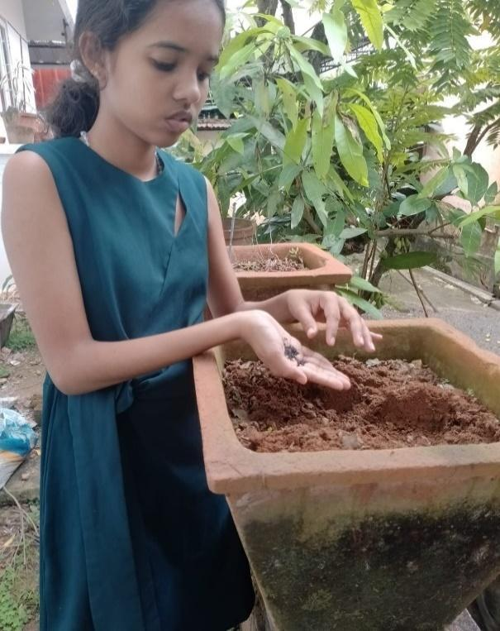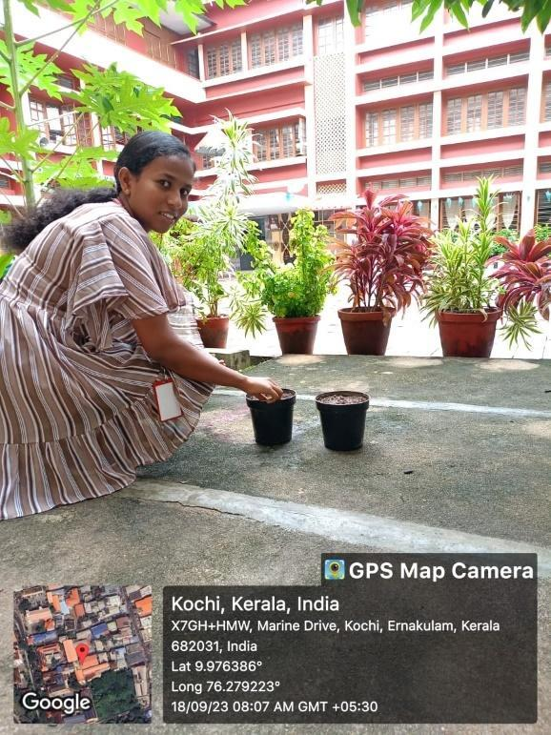
PROGRAMME NAME 3: POSHAKARAAMAM
VENUE: ST. JOSEPH’S SCHOOL, PANAMBUKKAD (ADOPTED SCHOOL)
DATE: 04/10/2023
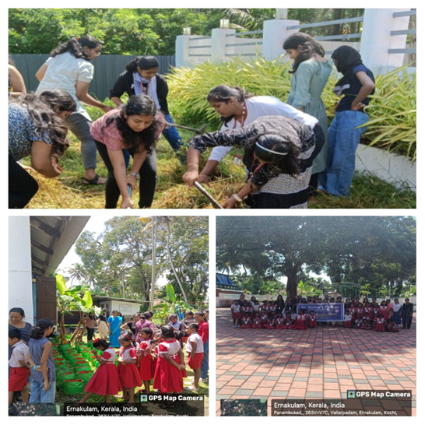
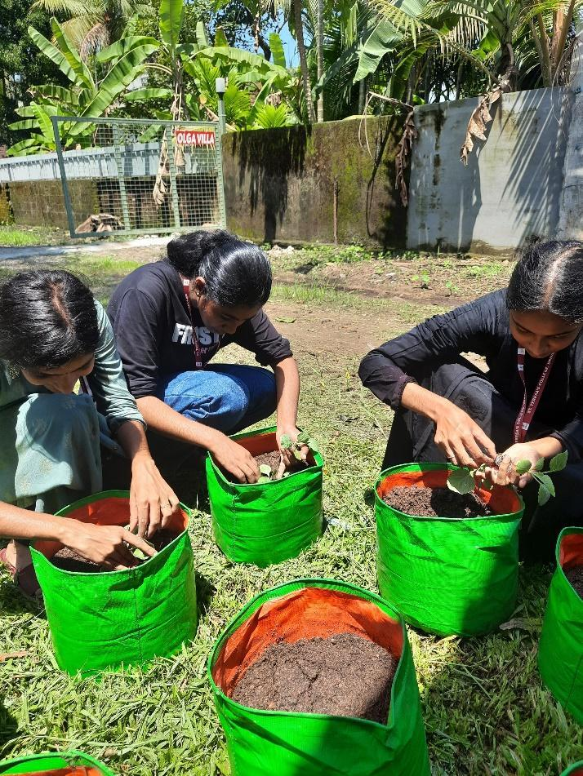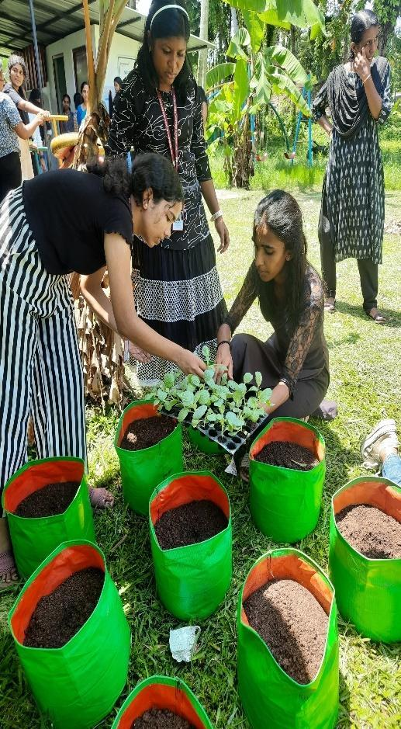

PROGRAMME NAME 4 : PLANTATION DRIVE
VENUE : ST.TERESA’S PROVINCIAL HOUSE
DATE : 13/12/2023

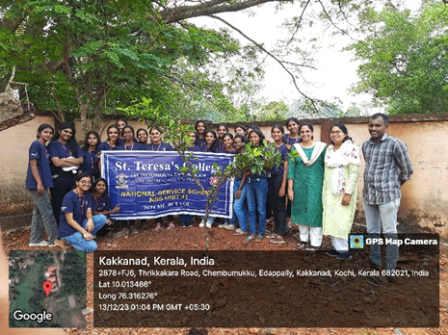
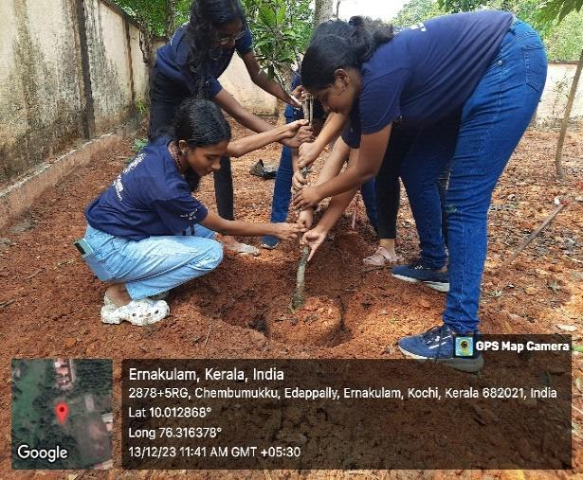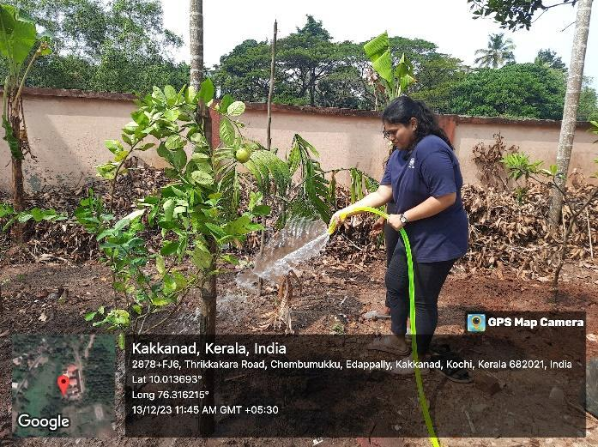

B. BLOOD DONATION

PROGRAMME NAME 1: BLOOD DONATION DAY CAMP VOLUNTEERING
VENUE : GENERAL HOSPITAL, ERNAKULAM
DATE : 24/06/2023

PROGRAMME NAME 2: BLOOD DONATION CAMP
VENUE : ST.TERESA’S COLLEGE, ERNAKULAM
DATE : 18/08/2023
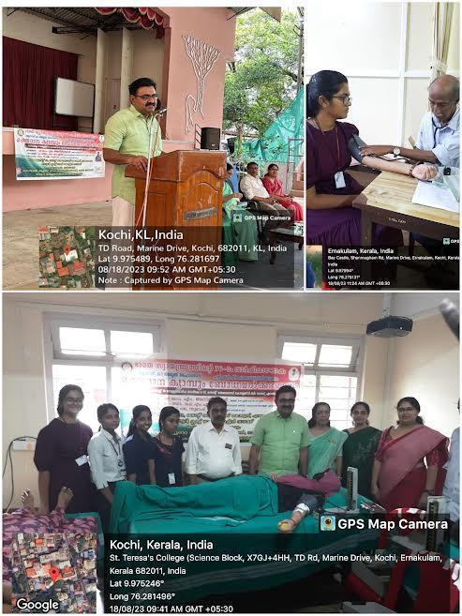

C. ORGANIZATION OF HEALTH / EYE / IMMUNIZATION CAMP

PROGRAMME NAME 1: SWASTHYA: ΑΝΑΕΜΙΑ SCREENING AND AWARENESS SESSION
VENUE : ST.TERESA’S COLLEGE, ERNAKULAM
DATE : 22/01/2024
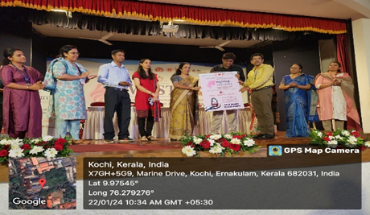
PROGRAMME NAME 2 : AWARENESS SESSION ON BREAST CANCER AND CERVICAL CANCER
VENUE: ST.TERESA’S COLLEGE ,ERNAKULAM
DATE:1/31/2023
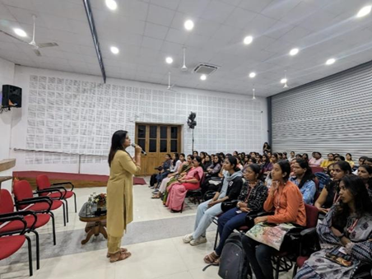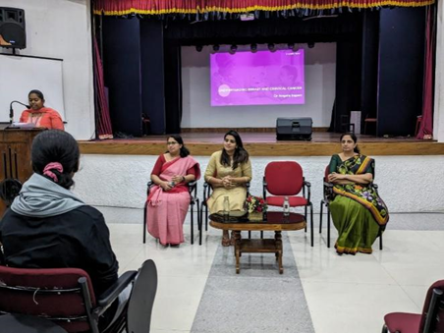
PROGRAMME NAME 3: CPR TRAINING SESSION
VENUE : ST.TERESA’S COLLEGE,ERNAKULAM
DATE: 13/2/2024
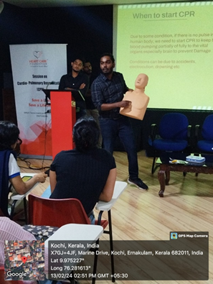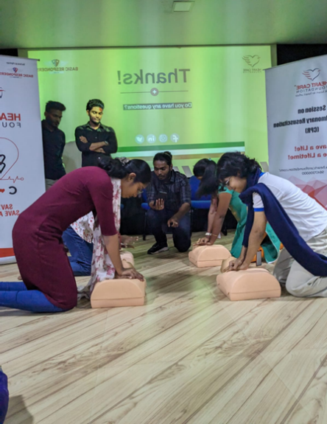

PROGRAMME NAME 4: SESSION ON BLOOD CANCER AND BLOOD STEM CELL
VENUE : ST.TERESA’S COLLEGE, ERNAKULAM
DATE :23/01/2024
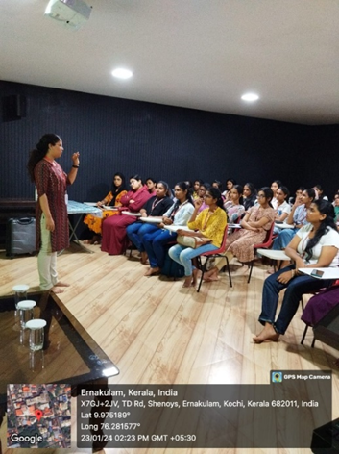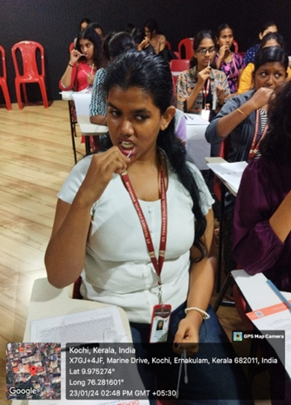

PROGRAMME NAME 5 : SESSION ON BLOOD DONATION
VENUE : ST.TERESA’S COLLEGE, ERNAKULAM
DATE : 16/08/2023

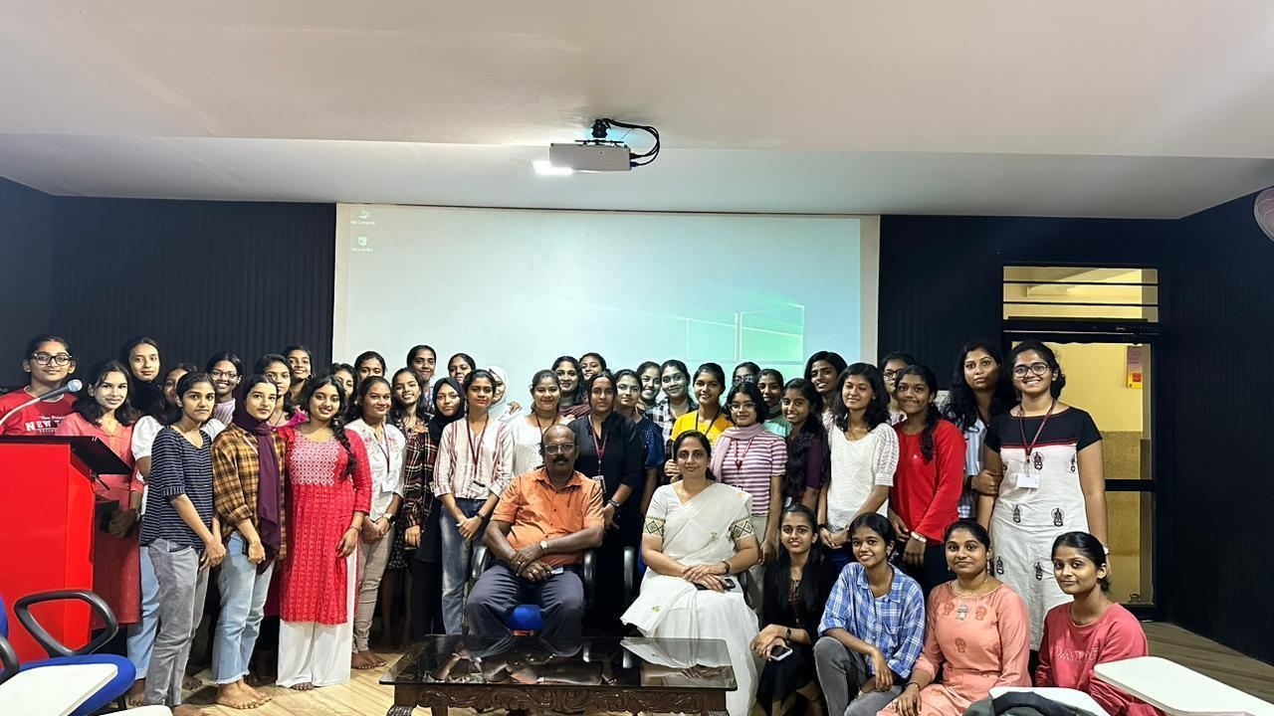

D. AWARENESS PROGRAMMES / RALLIES /CAMPAIGNS ORGANISED
PROGRAMME NAME 1: CANON EDUCATION CAMPAIGN
VENUE : ST.TERESA’S COLLEGE, ERNAKUAM
DATE : 10/06/2023
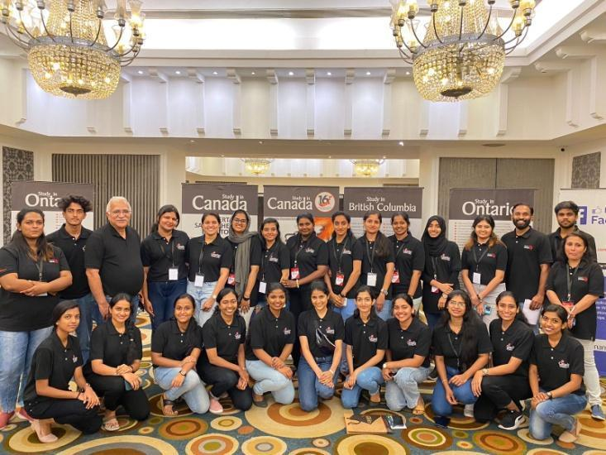

PROGRAMME NAME 2 : VENDA – (ANTI-NARCOTIC WEEK)
VENUE : ST.TERESA’S COLLEGE, ERNAKULAM
DATE : 26/06/2023 – 30/06/2023
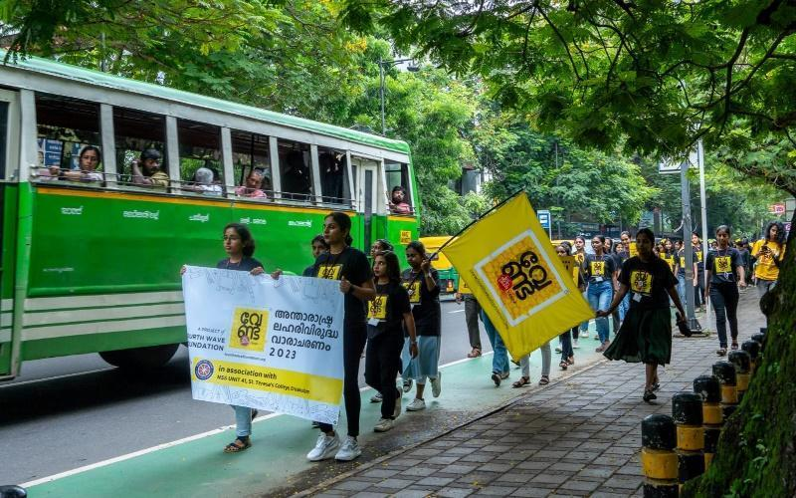
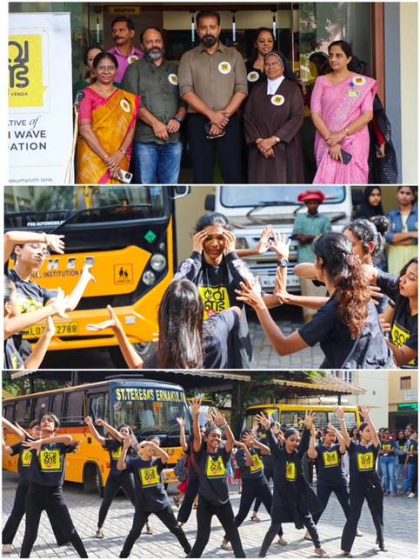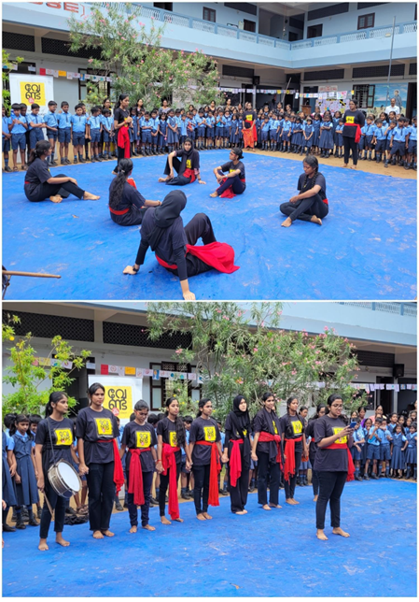

PROGRAMME NAME 3 : PROTEST RALLY
VENUE : HIGH COURT
DATE :26/07/2023

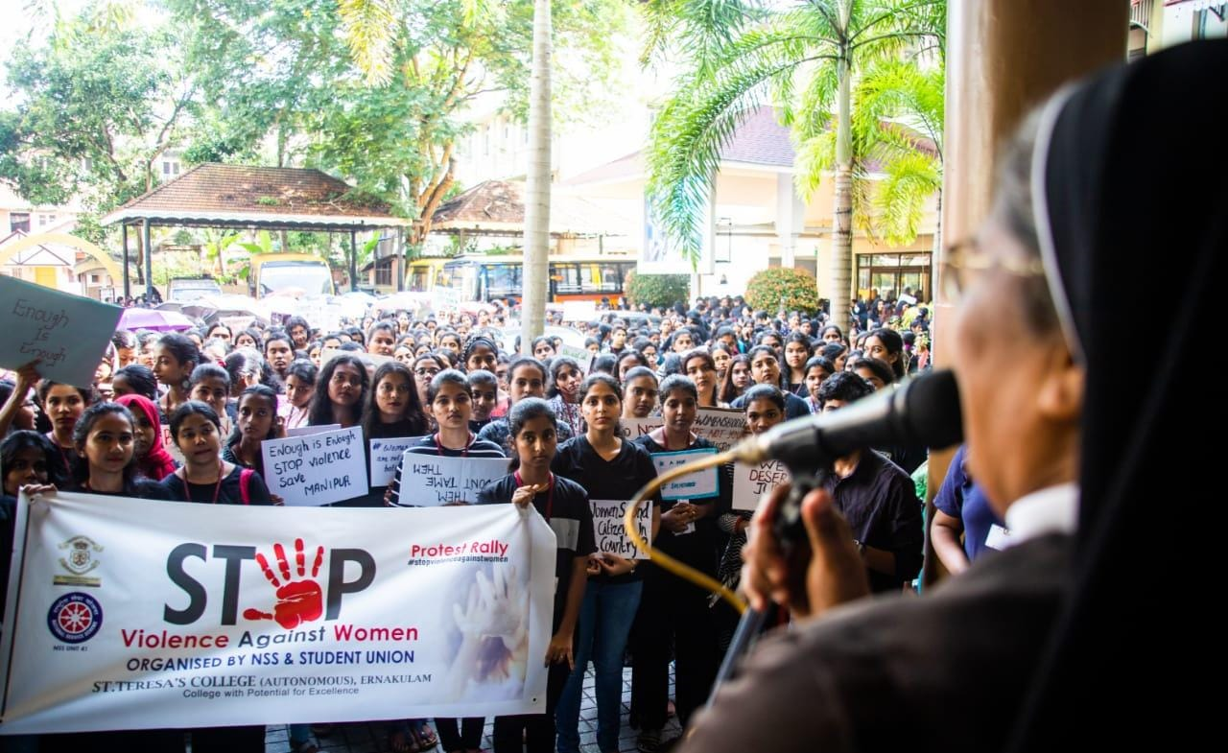

PROGRAMME NAME 4 : COMPETITION ON AIDS AWARENESS
VENUE : BHARATHA MATHA COLLEGE, THRIKKAKARA
DATE : 10/08/2023

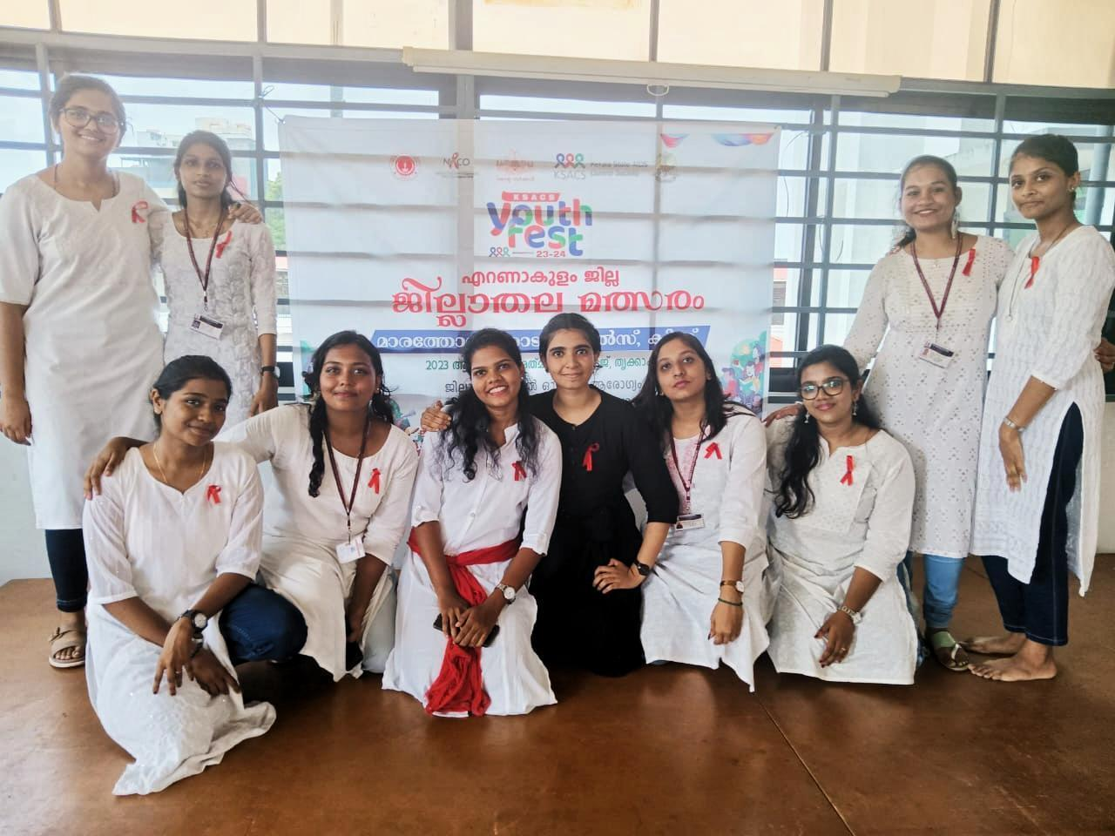

PROGRAMME NAME 5: HAR GHAR TIRANGA
VENUE : ST.TERESA’S COLLEGE, ERNAKULAM
DATE : 15/08/2023
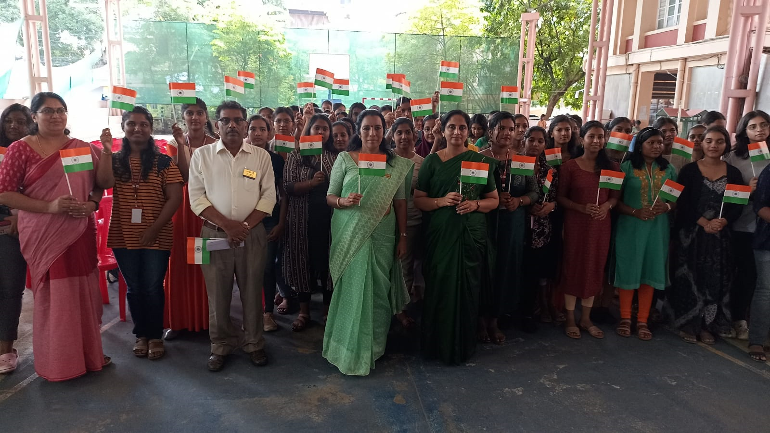

PROGRAMME NAME 6: SESSION COMMEMORATING WORLD SUICIDE PREVENTION DAY
VENUE : ST.TERESA’S COLLEGE, ERNAKULAM
DATE :08/09/2023
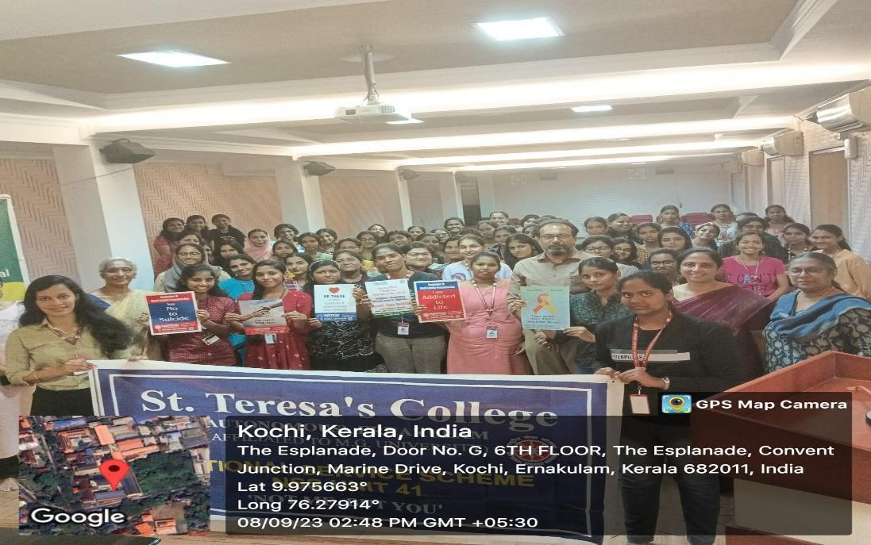

PROGRAMME NAME 7: ANTI-DRUG CAMPAIGN (FLASHMOB)
VENUE : COCHIN SPORTS ARENA, EDAPALLY
DATE : 22/09/2023
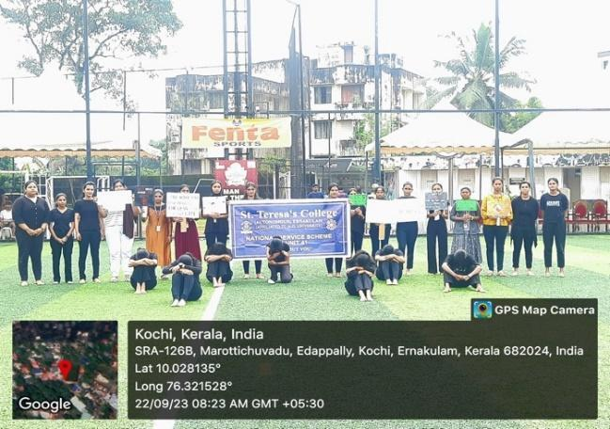
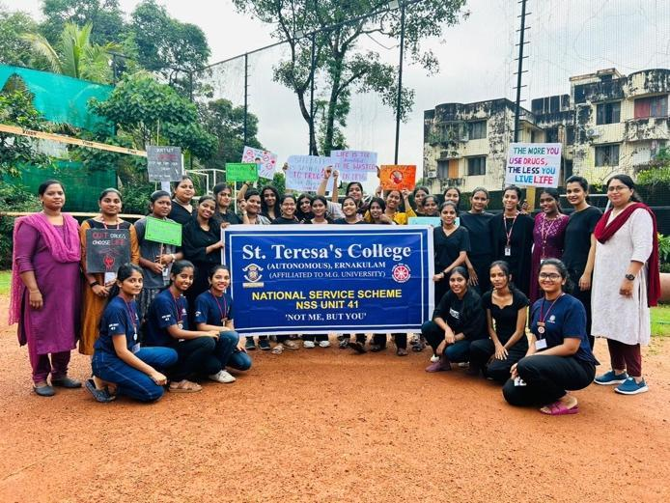
PROGRAMME NAME 8: ROAD SAFETY AWARENESS
VENUE : ST.TERESA’S COLLEGE, ERNAKULAM
DATE : 29/09/2023
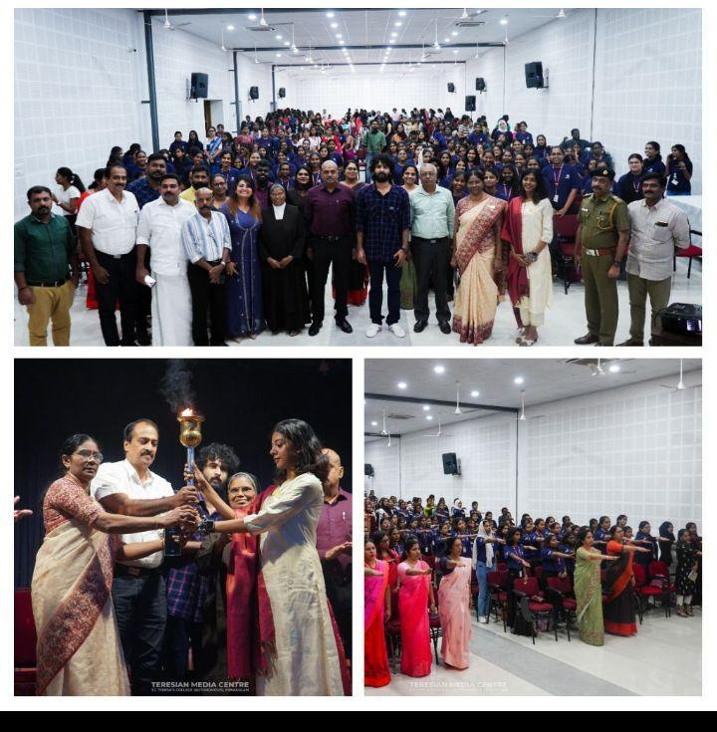

PROGRAMME NAME 9: SESSION ON LEGAL TUTALAGUE
VENUE : ST.TERESA’S COLLEGE, ERNAKULAM
DATE : 09/10/2023

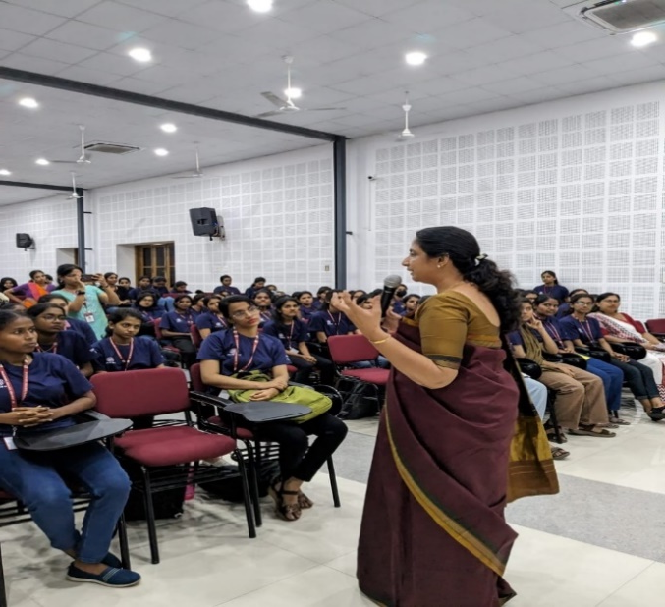
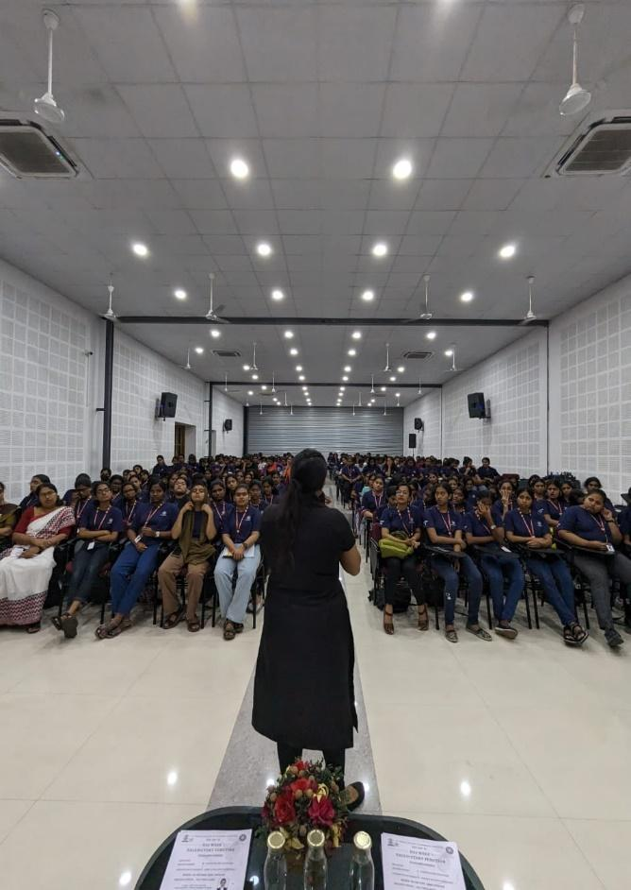

PROGRAMME NAME 10: ANTI-DRUG AWARENESS
VENUE : MAHARAJAS COLLEGE, ERNAKULAM
DATE:27/10/2023
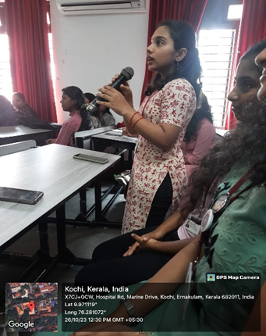
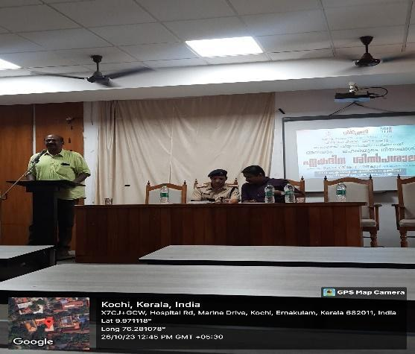
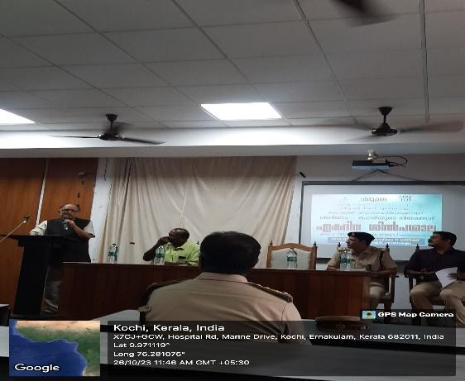

PROGRAMME NAME 11: DISASTER MANAGEMENT SESSION
VENUE : SACRED HEART COLLEGE, THEVARA
DATE : 16/12/2023

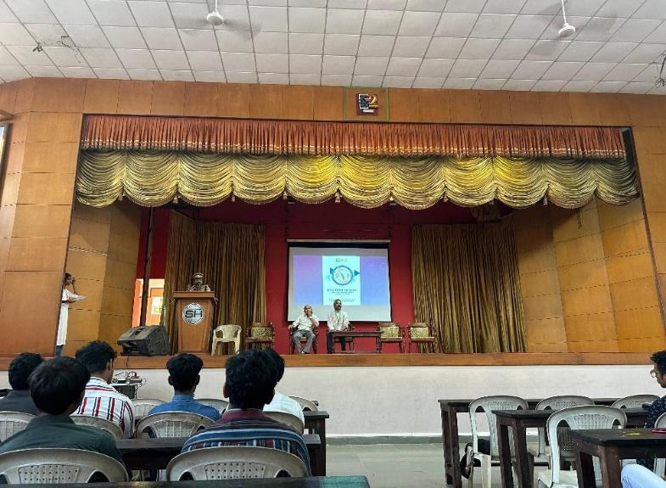
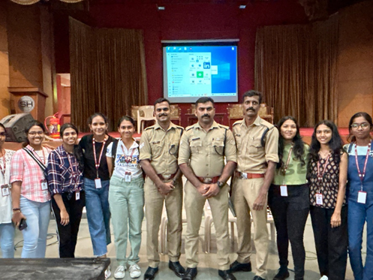

PROGRAMME NAME 12: ANTI-DRUG MEET
VENUE : ERNAKULAM SUBHASH PARK
DATE :25/01/2024

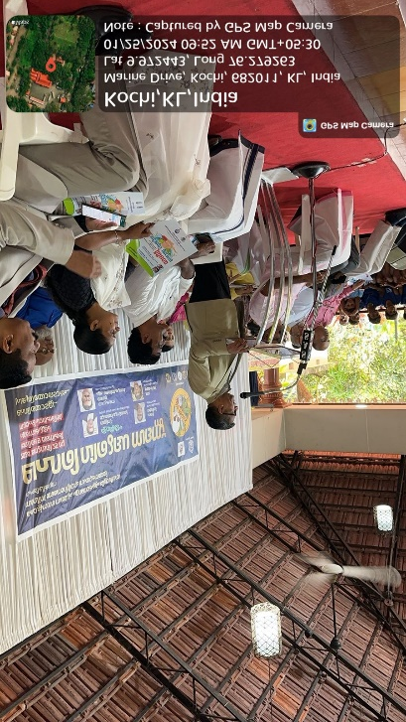
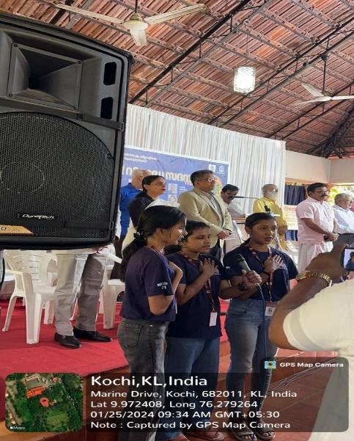
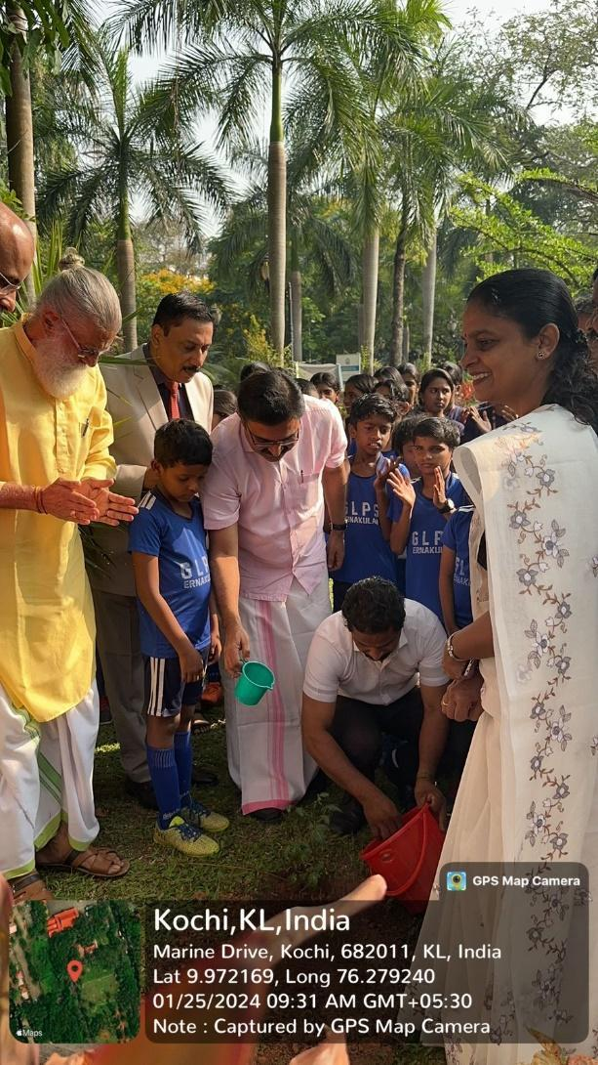

PROGRAMME NAME 12: BODHA POURNAMI (ANTI-DRUG ACTIVITY)
VENUE : BTH HOTEL
DATE : 13/02/2024
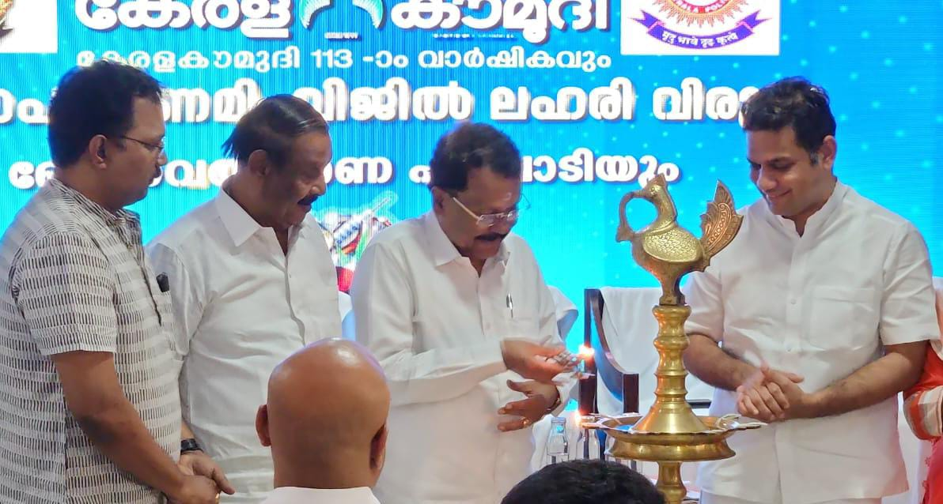 PROGRAMME NAME 13:UYIRPPU KALAJATHA
VENUE : 14 CONSTITUENCIES
DATE : 19/02/2024 – 21/02/2024

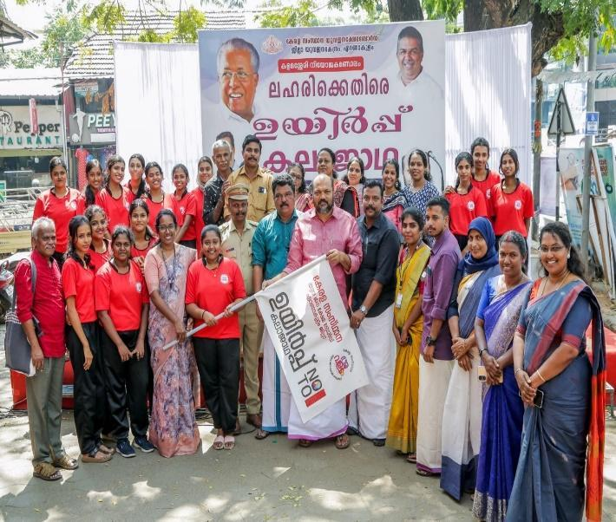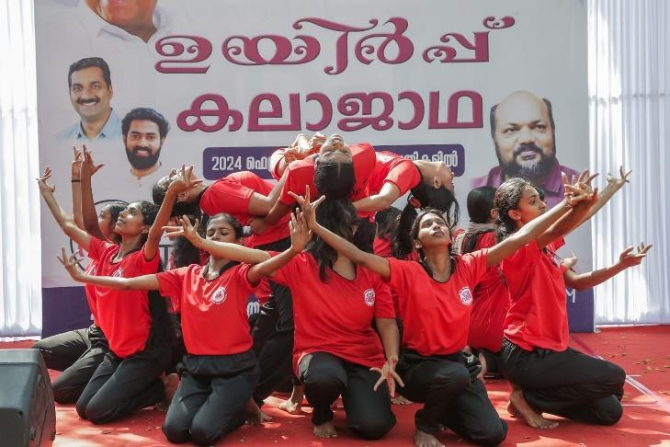
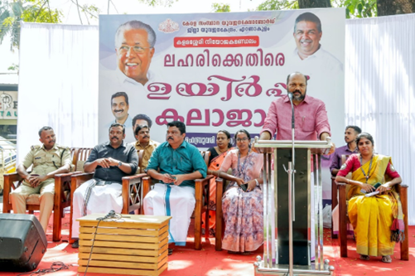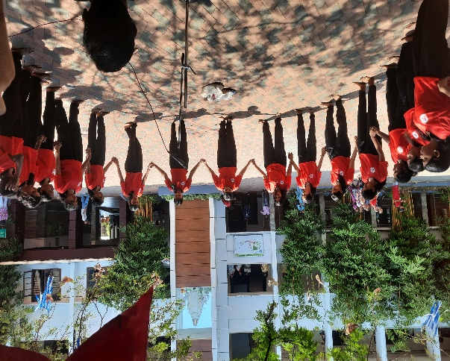
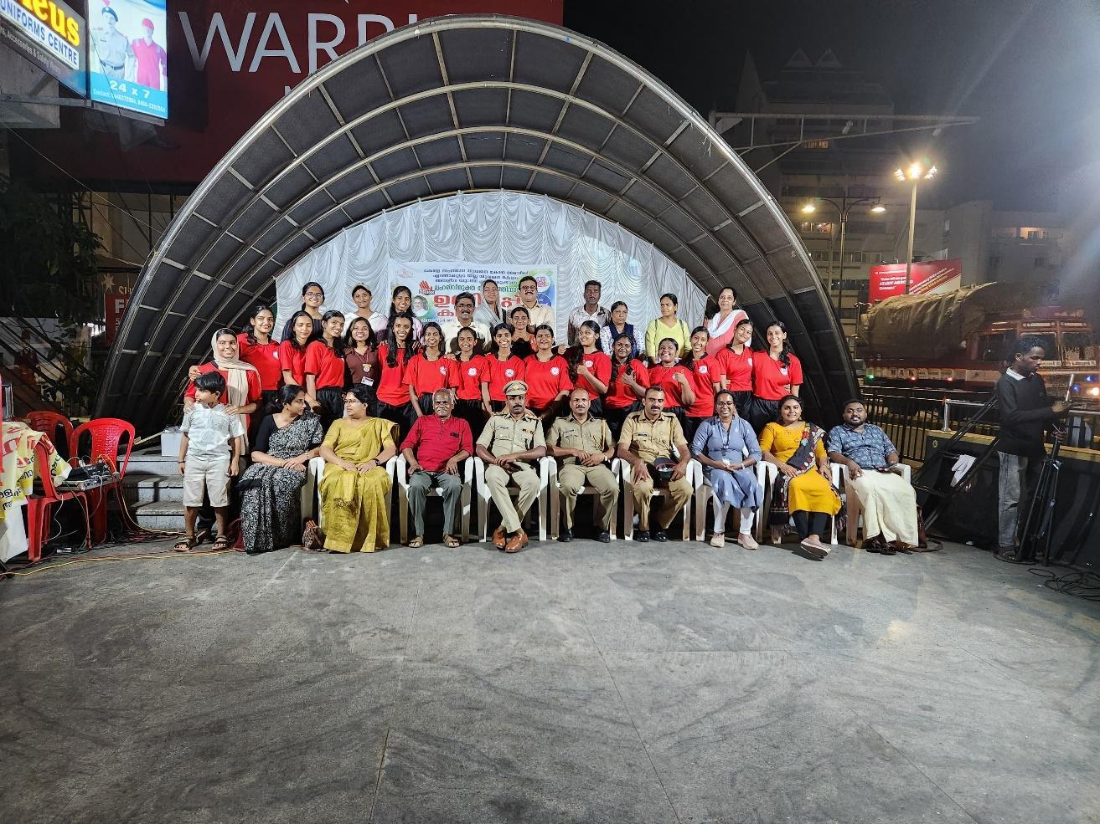
PROGRAMME NAME 14: CYCLE RALLY ON WOMEN’S DAY CELEBRATION
VENUE : PALARIVATTOM TO JLN STADIUM
DATE :07/03/2024
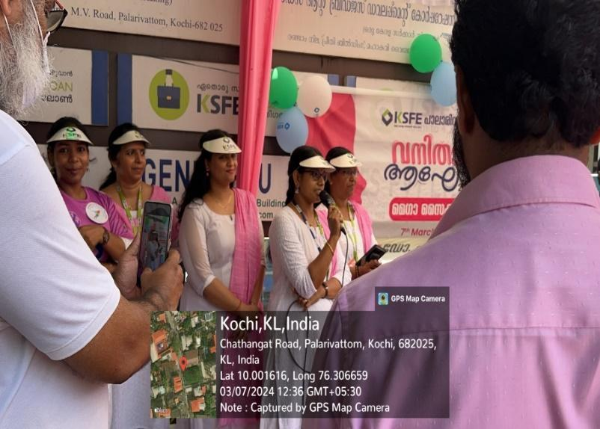
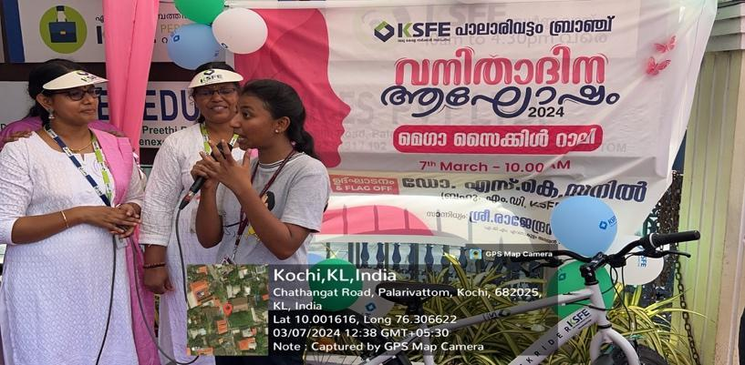
PROGRAMME NAME 15: AWARENESS SESSION ON WOMEN’S DAY CELEBRATION
VENUE : ST.TERESA’S COLLEGE, ERNAKULAM
DATE : 07/03/2024
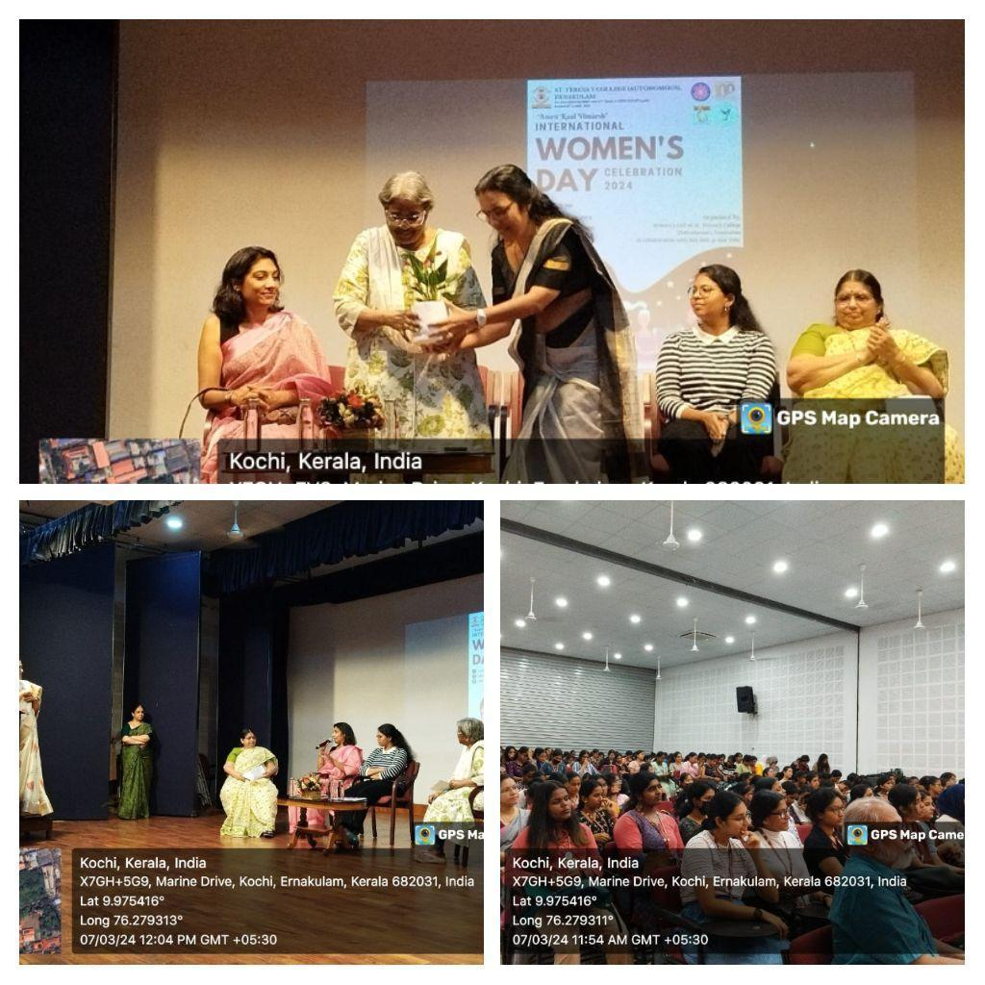
PROGRAMME NAME 16: TRAINING FOR REGISTRATION OF VOTERS ID
VENUE : ERNAKULAM COLLECTORATE
DATE : 13/03/2024
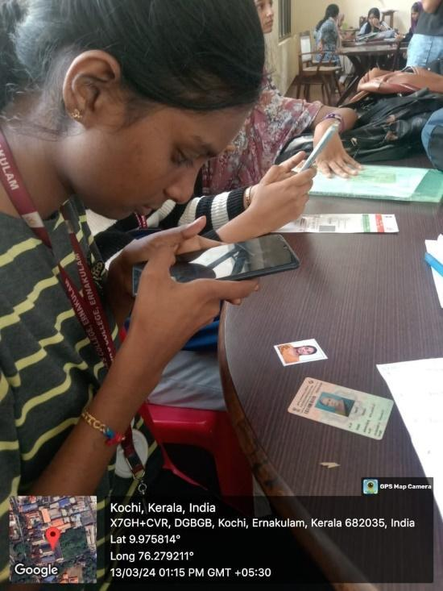
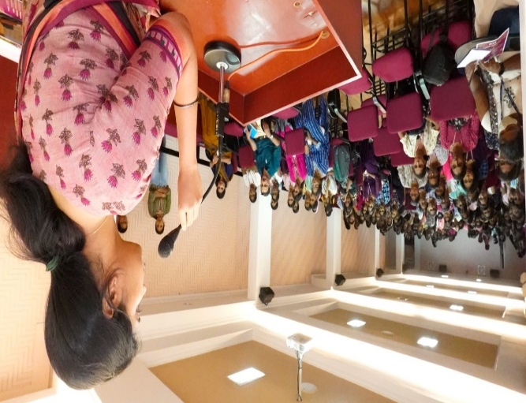

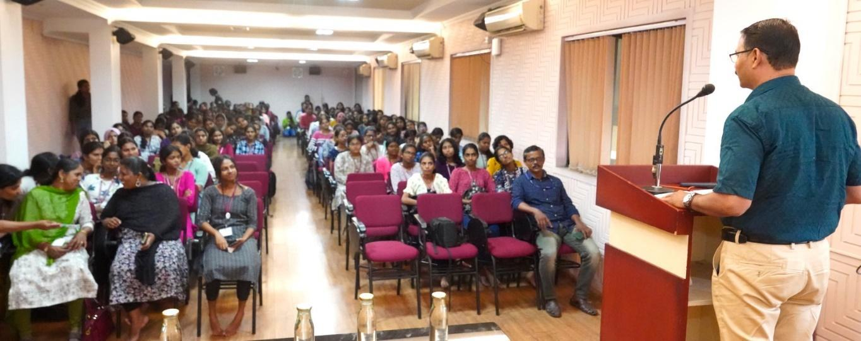

PROGRAMME NAME 17: AWARENESS ON VOTING - COMPETITION
VENUE : ERNAKULAM COLLECTORATE
DATE : 18/03/2024
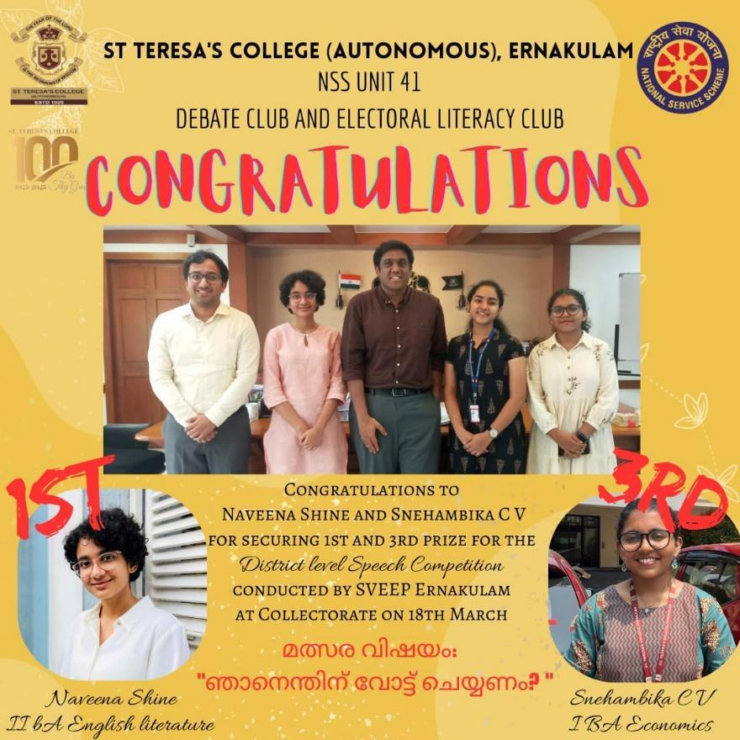

E. CREATION OF ASSETS

E1. NON DURABLE ASSET
NAME OF ASSET CREATED 1: KARUTHAL – POTHICHORU DISTRIBUTION
VENUE : GENERAL HOSPITAL, ERNAKULAM
DATE : 03/10/2023
Asset Value (Rs) : NIL
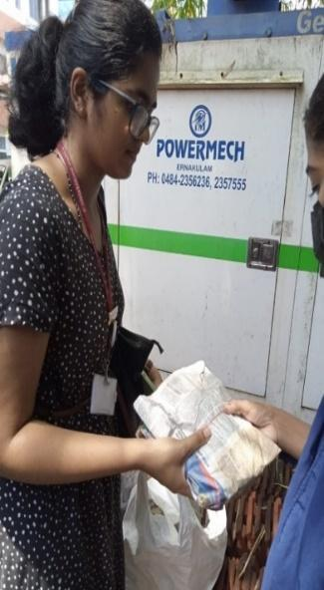

PHOTO
NAME OF ASSET CREATED 2: KARUTHAL – POTHICHORU DISTRIBUTION
VENUE : GENERAL HOSPITAL , ERNAKULAM
DATE : 08/11/2023
Asset Value (Rs) : NIL
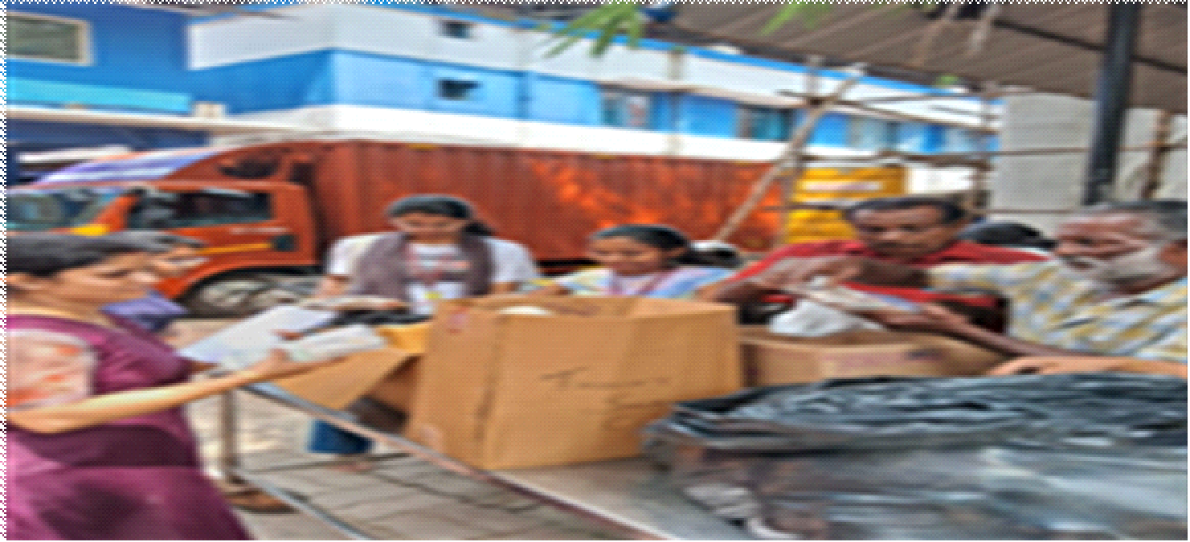
NAME OF ASSET CREATED 3: KARUTHAL – POTHICHORU DISTRIBUTION
VENUE : GENERAL HOSPITAL, ERNAKULAM
DATE : 14/12/2023
Asset Value (Rs) : NIL
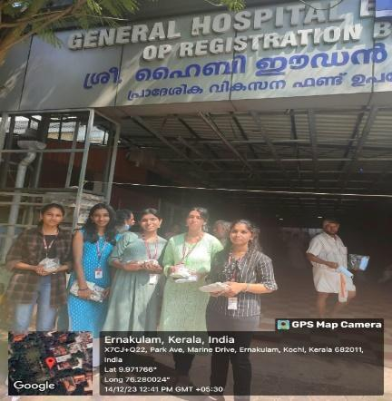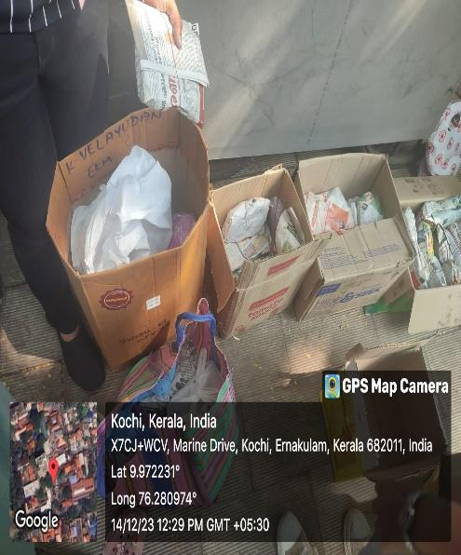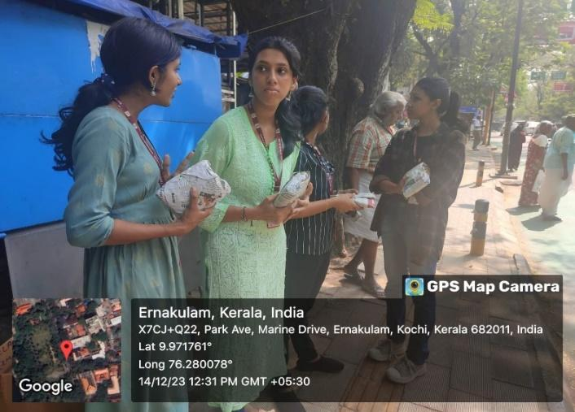

NAME OF ASSET CREATED 42: KARUTHAL – POTHICHORU DISTRIBUTION
VENUE : GENERAL HOSPITAL, ERNAKULAM
DATE : 18/01/2024
Asset Value (Rs) : NIL
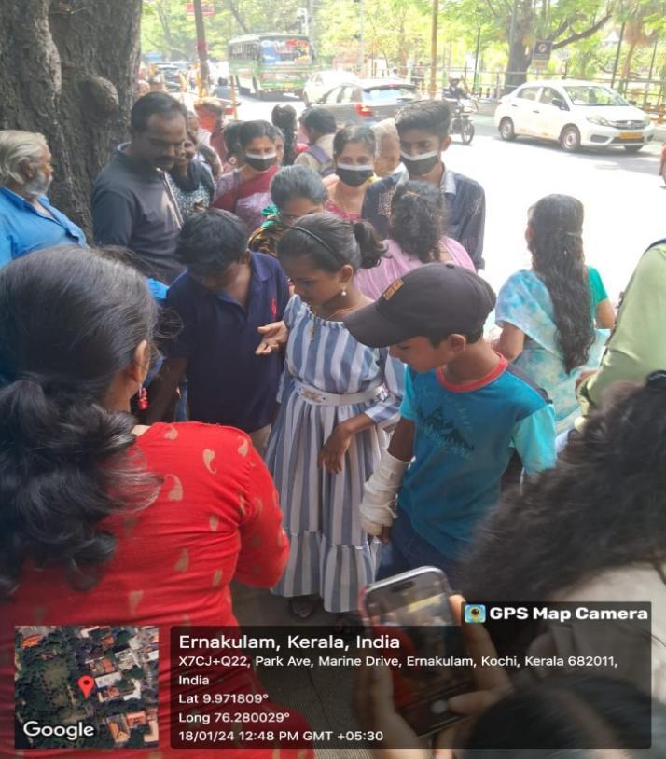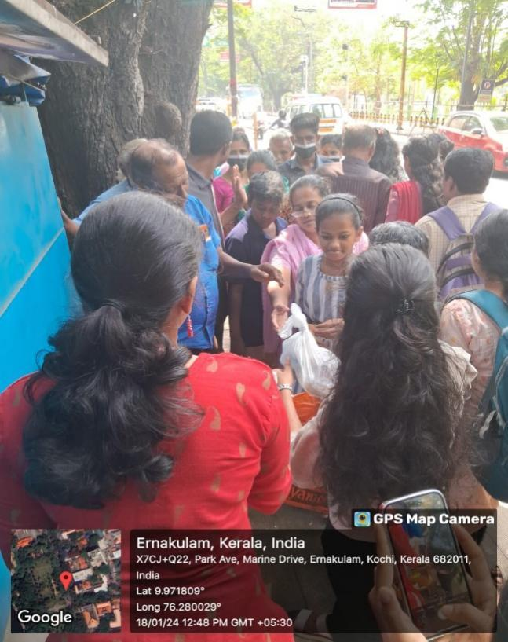
NAME OF ASSET CREATED 5: KARUTHAL – POTHICHORU DISTRIBUTION
VENUE : GENERAL HOSPITAL, ERNAKULAM
DATE : 12/03/2024
Asset Value (Rs) : NIL
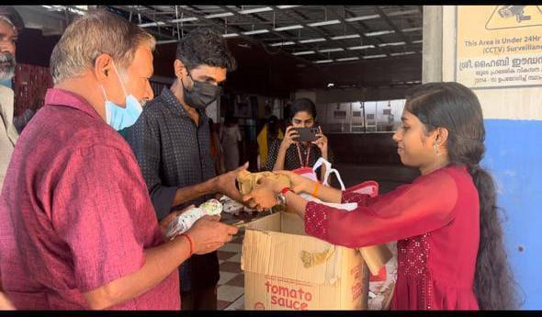
E2. DURABLE ASSET
NAME OF ASSET CREATED 1 : SNEHARAAMAM
VENUE : ST.TERESA’S COLLEGE, ERNAKULAM
DATE : 01/03/2024
Asset Value (Rs) : NIL

NAME OF ASSET CREATED 2: FOUNDATION STONE LAYING CEREMONY OF SNEHAVEEDU-I
VENUE : PUHUVYPPE
DATE : 22/06/2023
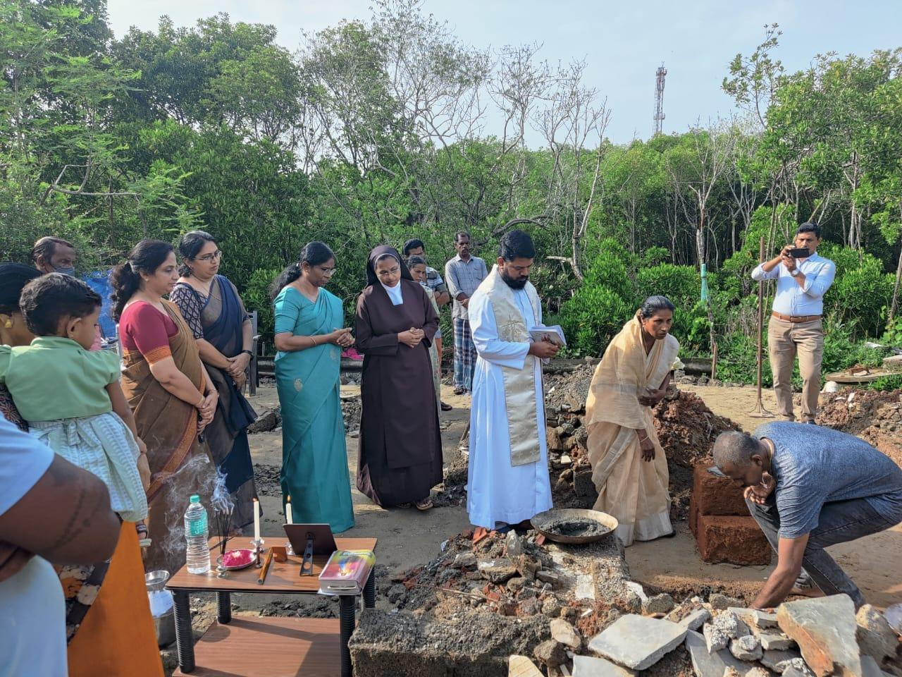
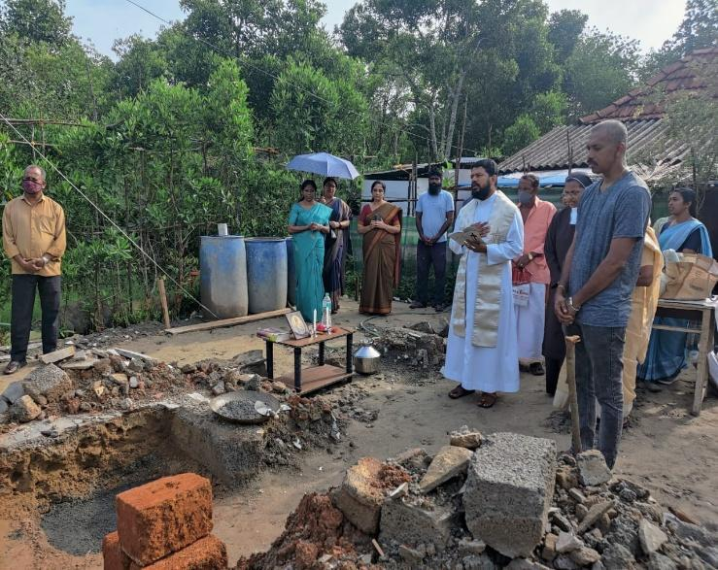
Asset Value (Rs) : NIL

NAME OF ASSET CREATED 3: HANDING OVER CEREMONY OF SNEHAVEEDU-I
VENUE : ELOOR
DATE : 16/12/2023
Asset Value (Rs) : NIL
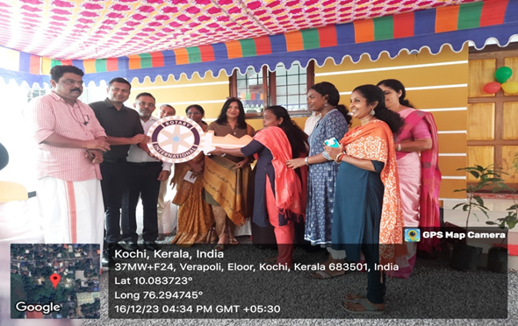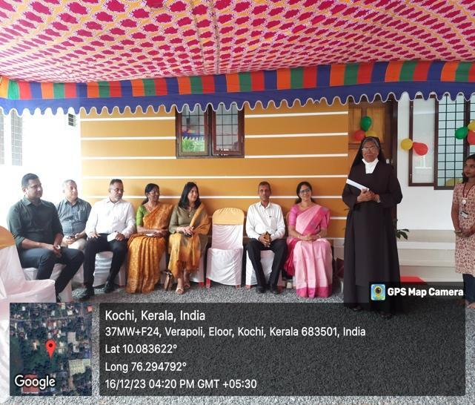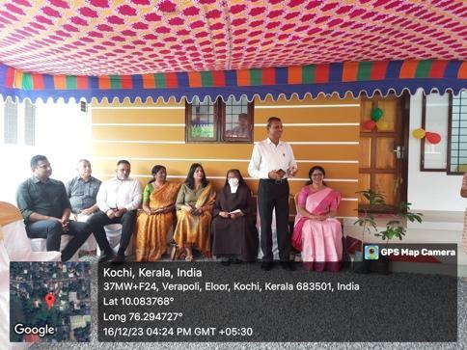
NAME OF ASSET CREATED 4: KEY HANDING OVER CEREMONY OF SNEHAVEEDU- II
VENUE : PUTHUVYPPE
DATE : 11/02/2024
Asset Value (Rs) : NIL
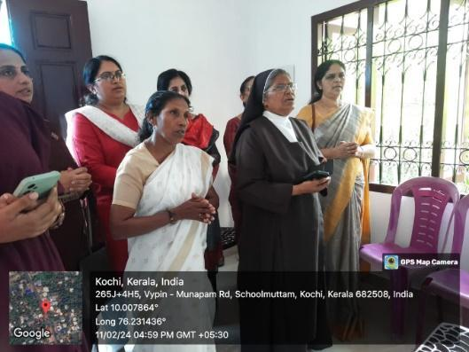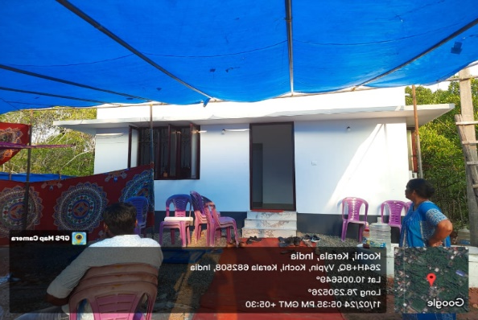
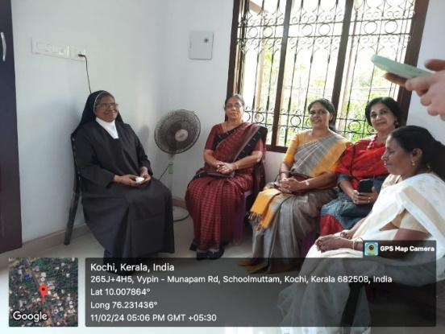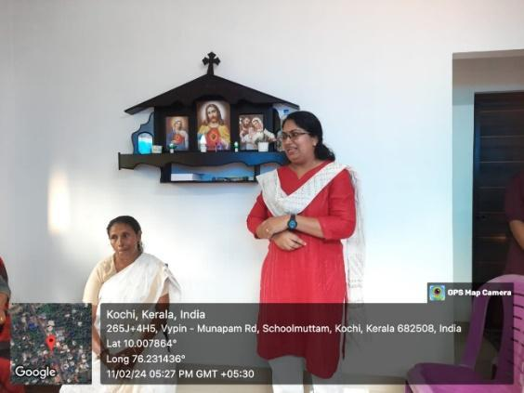

NAME OF ASSET CREATED 5: PLOT VISIT OF SNEHAVEEDU-III
VENUE : ALANGAD, PARAVOOR
DATE : 26/02/2024
Asset Value (Rs) : NIL
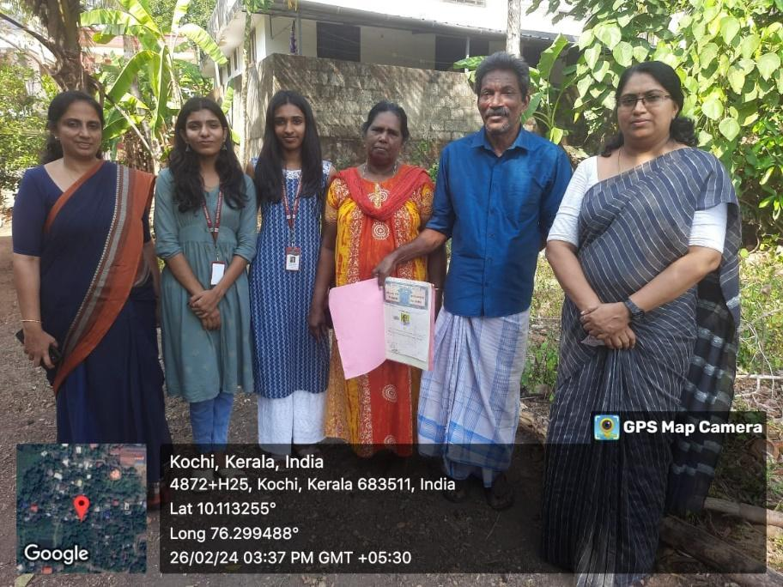

NAME OF ASSET CREATED 6: PLOT VISIT OF SNEHAVEEDU-III
VENUE : PARAVOOR
DATE : 30/04/2024
Asset Value (Rs) : NIL
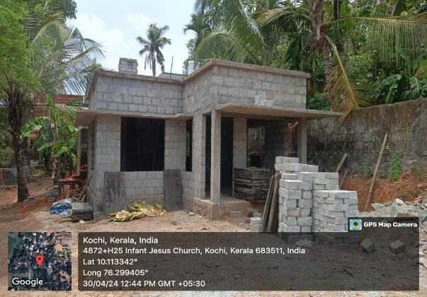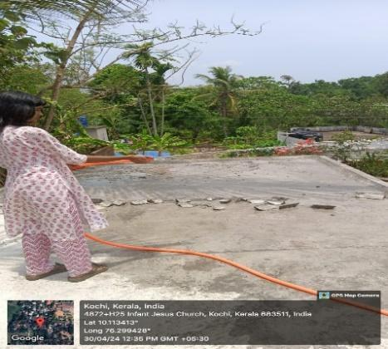
F. CLEANLINESS ACTIVITIES
PROGRAMME NAME 1: SWACCHTHA HI SEVA
VENUE : ST.TERESA’S COLLEGE, ERNAKULAM
DATE : 1/10/2023
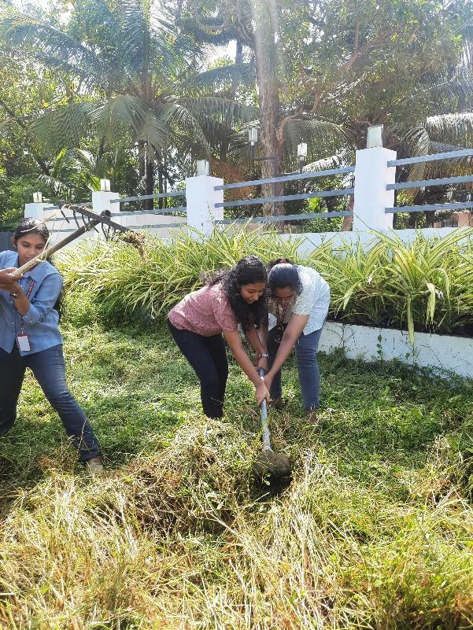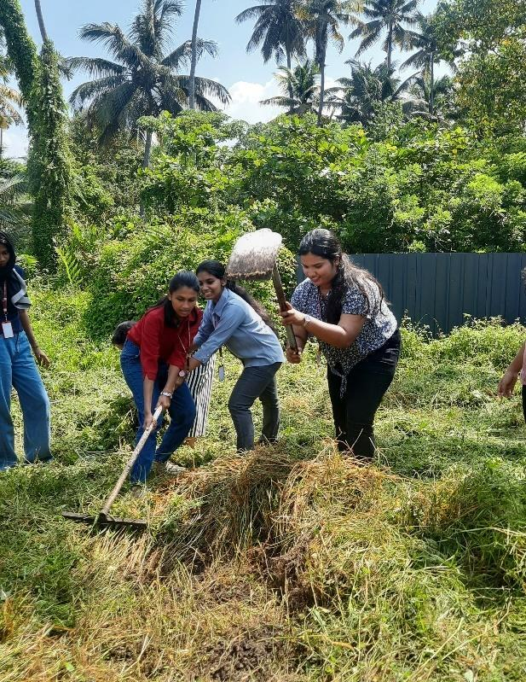

PROGRAMME NAME 2: MALINYA MUKTHA KERALAM CAMPAIGNING
VENUE : GENERAL HOSPITAL, ERNAKULAM
DATE : 20/10/2023
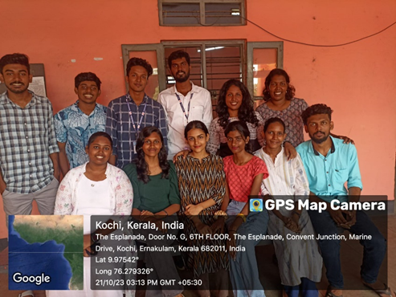

PROGRAMME NAME 3: ‘REVIVE KOCHI’
VENUE : MARINE DRIVE
DATE : 27/10/2023 – 28/10/2023
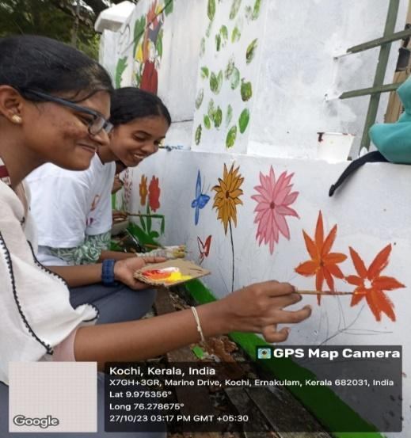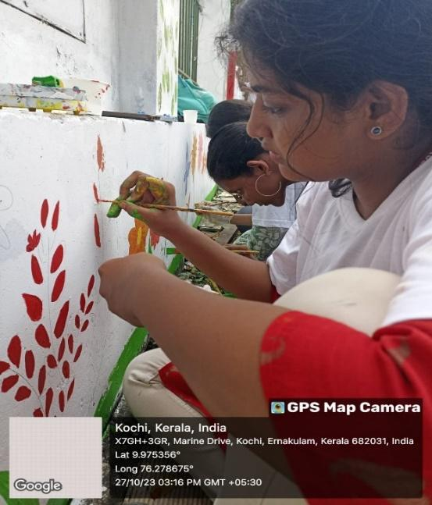
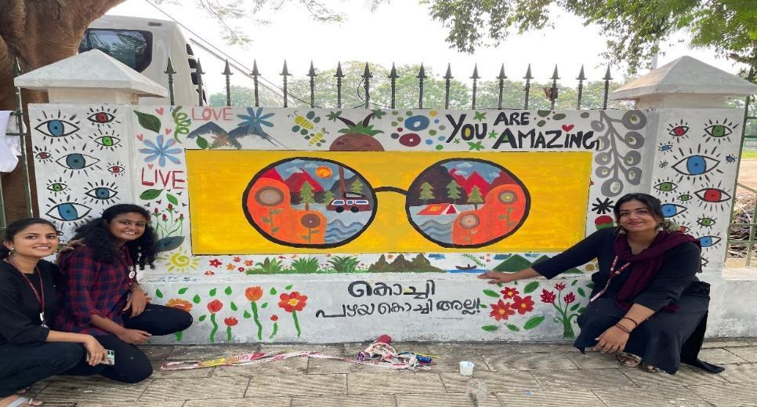

PROGRAMME NAME 4: BEACH CLEAN-UP
VENUE : FORT KOCHI BEACH
DATE : 10/11/2023
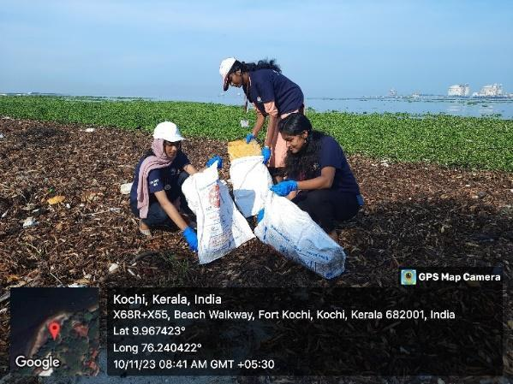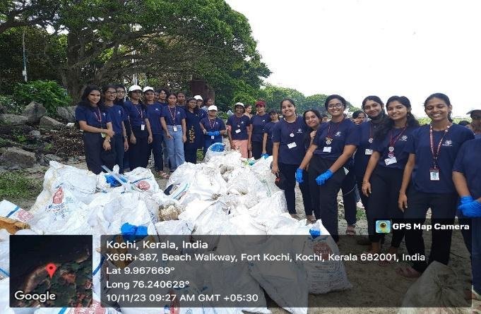
PROGRAMME NAME 5: BEACH CLEAN-UP
VENUE : FORT KOCHI BEACH
DATE : 07/01/2024
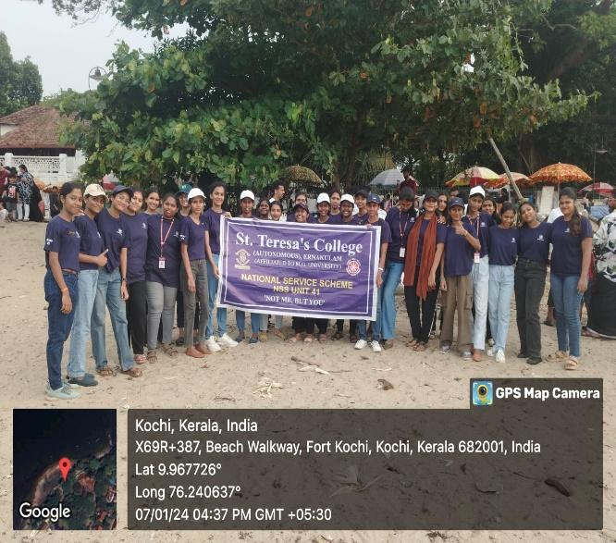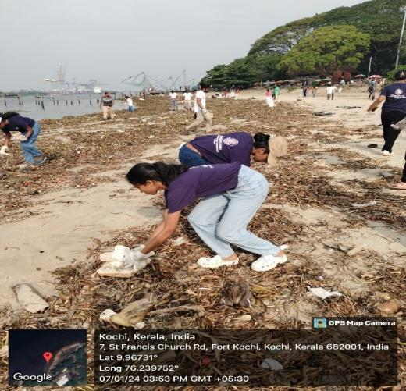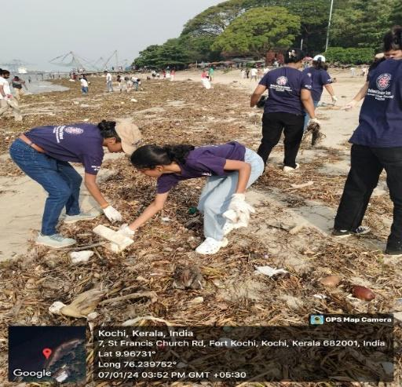
PROGRAMME NAME 6: FALCON BEACH CLEAN-UP
VENUE : FALCON BEACH,
DATE : 11/02/2024
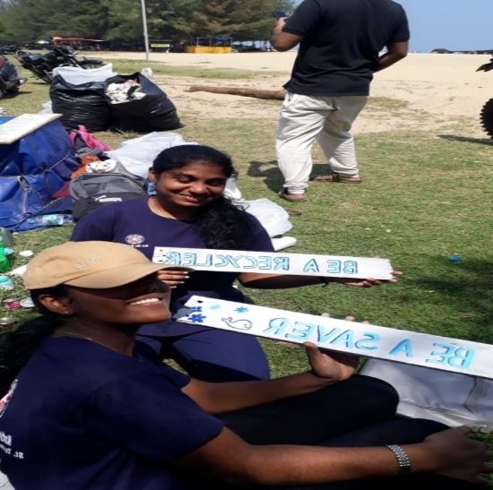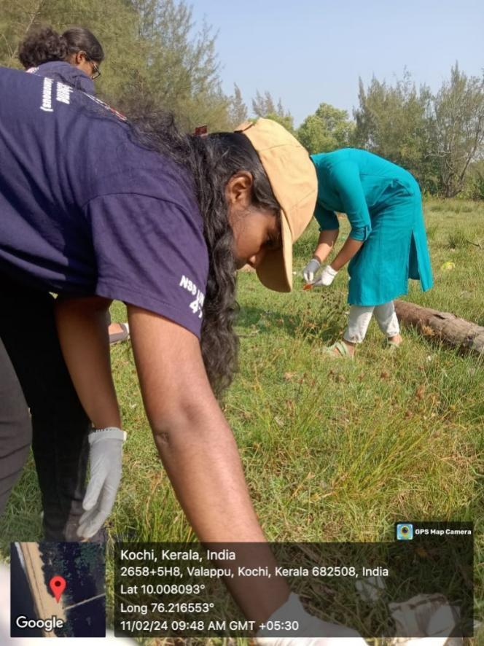
G. CONTRIBUTION TO VARIOUS NATIONAL SCHEMES
PROGRAMME NAME 1:
VENUE :
DATE :

PHOTO

H. OTHER ACTIVITIES
PROGRAMME NAME 1: INTERNATIONAL YOGA DAY CELEBRATION
VENUE : ST.TERESA;S COLLEGE, ERNAKULAM
DATE : 21/06/2023

PROGRAMME NAME 2: DEEKSHARAMB VOLUNTEERING
VENUE : ST.TERESA’S COLLEGE, ERNAKULAM
DATE : 10/07/2023 – 12/07/2023

PROGRAMME NAME 3: KARGIL VIJAY DIWAS
VENUE : ST.TERESA’S COLLEGE, ERNAKULAM
DATE : 26/07/2023
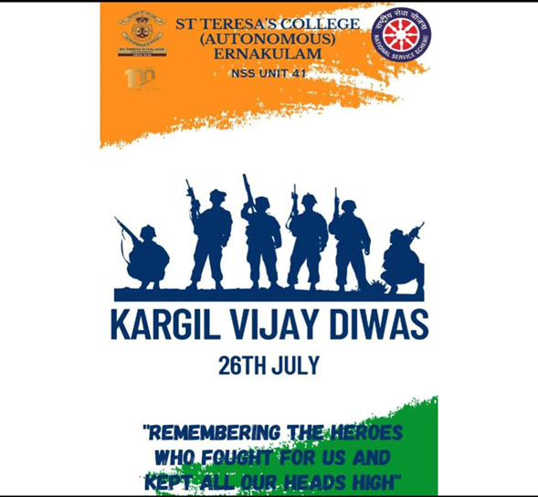

PROGRAMME NAME 4: DR. A P J ABDUL KALAM DEATH ANNIVERSARY
VENUE : ST.TERESA’S COLLEGE, ERNAULAM
DATE : 27/07/2023

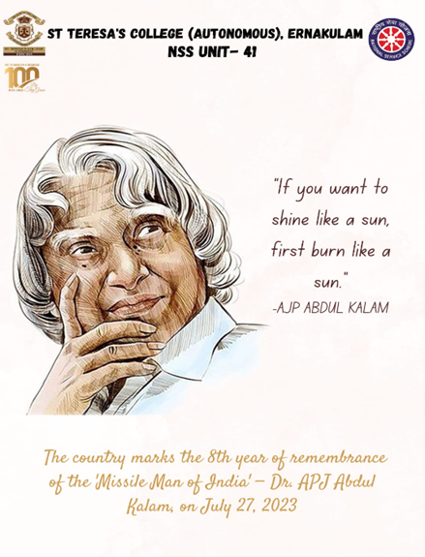

PROGRAMME NAME 5: HIROSHIMA DAY
VENUE : ST.TERESA’S COLLEGE, ERNAKLAM
DATE : 05/08/2023
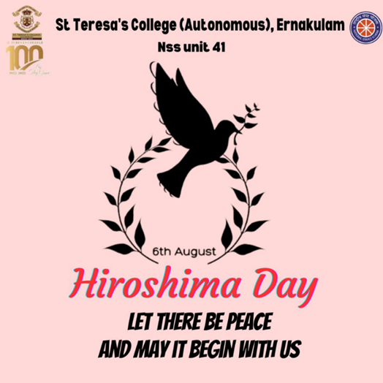
PROGRAMME NAME 6: INTERNATIONAL YOUTH DAY
VENUE : ST.TERESA’S COLLEGE, ERNAKLAM
DATE : 12/08/2023
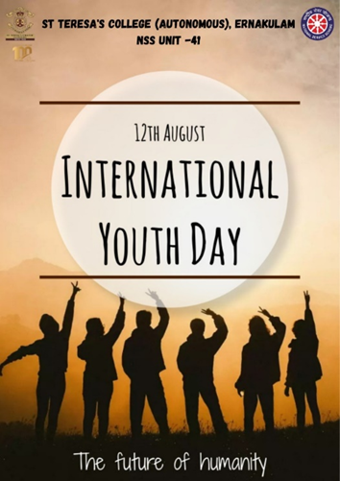
PROGRAMME NAME 7: WORLD ORGAN DONATION DAY
VENUE : ST.TERESA’S COLLEGE, ERNAKLAM
DATE : 13/08/2023
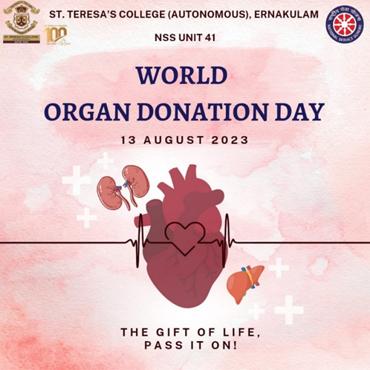
PROGRAMME NAME 8: INDEPENDENCE DAY
VENUE : ST.TERESA’S COLLEGE, ERNAKULAM
DATE : 15/08/2023
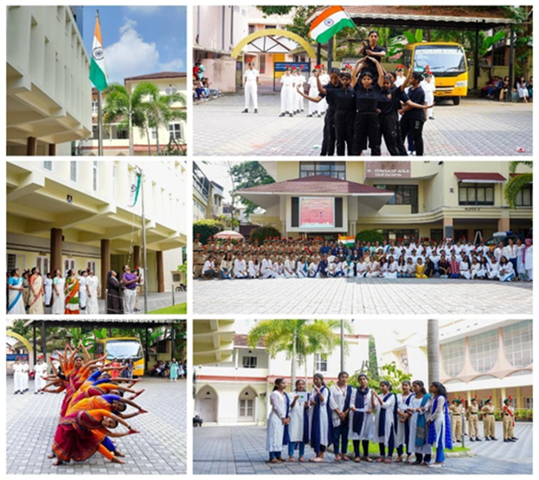

PROGRAMME NAME 9: 2 DAY RESIDENTIAL CAMP FOR NSS VOLUNTEER SECRETERIES
VENUE : SACRED HEART SOLLEGE, THEVARA
DATE : 18/08/2023 – 19/08/2023
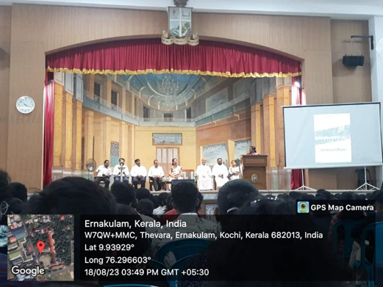
PROGRAMME NAME 10: ORIENTATION FOR FIRST YEAR NSS VOLUNETEERS
VENUE : ST.TERESA’S COLLEGE, ERNAKULAM
DATE : 24/08/2023 – 26/08/2024
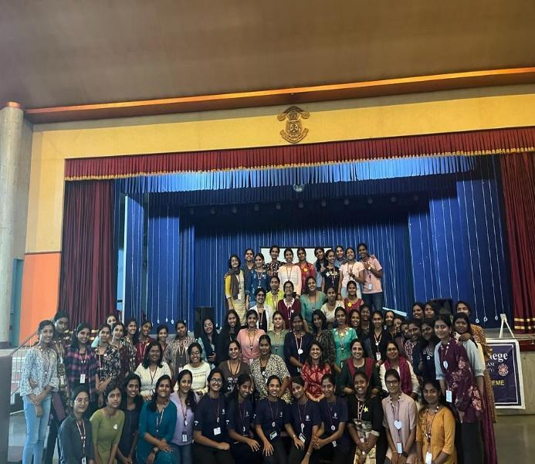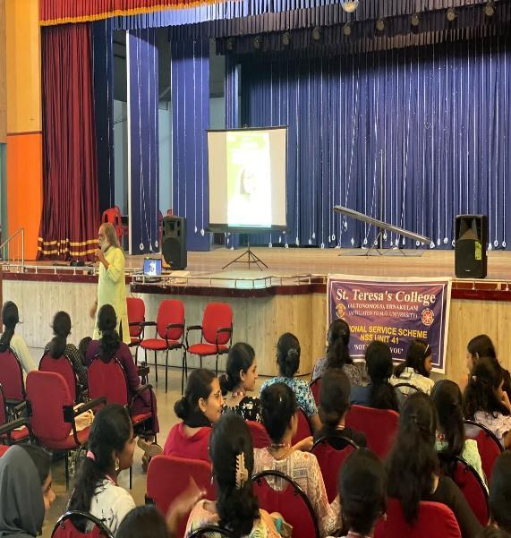

PROGRAMME NAME 11: TEACHERS DAY CELEBRATION
VENUE : ST.TERESA’S COLLEGE, ERNAKLAM
DATE : 05/09/2023
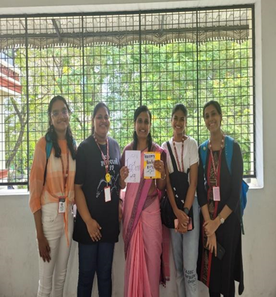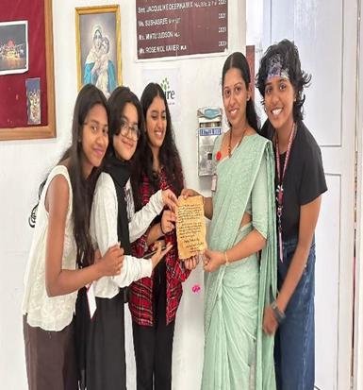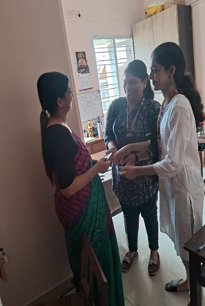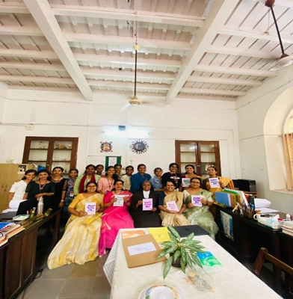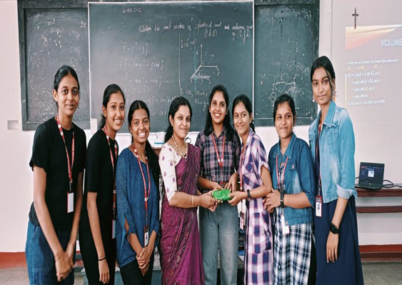

PROGRAMME NAME 12: NSS DAY CELEBRATION
VENUE : ST.TERESA’S COLLEGE, ERNAKULAM
DATE : 24/09/2023
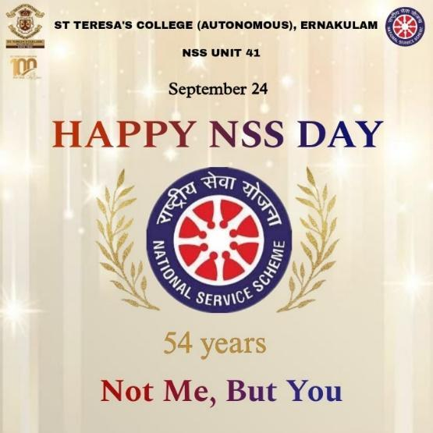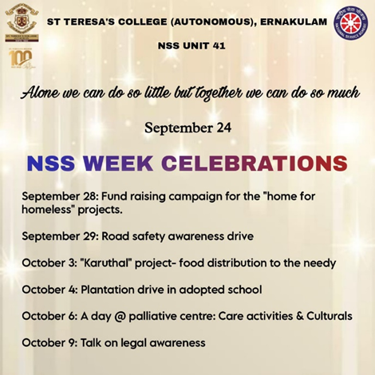
PROGRAMME NAME 13: FUNDRAISING FOR ‘SNEHAVEEDU’ PROJECT
VENUE : ST.TERESA’S COLEGE, ERNAKULAM
DATE : 28/09/2023

PROGRAMME NAME 14: GANDHI JAYANTHI
VENUE : : ST.TERESA’S COLLEGE, ERNAKLAM
DATE : 02/10/2023
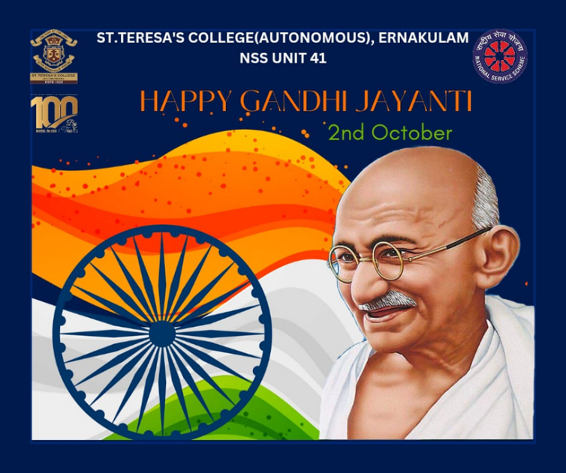
PROGRAMME NAME 15: NATIONAL UNITY DAY
VENUE : ST.TERESA’S COLLEGE, ERNAKLAM
DATE : 01/11/2023
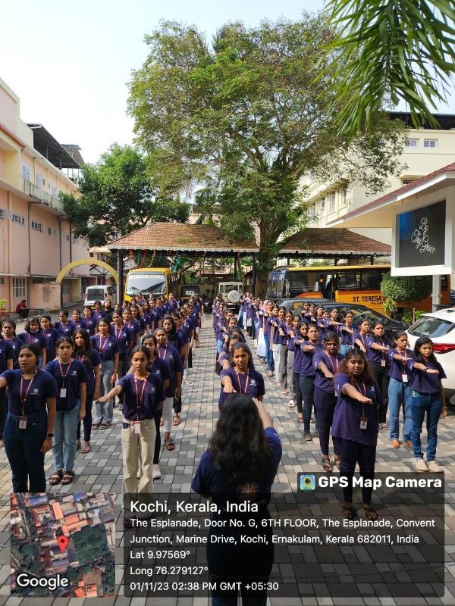

PROGRAMME NAME 16: INTERNATIONAL DAY OF DIFFERENTLY ABLED
VENUE : ST.TERESA’S COLLEGE, ERNAKLAM
DATE : 2/12/2023
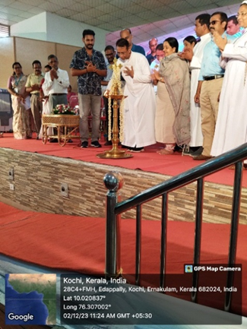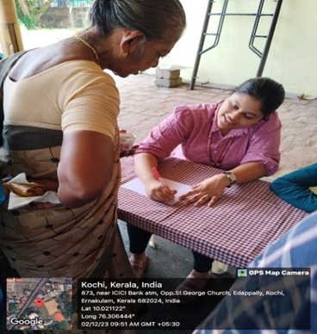

PROGRAMME NAME 16: FELICITATION CEREMONY FOR JILUMOL
VENUE : ST.TERESA’S COLLEGE, ERNAKLAM
DATE : 05/01/2024
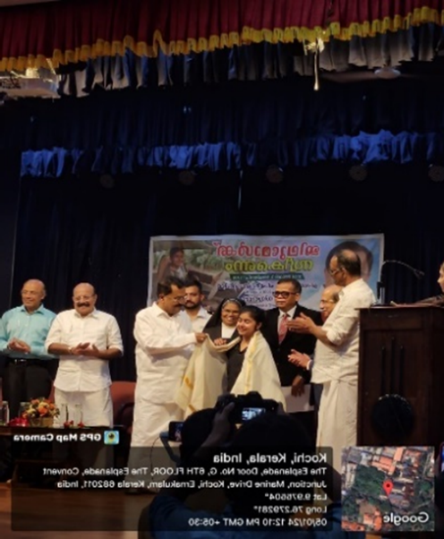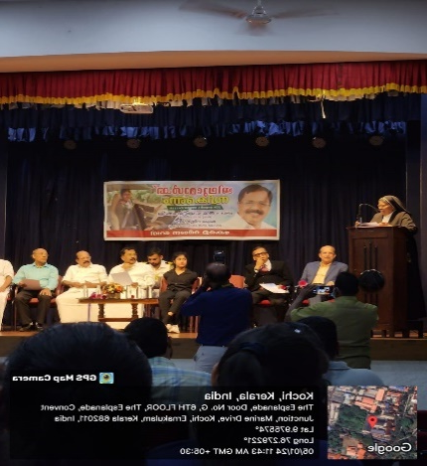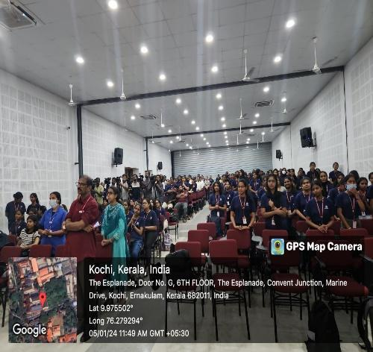
PROGRAMME NAME 17: REGISTRATION IN ‘MY BHARAT’ PORTAL
VENUE : ST.TERESA’S COLLEGE, ERNAKLAM
DATE : 08/01/2024
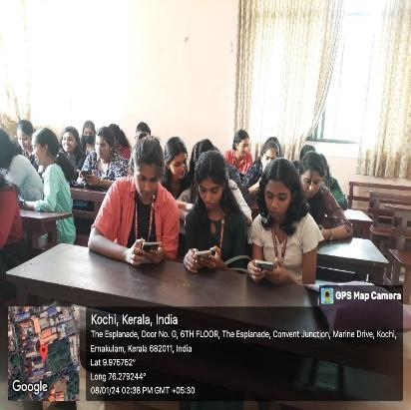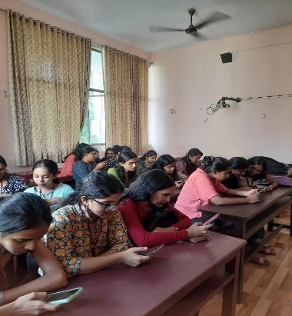
PROGRAMME NAME 18: NATIONAL YOUTH DAY
VENUE : ST.TERESA’S COLLEGE, ERNAKLAM
DATE : 12/01/2024
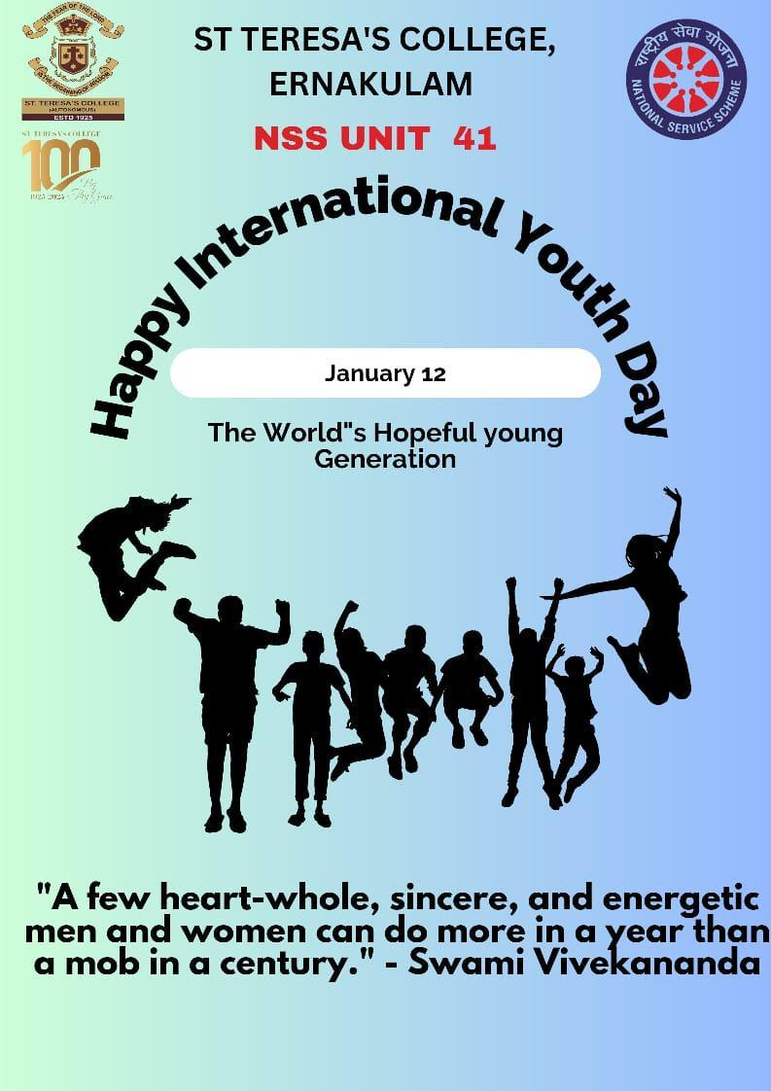

PROGRAMME NAME 19: NATIONAL GIRL CHILD DAY
VENUE : ST.TERESA’S COLLEGE, ERNAKLAM
DATE : 24/01/2024
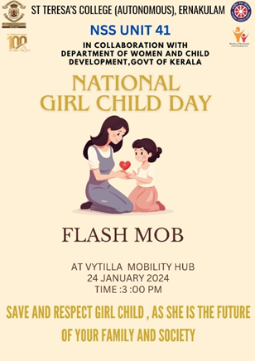
PROGRAMME NAME 20: REPUBLIC DAY
VENUE : ST.TERESA’S COLLEGE, ERNAKLAM
DATE : 26/01/2024
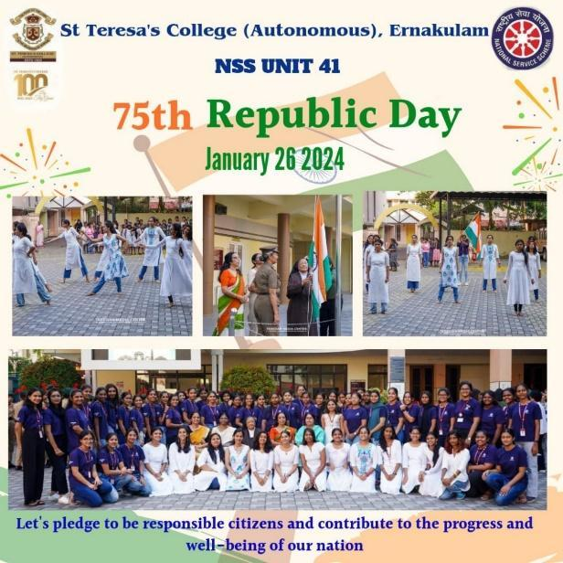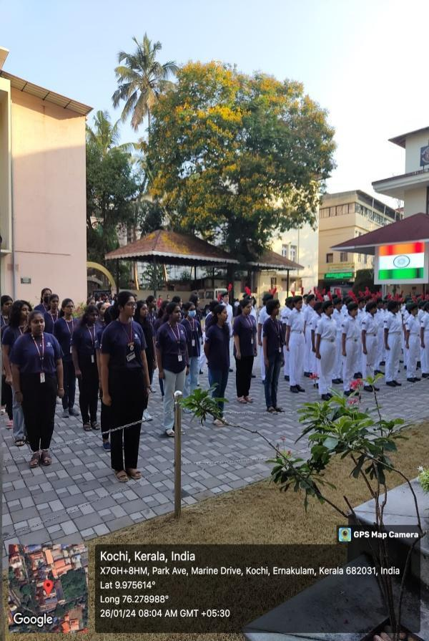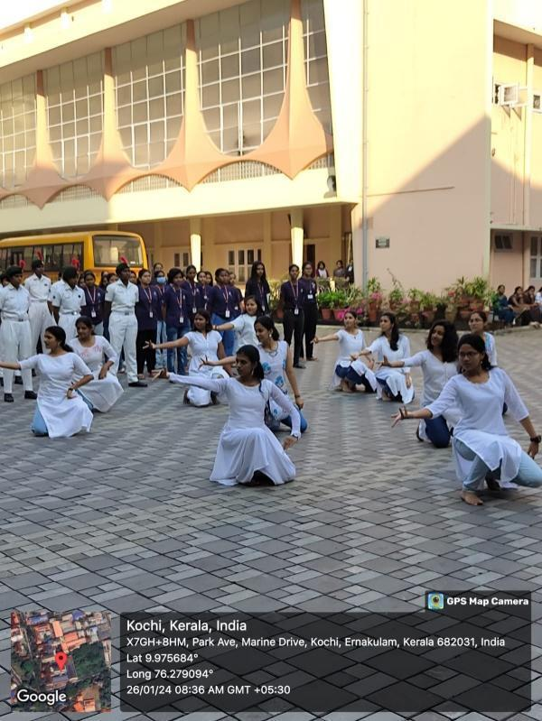
PROGRAMME NAME 21: NATURE CAMP
VENUE : ATHIRAPILLY- VAZHACHAL
DATE : 16/02/2024 – 17/02/2024

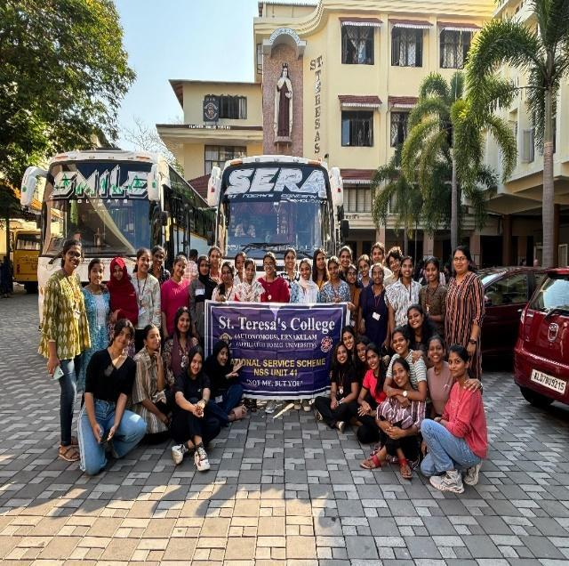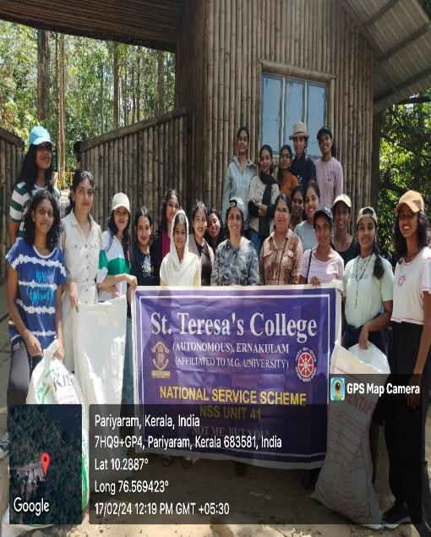

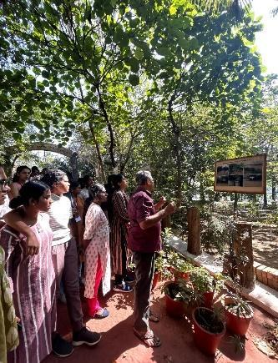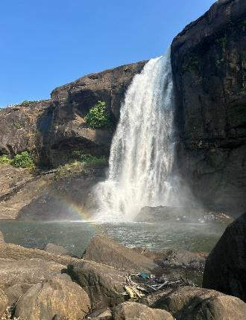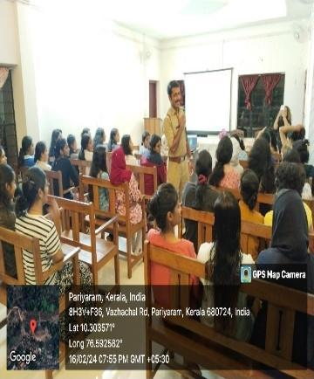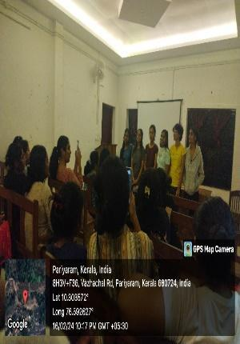

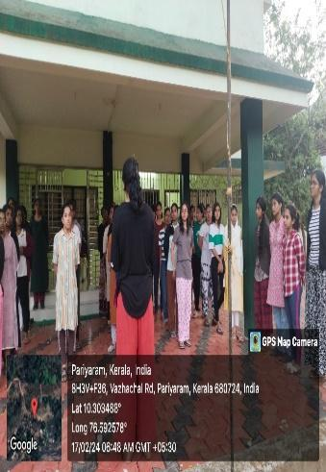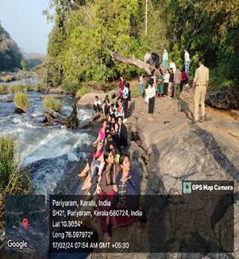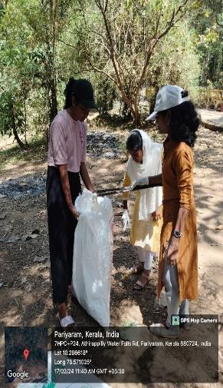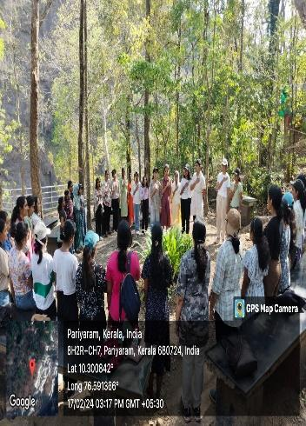

PROGRAMME NAME 22: AWARD CEREMONY
VENUE : M G UNIVERSITY, KOTTAYAM
DATE : 22/02/2024
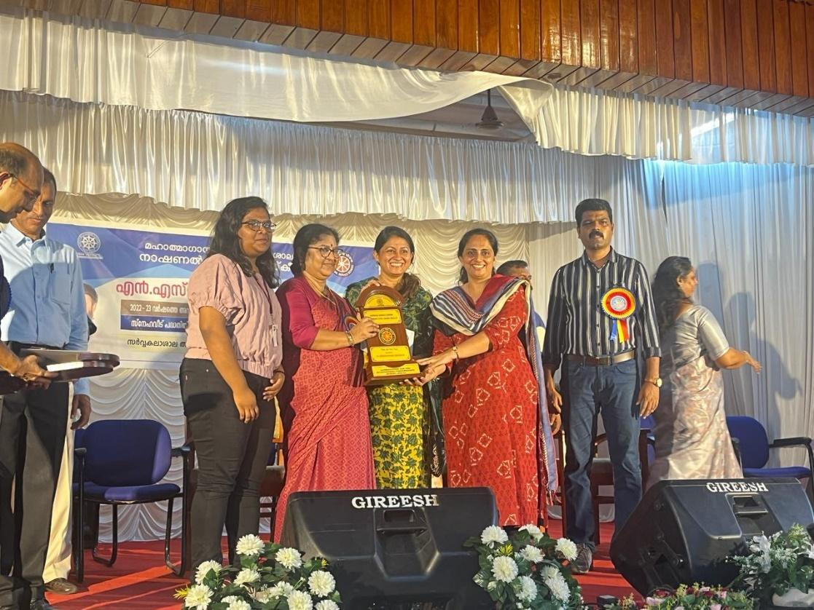
PROGRAMME NAME 23: KALOLSAVAM VOLUNTEERING
VENUE : KOTTAYAM
DATE : 26/02/2024 – 03/03/2024
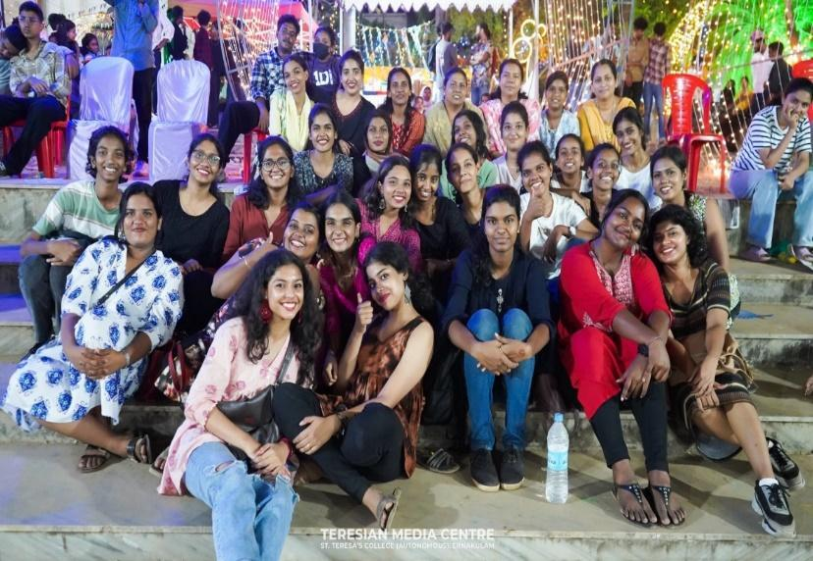
PROGRAMME NAME 24: INTERNATIONAL WOMEN’S DAY CELEBRATION
VENUE : ST.TERESA’S COLLEGE, ERNAKULAM
DATE : 07/03/2024

PROGRAMME NAME 25: ELECTION VOLUNTEERING DUTY
VENUE : ST.TERESA’S SCHOOL, ERNAKULAM
DATE : 26/03/2024

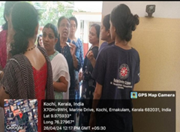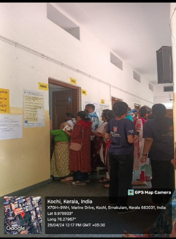

I. NATIONAL LEVEL PROGRAMMES ORGANISED
PROGRAMME NAME 1:
VENUE :
DATE :

PHOTO

J. STATE LEVEL PROGRAMMES ORGANISED

PROGRAMME NAME 1:
VENUE :
DATE :

PHOTO

K. UNIVERSITY LEVEL PROGRAMMES PROJECTS

K1. SCHOOL ADOPTION

PROGRAMME NAME 1: POSHAKARAAMAM
VENUE : ST.JOSEPH’S SCHOOL, PANAMBUKKAD
DATE : 04/10/2023
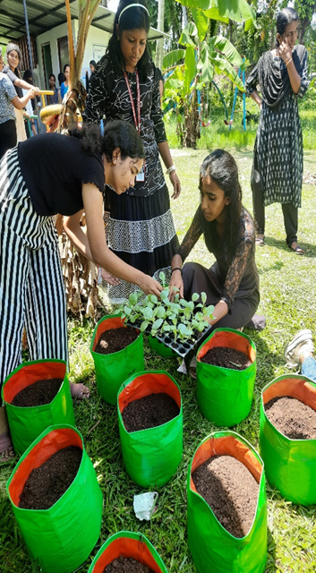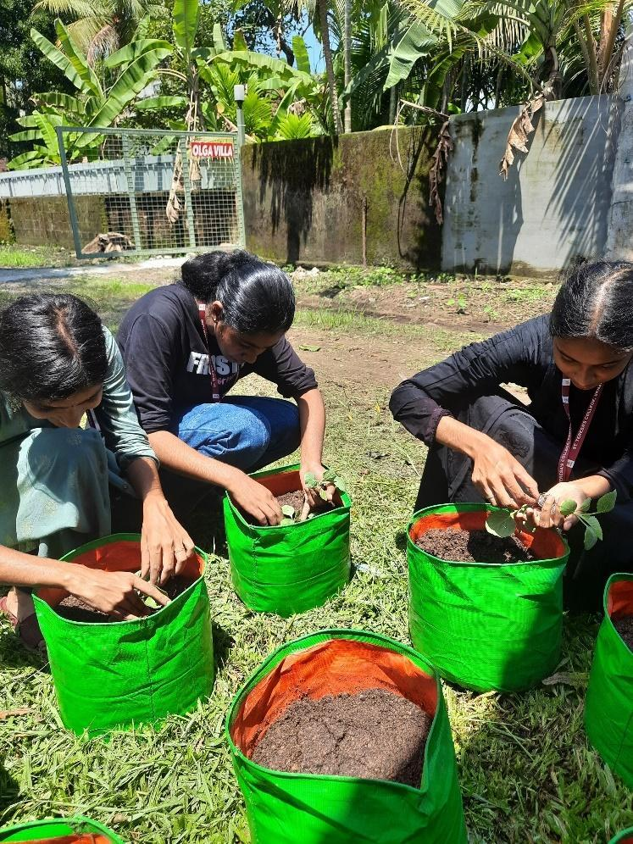

K2. DISASTER MANAGEMENT TEAM ( MGU ON TEAM ON SPOT)

NAME OF VOLUNTEERS IN DISASTER MANAGAMENT TEAM:
NO OF STUDENTS REC 20
1, AADRIKA PREM
2, AAMILAH RIYAS D
3, AISWARYA P S
4, ALEENA T P
5, ALISHA C H
6, AMRITA SW RAJ
7, ANDREA S
8, ANGEL MARY TOM
9, APARNA MARIA P S
10, ARDRA BAIJU
11, ASHLY MATHEW
12, DEVNA S
13, JEEVA ROSE
14, JIYA AISHA
15, LIMA ROSE
16, SAANDHYATHAARA
17, SANIA SAJI
18, SIVAPRIYA K S
19, TANIA TERESA GEORGE
20, VENESSA LESLIE

K3. SNEHAVEEDU

COMPLETED HOUSE DETAILS
NAME& ADDRESS OF THE BENEFICIARY1: LIJIMOL (MOTHER OF AISWARIYA SREEKUTTY)
PLACE: ELOOR
AMOUNT SPEND : 13 LAKHS
WE RAISED: 1 LAKH
FOR BUYIND THE LAND: 2.5 LAKH
DATE OF COMPLETION : 16.12.2023

HOUSE DETAILS-WORK ON PROGRESS
NAME & ADDRESS OF THE BENEFICIARY1: REETHA
PLACE: ELAKUNNAPUZHA, PUTHUVYPU
TOTAL EXPENSE :8.15 LAKH
WE GAVE :4.15 LAKH
HANDING OVER :11.02.2024

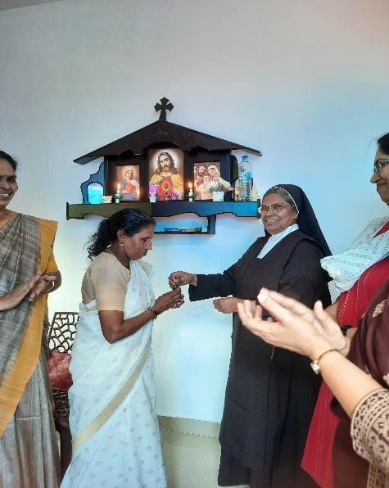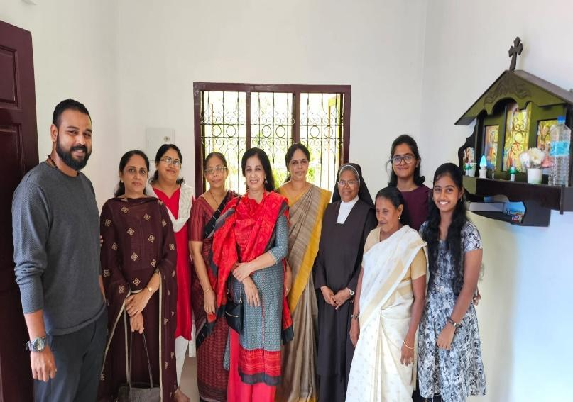

K4. BIODIVERSITY PARK AT COLLEGE CAMPUS / ADOPTED SCHOOL

PLACE :
AREA IN CENTS :

PHOTO

K5. DRINKING WATER CONSERVATION

PROGRAMME NAME 1:
NAME OF WATER SOURCE MAINTAINED :
VENUE :
DATE :

PHOTO

K6. SUSTAINABLE REGIONAL TOURISM PROMOTION

PHOTO

NAME OF TOURIST DESTINATION
ADDRESS
LINK

K7.PALLIATIVE CARE UNITS

PROGRAMME NAME 1: WORLD HOSPICE DAY AND PALLIATIVE CARE DAY CELEBRATION
VENUE : ST.TERESA’S COLLEGE, ERNAKULAM
DATE : 14/10/2024
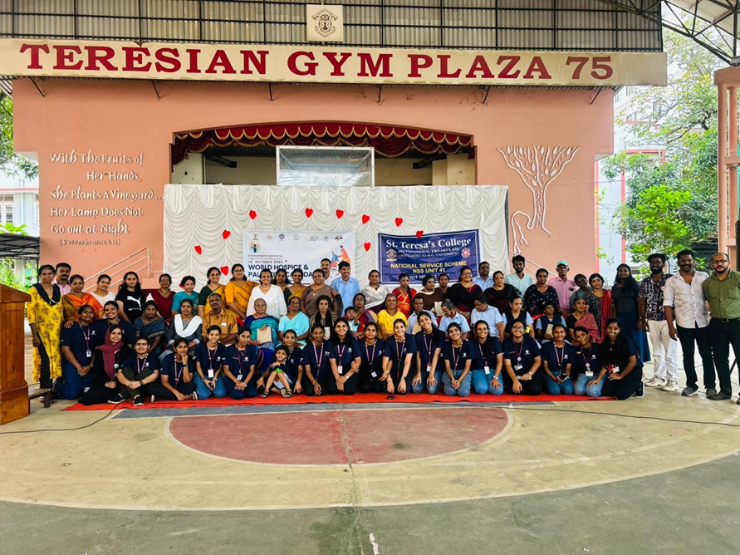
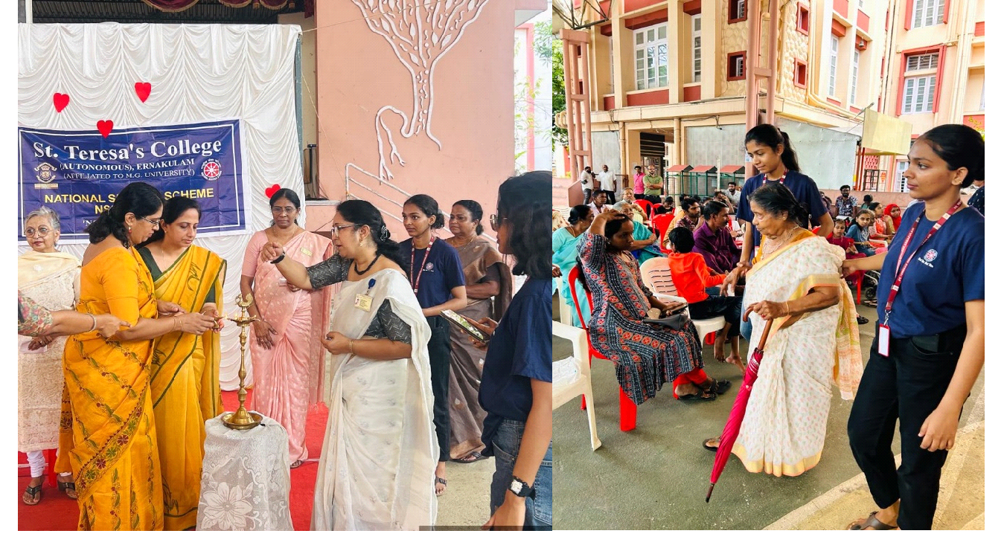

PROGRAMME NAME 2: PALLIATIVE CARE SESSION
VENUE : ST.TERESA’S COLLEGE, ERNAKULAM
DATE: 10/01/2024
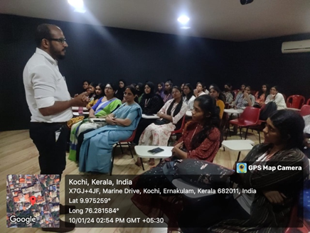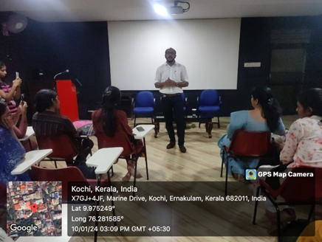

PROGRAMME NAME 3: PALLIATIVE CARE
VENUE : JEREMIAH PALLIATIVE CARE HOME
DATE: 12/01/2024
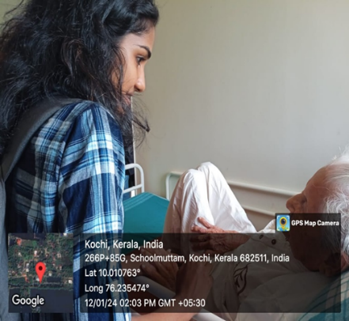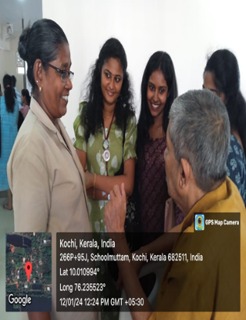

L. ANY OTHER UNIQUE PROGRAMMES ORGANISED

PROGRAMME NAME 1: PROJECT ‘SHARP’
VENUE : METRO STATION, M G ROAD
DATE : 06/06/2023

PROGRAMME NAME 2: LAUNCH OF PROJECT ‘REFORM’
VENUE : ST.TERESA’S COLLEGE, ERNAKULAM
DATE : 08/06/2023
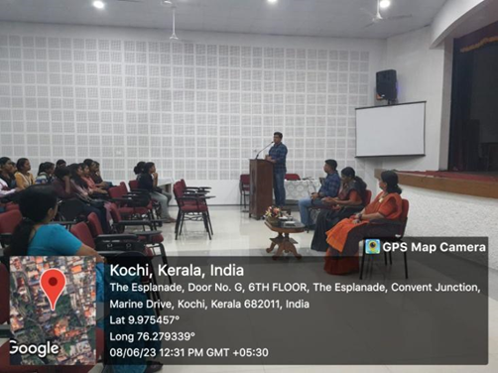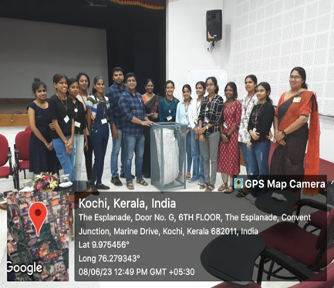

PROGRAMME NAME 3: OPEN MIC
VENUE : ST.TERESA’S COLLEGE, ERNAKULAM
DATE : 23/06/2023
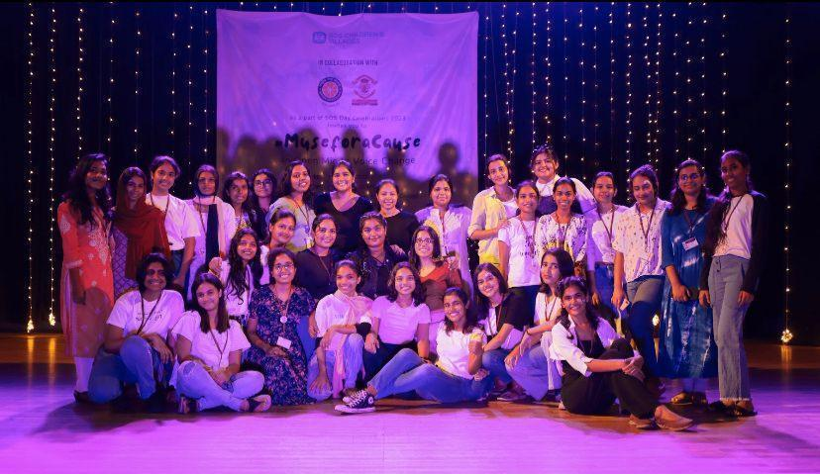

PROGRAMME NAME 4: PROJECT ‘DISHA’ ORIENTATION
VENUE : ST.TERESA’S COLLEGE, ERNAKULAM
DATE : 27/07/2023
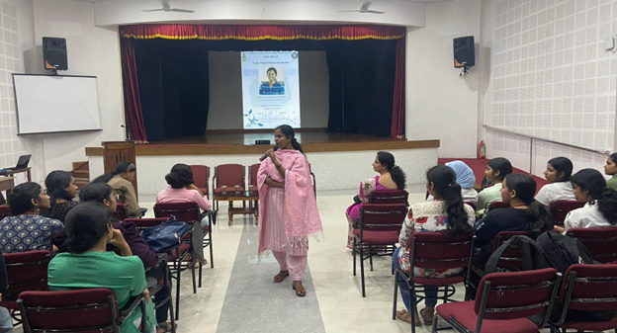

PROGRAMME NAME 5: UTS APP PROMOTION ACTIVITIES
VENUE : SOUTH RAIWAY STATION , ERNAKULAM
DATE : 10/10/2023 , 30/10/2023 , 01/11/2023, 02/11/2023 , 06/11/2023, 08/11/2023
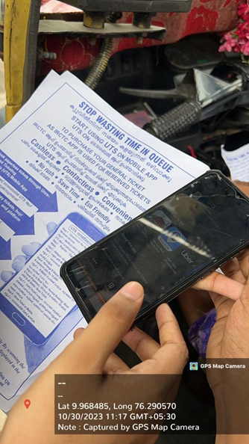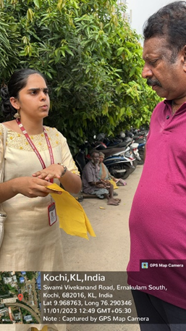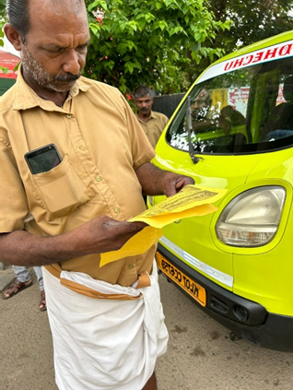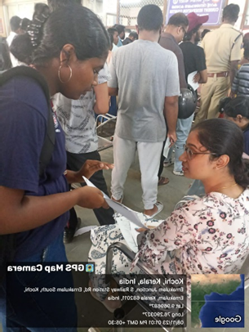
PROGRAMME NAME 6:BODHI MEMORY WALK
VENUE : DARBAR HALL GROUND, ERNAKULAM
DATE : 17/10/2023

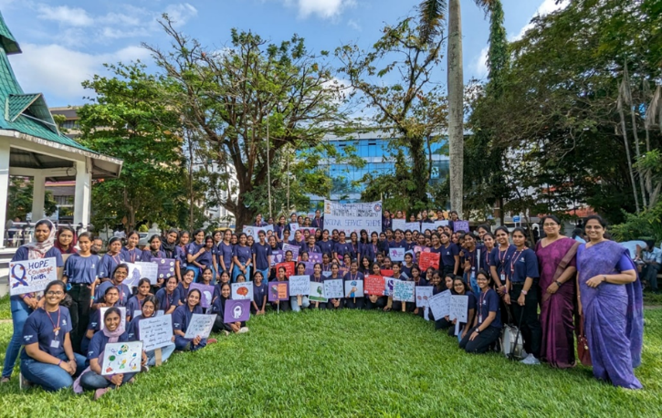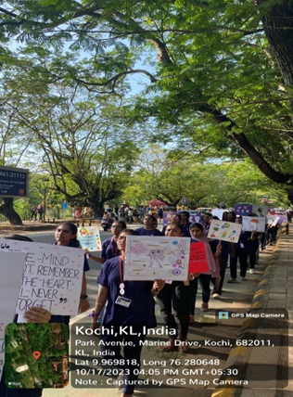
PROGRAMME NAME 7: THRIFT SALE – ‘SWEET REPEATS- FUNDRAISING FOR PROJECT ‘SNEHAVEEDU’
VENUE : ST.TERESA’S COLLEGE, ERNAKULAM
DATE : 09/11/2023 -10/11/2023
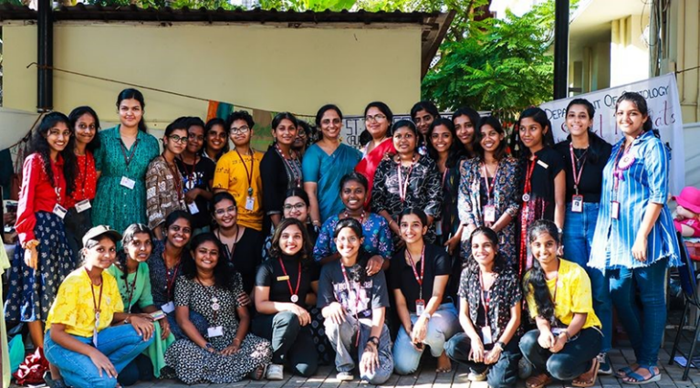

PROGRAMME NAME 8: PROJECT ‘GOONJ IT’
VENUE : ST.TERESA’S COLLEGE, ERNAKULAM
DATE : 06/12/2023
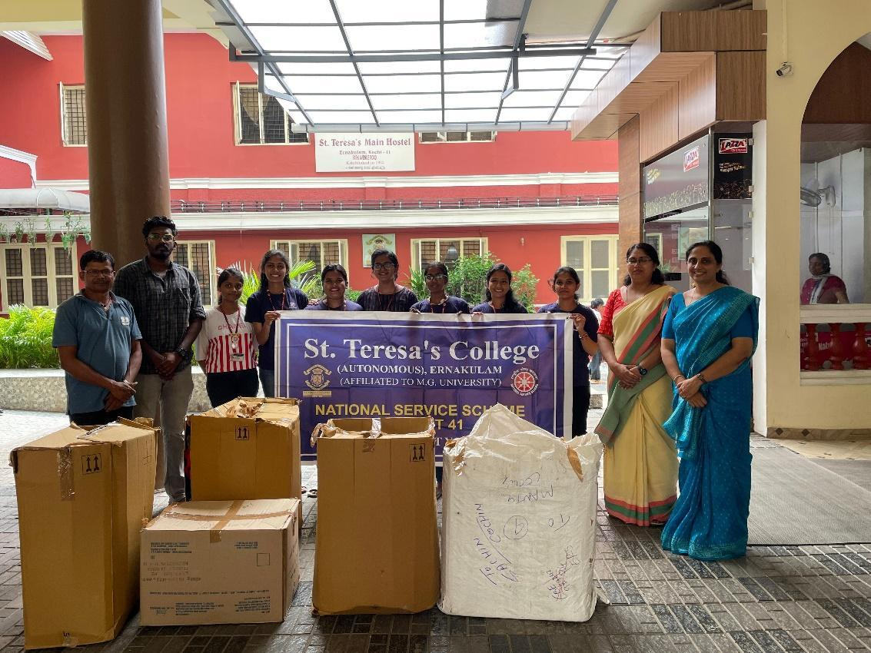

PROGRAMME NAME 9: CAKE CHALLENGE 4.0
VENUE : ST.TERESA’S COLLEGE, ERNAKULAM
DATE : 19/12/2023

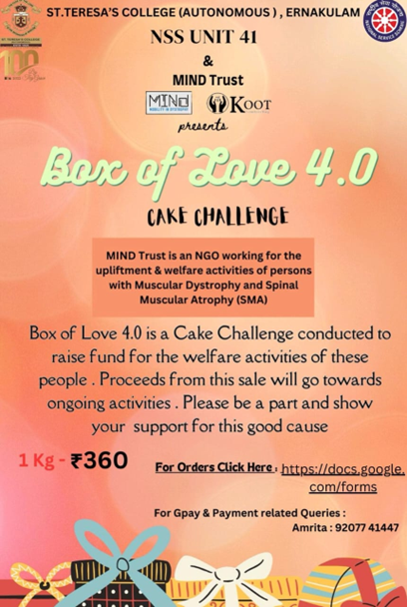

PROGRAMME NAME 10: 5TH WOMEN’S INTERNATIONAL FILM FEST
VENUE : SARITHA, SAVITHA AND SANGEETHA THEATRE , KACHERIPPADY
DATE : 10/02/2024 – 13/02/2024
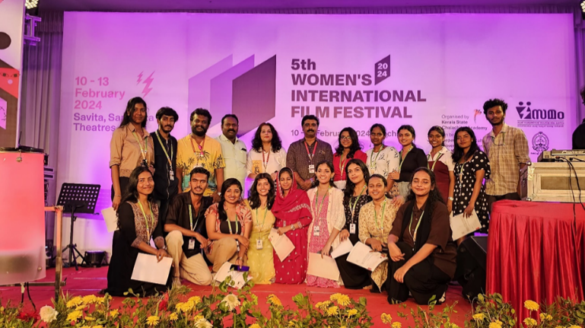

PROGRAMME NAME 11: SCREENING OF THE DOCUMENTARY ‘ THE GREEN MAN
VENUE : ST.TERESA’S COLLEGE, ERNAKULAM
DATE : 19/02/2024
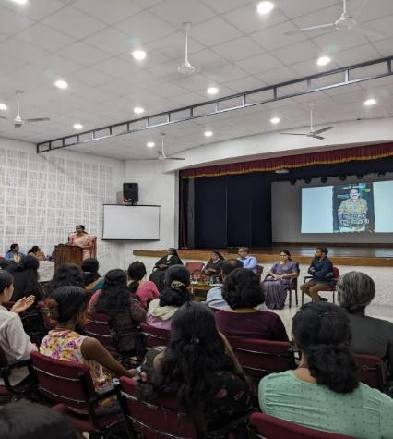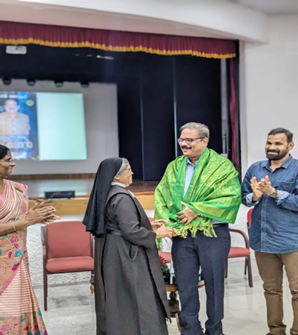
PROGRAMME NAME 12: KOCHI VOLUNTEER BANK INAUGURATION
VENUE : ST.TERESA’S COLLEGE , ERNAKULAM
DATE : 21/02/2024
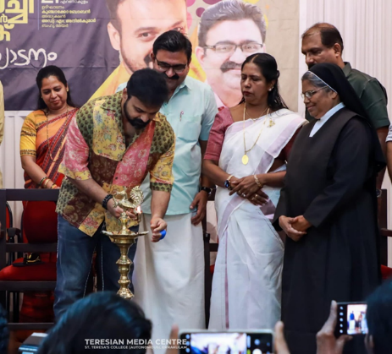
PROGRAMME NAME 13: HANDING OVER OF WHEELCHAIR
VENUE : ST.TERESA’S COLLEGE, ERNAKULAM
DATE : 29/02/2024

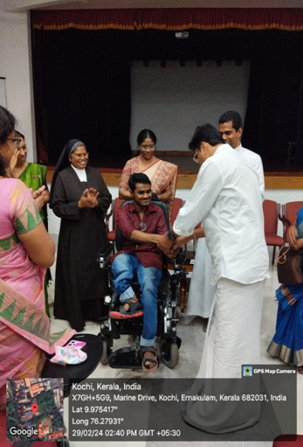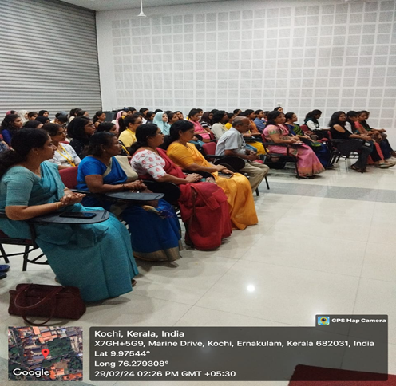

PROGRAMME NAME 14: DISTRIBUTION OF BUTTERMILK
VENUE: BUS STAND, IN FRONT OF ST.TERESA’S COLLEGE, ERNAKULAM
DATE : 14/03/2024 – 15/03/2024,18/03/2024-20/03/2024, 22/03/2024, 25/03/2024, 27/03/2024
