ACTIVITY 1 :
TITLE OF THE ACTIVITY : DISTRIBUTION OF STATIONERY ITEMS.
Panchayat | Kuzhuppilly
Type of Activity | Distribution of Stationery items
Date | 14/06/2022
Venue | Pallathamkulangara Bhagavathi Devaswom L.P. School.
No: of Teachers involved | 1
No: of students involved | 7
No: of Beneficiaries | 41

Need of the Activity : To provide the students with stationery items to help them in their learning process.
Brief Description (Need/Impact/action/Picture (If any) :
On 14th June 2022, as a part of TROP activity of Department of Commerce Regular, Assistant Professor Elizabeth Rini K F, along with 7 students handed over 95 books, ….to the students of Pallathamkulangara Bhagavathi Devaswom L.P School of Kuzhuppilly Panchayath. These stationery items were distributed to 27 students present at the time of the function and the rest were distributed by the teachers of the respected school. Expenses of the same were met from the fund collected from B.com Regular students. The teachers and staffs of the school appreciated and showed their gratitude to the students and also to our department.

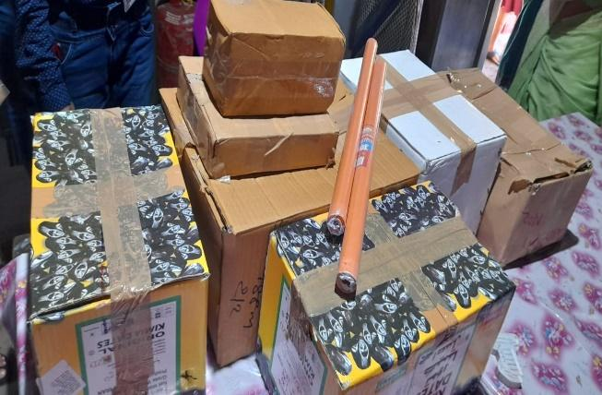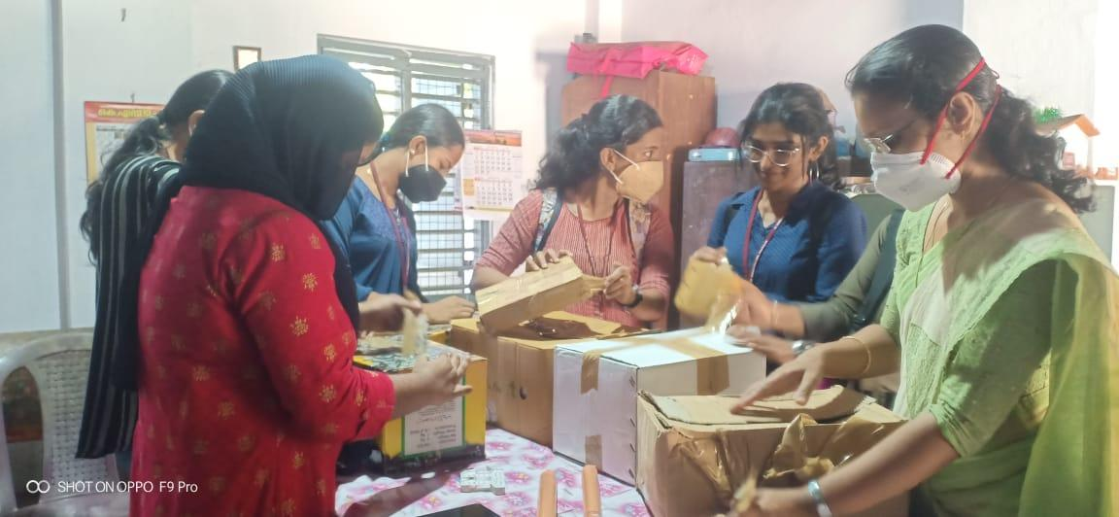
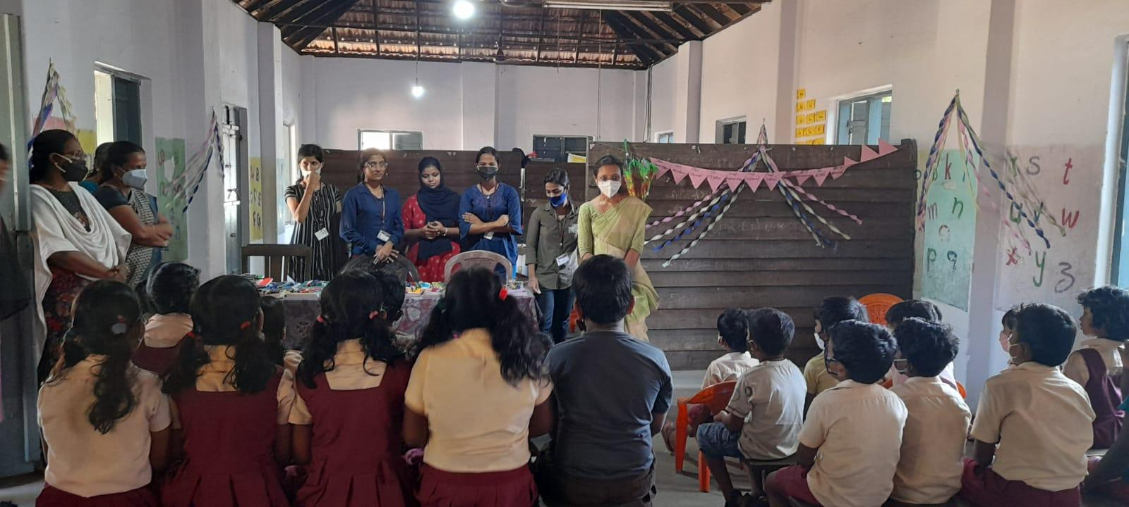

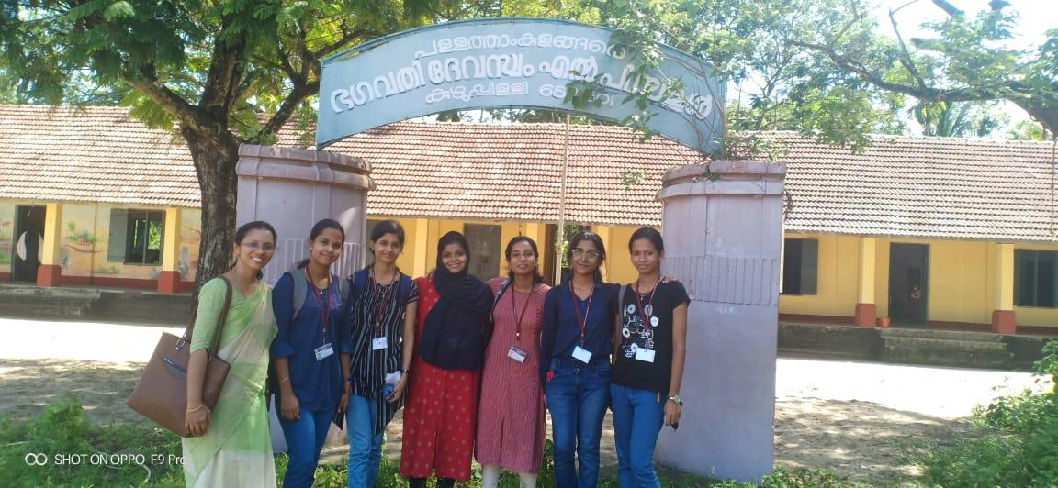
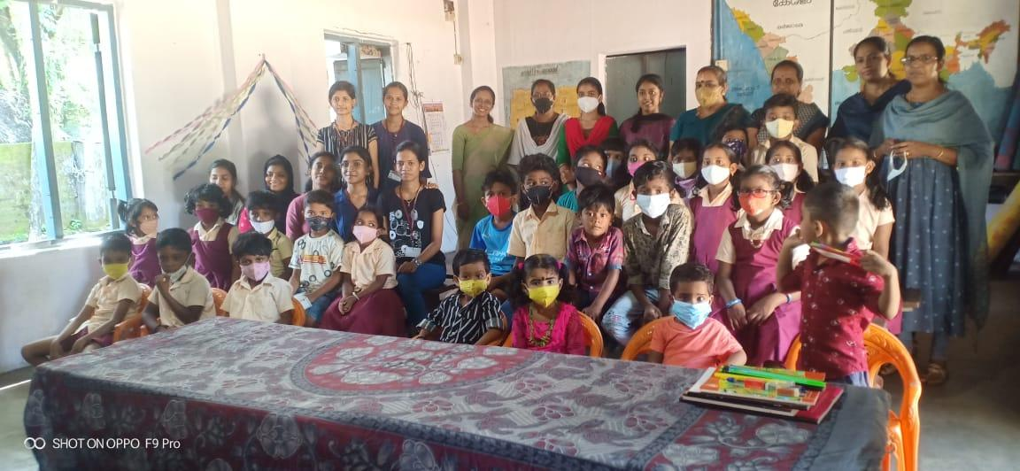

Outcome :
The students are equipped with the basic requirements involved in learning.

ACTIVITY 2:

TITLE OF THE ACTIVITY : TEACHING STUDENTS MANNERS,ENGLISH AND USEFUL TECHNIQUES FOR DRAWING
Panchayat | Kuzhuppilly
Type of Activity | Teaching students
Date | 21/07/2022
Venue | Pallathamkulangara Bhagavathi Devaswom L.P. School.
No: of Teachers involved | 1
No: of students involved | 5
No: of Beneficiaries | 22

Need of the Activity: To have an interactive session with students by teaching them basic manners, English rhymes and drawing.
Brief Description (Need/Impact/action/Picture (If any) :
On 21 July 2022, as a part of TROP activity of the Department of Commerce (Regular), Assistant Professor Elizabeth Rini K F, along with 5 students taught the children in Pallathamkulangara Bhagavathi Devaswom L.P School of Kuzhuppilly Panchayath basic manners, rhymes and drawing. Ms. Malavika P S taught the students basic manners and good habits like brushing teeth twice a day and greetings. In the light of covid, they were also taught the right way to wash their hands. This made them aware of cleanliness in daily life. The students had a fun time learning to draw posters and figures using easy techniques, which was taught by Ms. Nandhana P B. They also had an interactive session of ‘hands up hands down’ which helped in increasing their concentration, focus and listening skills. They joined Ms. Anula Menon in singing the English alphabet, after which they sang rhymes to each other. They did a role play on rhymes and sang with great enthusiasm. This made helped them to develop and enhance team spirit. Lastly, there was a clapping session using fingers to test their attentiveness by Malavika. Overall, it was a vibrant and lively session with these bubbly children. All students were distributed biscuits and chocolates as a reward for their energy and initiative to participate. The cost for the treats were borne by the involved students themselves. In the end, the students had a fun time singing, dancing and displaying their talent. The children, teachers and staff showed gratitude towards the student and the department.
Outcome: The students were educated with good manners and developing talents like drawing and singing as well.
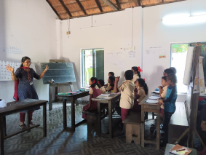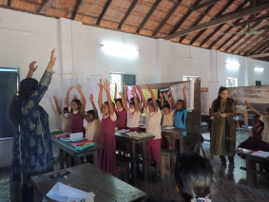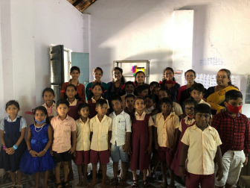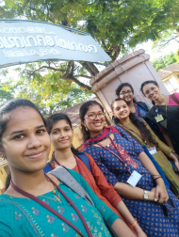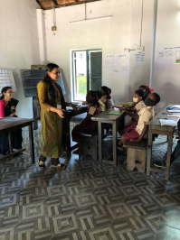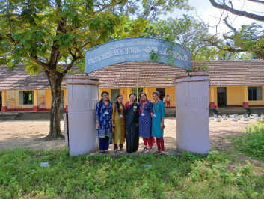

ACTIVITY -3
TITLE OF THE ACTIVITY- INDEPENDENCE DAY CELEBRATION AT KUZHUPILLY PANCHAYAT

Panchayat | Kuzhupilly
Type of activity | Independence day celebration
Date | 15/08/2022
venue | Kuzhupilly panchayat
No of teachers involved | 1
No of students involved | 1
Need of the activity- To take part in independence day celebration Brief Description (Need/Impact/action/Picture (If any) :

On 15th August 2022,As a part of TROP activity of Department of Commerce, by the instruction of the faculty in charge of TROP, Assistant Professor Elizabeth Rini K F ,one of the student visited Kuzhupilly panchayat for taking part in the independence day celebration. The programme started at eight by a speech on independence day by the panchayat president Mr K S Nibin. He delivered a speech on the importance of independence day and the brave deeds of many freedom fighters who struggled for independence. It was followed by the flag hoisting ceremony where everyone sang the national anthem in unity. The panchayat president hoisted the national flag. Some of the ward members Mr Pramukhan, Ms Varsha, Ms Beena Devassy ,Mr Chandran,Ms Jiji etc including the panchayat secretary took part in this glorious independence day celebration. They even distributed some sweets. The president interacted with the student and enquired about the future activities to be conducted in the panchayat. The president as well as all the ward members were very supportive and encouraging in all the activities.
Outcome: To instill patriotism, national pride and to commemorate independence from colonial rule.

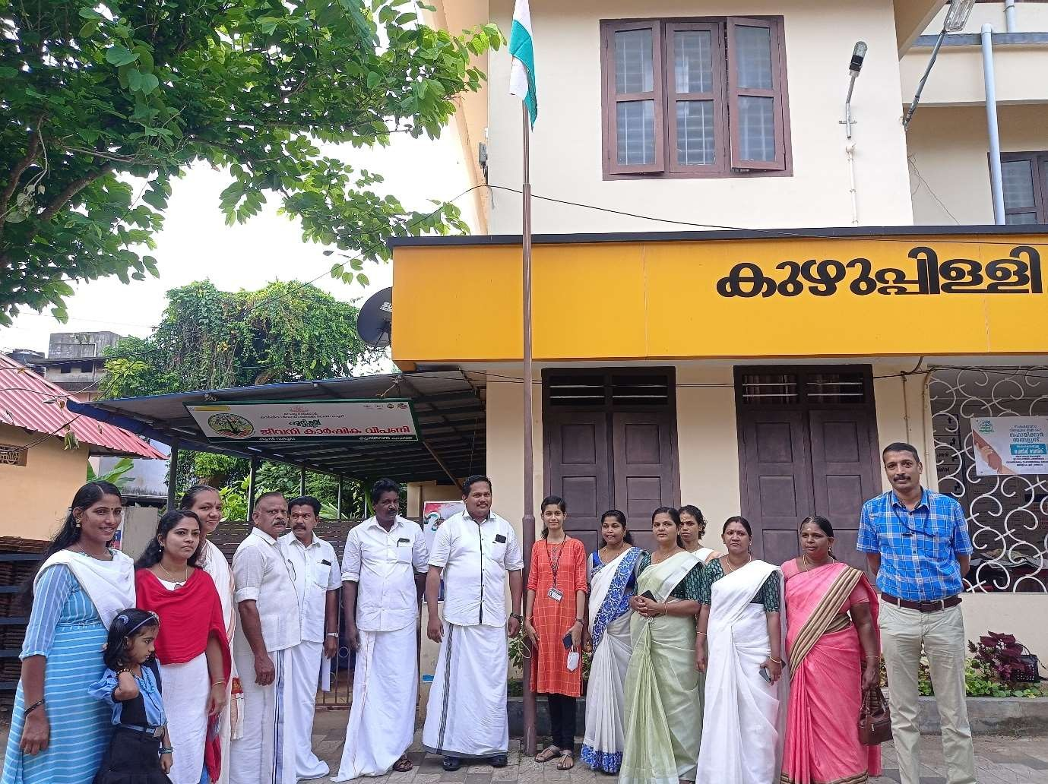

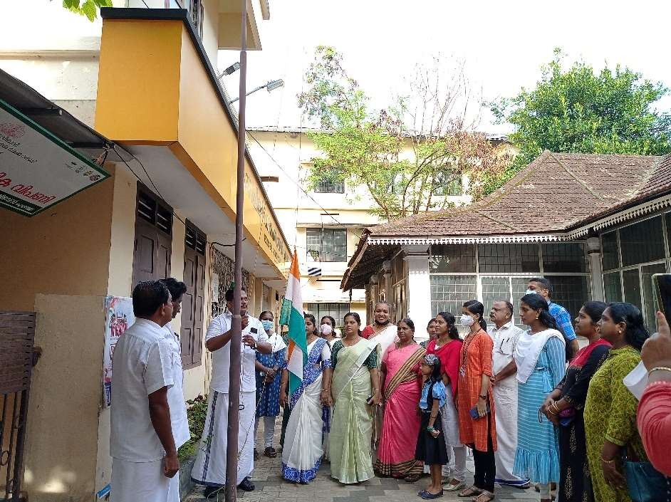

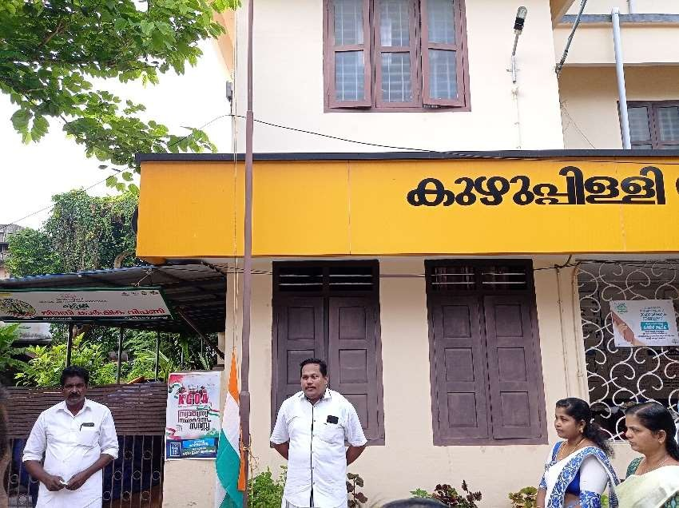

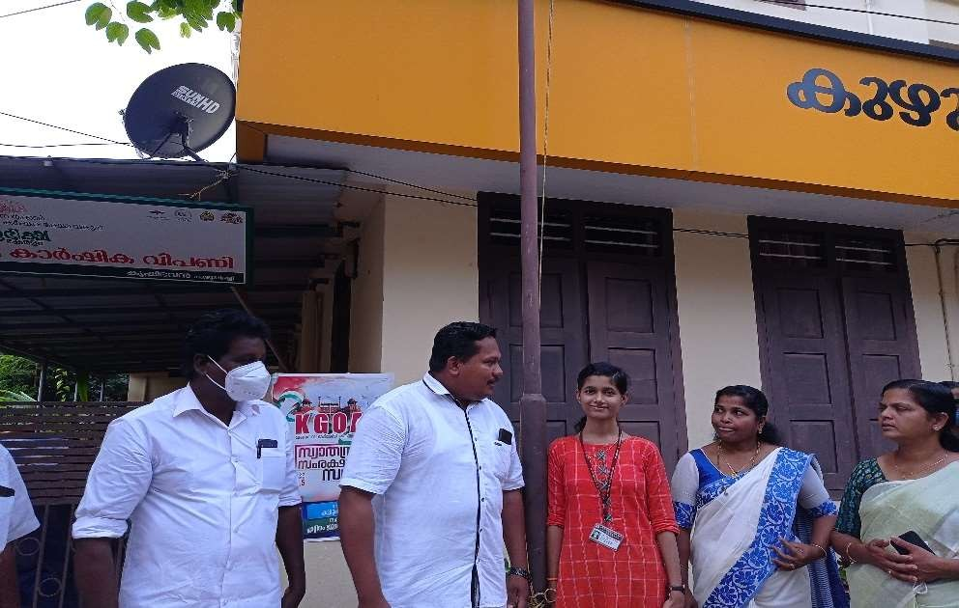

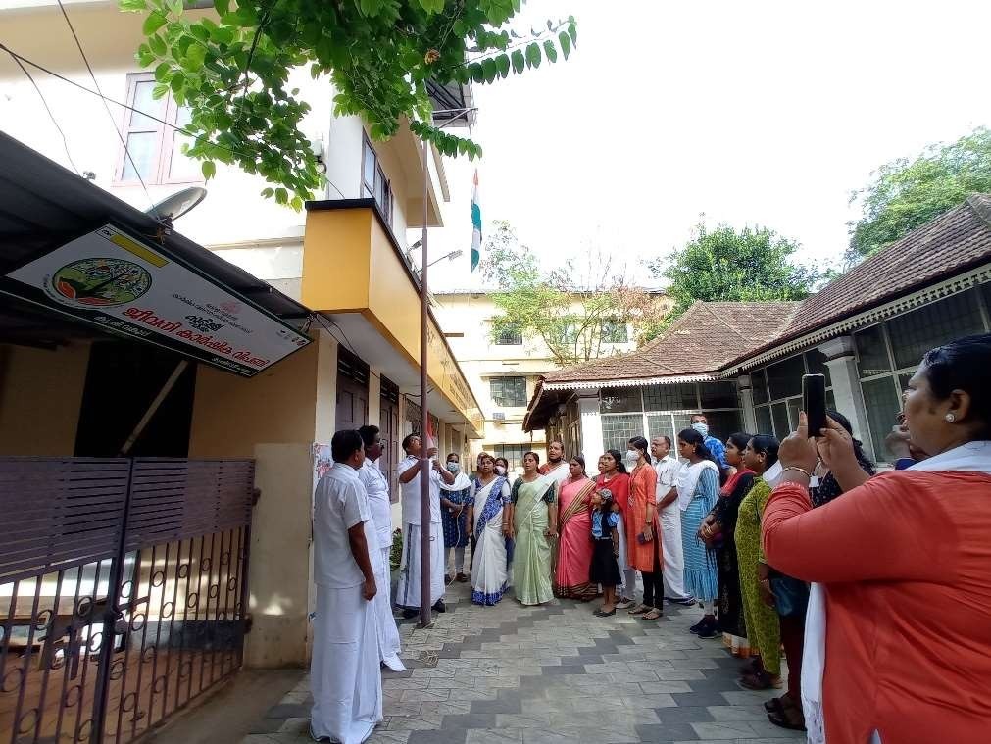
ACTIVITY 4:
TITLE OF THE ACTIVITY: DISTRIBUTION OF WASTE BINS AND WASTE DISPOSAL AWARENESS
Panchayat | Kuzhupilly
Type of activity | Distribution of dustbins, Waste disposal awareness
Date | 19/10/2022
Venue | V D Sabha LP School , Kuzhupilly
No of teachers involved | 1
No of students involved | 12
No of Beneficiaries | 100
Need of the activity: To aware students about proper waste disposal and distribute waste bins
Brief Description (Need/Impact/action/Picture (If any) :
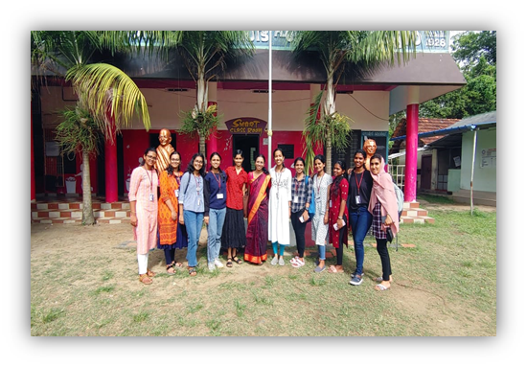
The students of II B. Com (Taxation) as the part of Teresian Rural Outreach Programme went to V D Sabha LP School in Kuzhupilly on 19th October 2022 under the guidance of Ms. Elizabeth Rini. Waste is a major contributor to land and water pollution and can also cause health problems. Improper disposal of waste can also lead to the release of dangerous chemicals, toxins, and other pollutants into the environment. Therefore, it is important to be aware of how to properly dispose of waste and to reduce the amount of waste we produce. As a part of the campaign, St Teresa's College distributed waste bins for wet and dry waste being green and blue in the presence of teachers Sinitha AK, Shiney NP, and Sreekanth S. The students were then given waste disposal awareness class by Anjana, Gayatri, and Devika. Over 100 students attended the awareness class. Others followed with cleaning the school premises. The headmaster Mr. Manoj on behalf of the school was contented with the initiatives taken by students of St Teresa's College and the students of II B. Com got amazing learning experiences through the TROP activity.

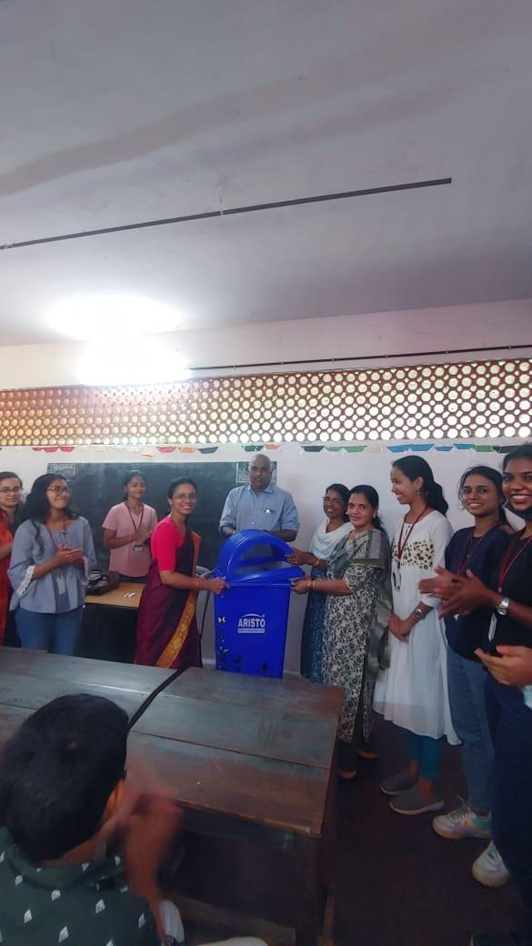
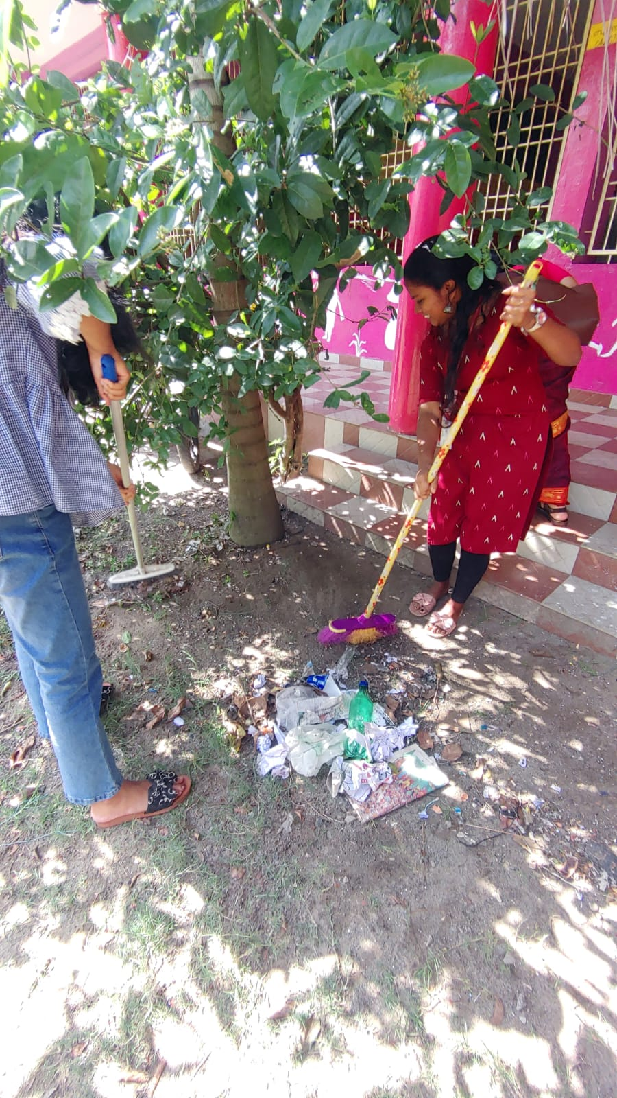

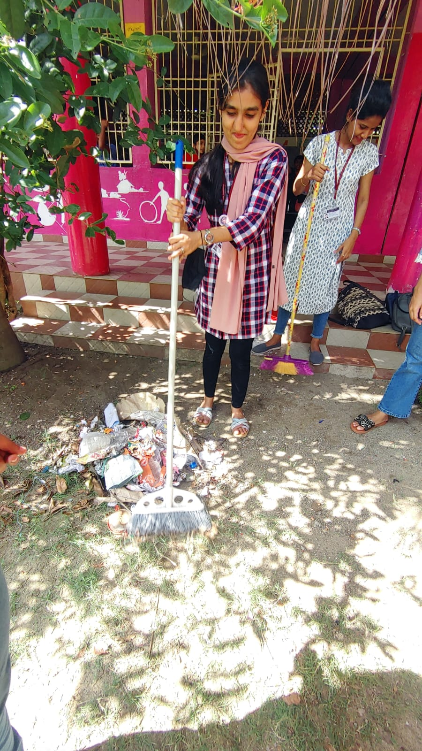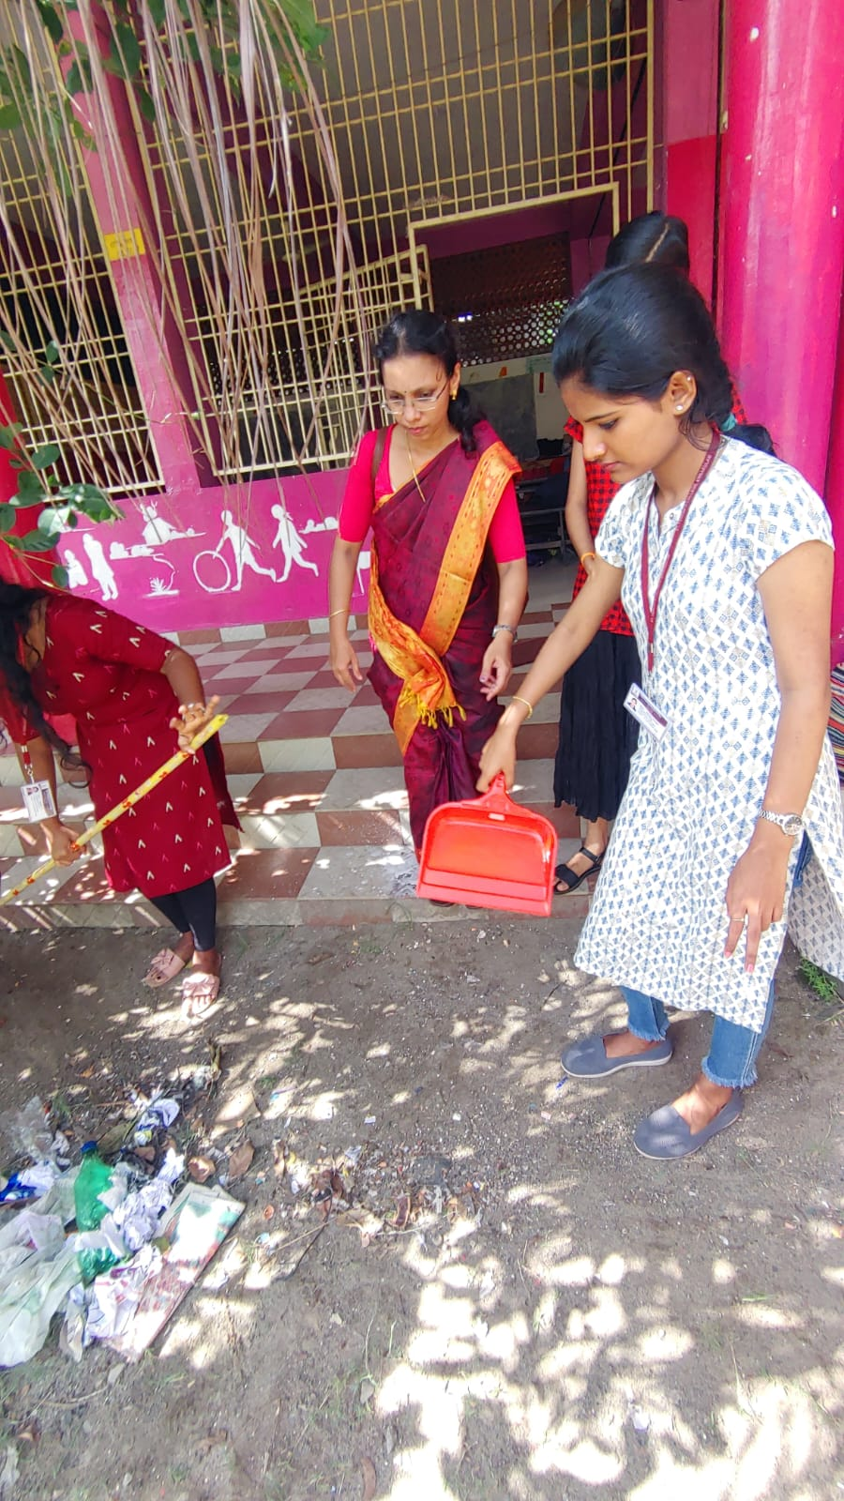
Outcome:
The students were enriched with knowledge of proper waste disposal, they also received waste bins to put the plastic and green waste separately.

