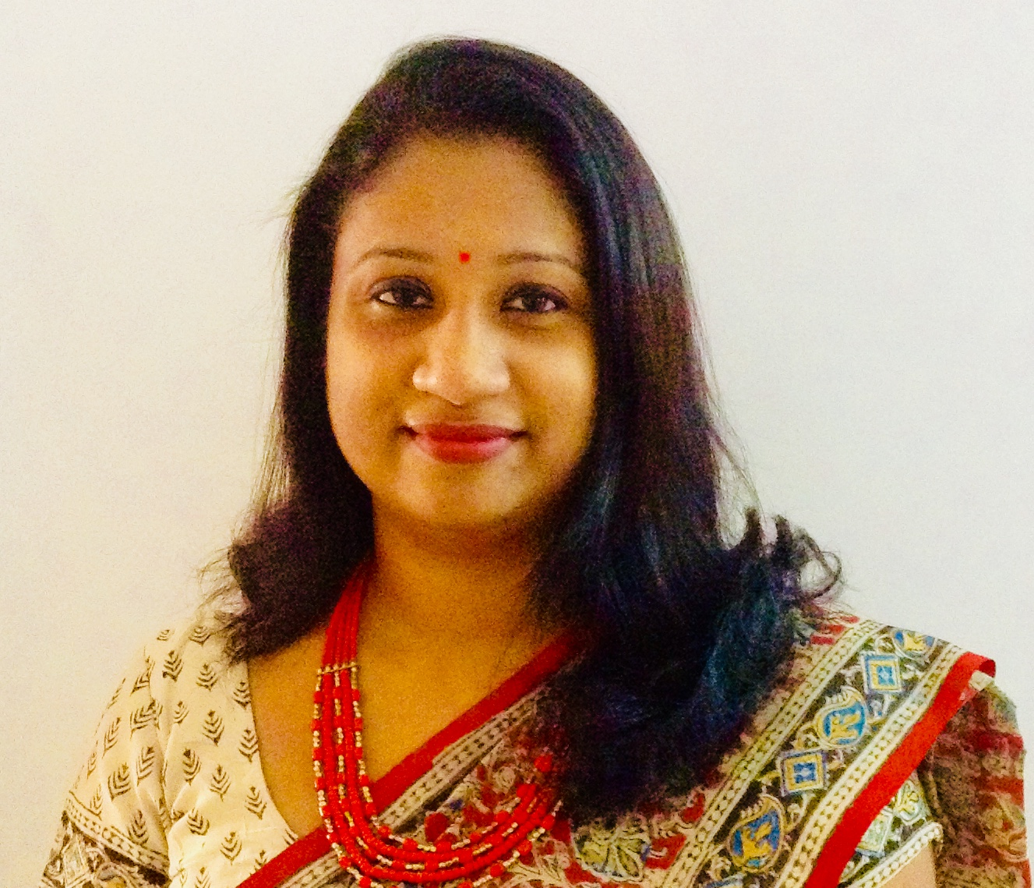

Dr. Jeena Ann Joseph
Assistant Professor
Department of English
St.Teresa’s College
Ernakulam

Mob: +919895084228 Email: annjeena@gmail.com

Profile at a Glance:
- PhD in English, 2017.
- Secured UGC-National Eligibility Test for Lectureship in English.
- M.Phil in English Language and Literature, 2006.
- 9 years of experience in teaching as Assistant Professor
- 2 years of prior service as FIP substitute at Mar Ivanios College.
- Also worked as Guest Lecturer in English at the Institute of Distance Education.

Professional Education:

- PhD in English, Title: “Towards an Ambivalent Narrativization: Discourse of the Other in Orhan Pamuk’s Fiction.”2017, Institute of English, University of Kerala.

- M.Phil in English Language and Literature, 2006, Grade ‘A’, Institute of English, University of Kerala.
- Secured UGC-National Eligibility Test for Lectureship in English, December 2005.
- M. A. in English Language and Literature, 2004, First Class, Mar Ivanios College, University of Kerala.
- B. A. in English Language and Literature, 2002, First Class, Mar Ivanios College, University of Kerala.
- Certificate Course in German, 2005, First Class, University of Kerala.
- NPTEL Certification: Introduction to Culture Studies, 85%, July to Oct 2018 course (12 weeks-IIT Madras)

Professional Experience:

ST.TERESA’S COLLEGE, Mahatma Gandhi University, Ernakulam
Assistant Professor from September 2010 till date

Responsibilities:

- Handling General English Classes-Fine Tune Your English and Issues that Matter at the Under Graduate level.
- Handling core papers- Methodology of Literary Studies and Introducing Language and Literature -at the UG level.
- Handling PG Classes- Revolution and Enlightenment, Indian English Literature, Modes of Fiction, Modernism in Context, Theories of Knowledge, Literature and the Empire

- In charge of two M.A. Literature projects and five U.G. Projects every year.

- In charge of College Extension Activities-TROP, UBA and Learning Management System -Moodle

MAR IVANIOS COLLEGE, University of Kerala, Trivandrum
FIP Lecturer in English (August 2006 – March 2008)
Responsibilities:

- Handled History of English language and European Drama in the Post graduate level
- Guided post graduate students in various assignments and seminars which was part of their internal assessment
- Set question papers and conducted semester tests for Post graduate classes
- Handled Communicative English, Drama, Poetry, History of English literature, Prose, and Phonetics in the Under graduate level

ST. XAVIER’S COLLEGE, University of Kerala, Trivandrum
Guest Lecturer in English (September 2004 – June 2005)
Responsibilities:

- Handled History of English Language , History of English Literature, Literary criticism, Drama, and Poetry for Under graduate students
- Supervised internal semester tests and projects which was part of the course

INSTITUTE OF DISTANCE EDUCATION, University of Kerala, Trivandrum
Guest Lecturer in English
Responsibilities:

- Handled Postgraduate and undergraduate classes during weekends

Major/ Minor Projects:

- A Minor Project had been sanctioned by the UGC for the proposal entitled Transmogrification of Identity; East-West Impasse in Orhan Pamuk’s Fiction in November 2011, amount sanctioned 1 lakh. (First Instalment July 2012, Second-Feb 2014, and completed and submitted in June 2014 )

Research Publications: Refereed International/ National Journals:

- Published an article “Writing the Self – in Paulo Coelho’s Trilogy And on the Seventh Day” in the literary journal Littcrit , June 2007. (Vol33. No:1.ISSN-0970-8049)

- Published an article “The way of Salvation: Paulo Coelho’s The Devil and Miss Prym” in the Teresian Journal of English Studies (TJES), October 2011. (Vol. 3, No.1. ISSN-0975-6302)

- The Dialectics of Globalisation in Orhan Pamuk’s My Name is Red in the Conference proceedings of UGC sponsored National Seminar on Creativity in the Era of Globalisation, Dept of English and Foreign Languages, CUSAT, Ernakulam, 13-14th March 2013. ISBN 978-93-80095-42-4

- Joseph, Jeena Ann. “Carnivalistic Subversion in Orhan Pamuk’s The White Castle”. Humour, Texts, Contexts. Ed. P.P.Ajayakumar, et al. New Delhi: Creative Books, 2015. 273-281. Print. (ISBN-978-81-8043-117-3)

- ---. “Orhan Pamuk’s Snow: An Interlacing of Culture and Nature”. Critical Encounter: A Journal of Literary Studies 1.1 (2015). 38-46. Print.( ISSN 2454 2083)

- ---. “The East-West Impasse in Orhan Pamuk’s The White Castle and My Name is Red”. Research Essence 2.2 (2014): 72-81.Print. (ISSN 2348-2389)

- ---. “Vehicles of Literary Modernity: Orhan Pamuk’s The Black Book”. Littcrit: An Indian Response to Literature 40.2 (2014): 67-73. Print. (ISSN 0970-8049)

- - - - . “English Decolonized: Chinua Achebe’s Things Fall Apart”. The Local and the Global in Postcolonial Literature. New Delhi: Authorpress, 2014. 28-39. Print. (ISBN 978-81-7273-881-5)

- Joseph, Jeena Ann. The Language of the Future: Paulo Coelho’s And on the Seventh Day. IJELLH (International Journal of English Language, Literature in Humanities), [S.l.], v. 6, n. 12, p. 17, dec. 2018. ISSN 2321-7065.: <http://www.ijellh.com/OJS/index.php/OJS/article/view/5823>.

- Joseph, Jeena Ann. Around the World and Across Centuries with Francis Itty Cora.IJELLH (International Journal of English Language, Literature in Humanities), [S.l.], v. 7, n. 3, p. 9, mar. 2019. ISSN 2321-7065. Available at: <https://ijellh.com/OJS/index.php/OJS/article/view/7483>.

Other Publications:

Retold children’s stories: ‘Vikram Vetal ’- for DC Books (TUMBI Series) and was published in February 2008.

- Old Wine in New Bottle ISBN 978-81-264-1779-7;
- The spendthrift King ISBN 978-81-264-1777-3;
- Who is the Killer? ISBN 978-81-264-1775-9;
- Tears and Laughter ISBN 978-81-264-1774-2;
- The Noblest Mind ISBN 978-81-264-1776-6.

Paper Presentations:

- Presented a paper titled “The Museum of Innocence and The Innocence of Objects: Orhan Pamuk’s Polemics of Words, Objects and History ” at the International Seminar on ‘Words, Visuals and Beyond: Mediatization of Narrative Spaces’ organized by The Postgraduate Department of English, Bharata Matha College, Thrikkakara ( 22and 23rd February 2018)

- Presented a paper titled “Carnivalistic Subversion in Orhan Pamuk’s Fiction” at the International seminar on ‘Humour: Texts Contexts, December 2013(7th -8th ) IIST, TVPM

- Presented a paper titled “To Veil or Unveil, That is the Question: Cultural Reverberations in Orhan Pamuk’s Snow” at the International seminar on ‘Ending Gendered Violence: From Theory to practice’. November 2013 (18th and 19th) All Saint’s college, TVPM.

- Presented a paper titled “The Dialectics of Globalization in Orhan Pamuk’s My Name is Red” at the UGC sponsored National seminar on ‘Creativity in the Era of Globalization’ March 2013(13th and 14th )CUSAT.

- Presented a paper titled “Around the World with Francis Itty Cora” at the UGC sponsored National Seminar on ‘Narrative of Narratives’ conducted at Sree Sankara Univeristy of Sanskrit, Kalady. (February 2013)

- Presented a paper titled “Orhan Pamuk’s Snow: An Interlacing of Culture and Nature” at the UGC sponsored National seminar on ‘Green Perspections: Ecology and Texts’. St.Paul’s College, Kalamassery, 15-16th Sept 2011

- Presented a paper titled “T.D.Ramakrishnan’s Francis Itty Cora: ‘Her’ Story versus ‘His’ Story” at the UGC sponsored National Seminar on Charting New Territories: Cartographies of Popular Media and Culture. All Saint’s college, Thiruvananthapuram. 18-19th August 2011.

- Presented a paper titled 'Latin Influence on Renaissance Tragedy' at the International Conference on Latin Languages and world Cultures- Conducted by Institute of English, Centre for Comparative Literature (University of Kerala) and Dept. of Latin, St.Xavier's college, Thumba. (University of Kerala) on 10th March 2010.

CONTRIBUTION TO CORPORATE LIFE

Details of Seminars, conferences, Symposia organized:

- Was a member of the organizing committee for the International conference on Multi Modality, Multi Literacies and Multi Lingualism: New Pedagogies for New Times held at St.Teresa’s College on 24th and 25th Jan 2011.
- Organised and participated in the National Seminar on Best Practices in Research and Consultancy: Opportunities and Challenged organised by the IQAC at St. Teresa’s College, Ernakulam, 20th Oct 2011.
- Was the Treasurer for the UGC sponsored National Seminar on Remapping of Reality through Visual technology-Interdisciplinary Engagements organised at St. Teresa’s College, Ernakulam, 28th to 29th June 2012.
- Member of the Organizing Committee: International Conference on Popularizing Science Writing and Celebrating Science Fiction held on 14, 15, and 16th Feb 2014, at St. Teresa’s College, Ernakulam.
- Organised (Co-convenor) the UGC Sponsored National seminar on Life and Literature in the post 9/11 World at St. Teresa’s College, Ernakulam, 23rd and 24th Sept 2014.
- Organised and participated in the National Seminar on Autonomy: Prospects and Challenges, organised by the Department of English , St. Teresa’s College 20th August 2015.
- Participated in Kochi Literature Festival, 8-10 Dec 2016 ( Convenor for one session at STC).
- Organised and participated in the UGC(CPE scheme) sponsored translation studies workshop on “ Traversing Borders” organised by the department of English, St. Teresa’s college -1 Feb 2017.
- Coordinated, Organised and participated in the UGC(CPE scheme) sponsored national seminar on Digital literature organised by the department of English, St. Teresa’s college -3rd Sept 2016.
- Organised and participated in the National Seminar on The Politics of Food: Representations and Practices organised by the Department of English, St. Teresa’s college – 21st Feb 2018.
- Organized and participated in the International Workshop on International Research Methods and Academic Skills, organized by the Department of English in collaboration with Roots International UK at St. Teresa’s college – 8th and 9th August 2018.
- Organized (Co-ordinator) the 12th International and 48th ELTAI annual conference on the theme “English Language Acquisition: Western Theories and Eastern Practices” held at St. Teresa’s college – 29th June to 1st August 2017.
- Organized and coordinated a Two day National workshop on Techno-Pedagogy and Learning Management System on 28th and 29th sept 2018.
- Coordinated the National seminar on e-learning and MOOCS in Higher Education organized by the IQAC and MHRD on 1st March 2019.
- Coordinated an International Workshop on Know Violence on Children on 18th Jan 2019.
- Coordinated the One week FDP on E-Content Development organized by the IQAC from 1st April to 7th April 2019.
Responsibilities Undertaken:
- Staff Advisor of English Association 2010-2011, 17-18.
- Staff Advisor of the Writer’s Forum 2010-2011.
- Staff Editor of the Department newsletter Littera, 2013.
- English language Editor of the College Magazine for the years 2011-12, 12-13.
- Staff Advisor of Debate Club (2012-13 and 2013-2014). Organized the Mother Digna -All Kerala Intercollegiate Debate Competition these two years.
- Staff Advisor of Poets Club (2014-15 and 2015-16).
- SSP Internal Mentor: 2014-15, 18-19.
- Class Teacher of I UG- 2014-15, 2016-17, 2018-19/ I PG- 2017-18/ II PG- 2019-20.
- In charge of UGC Funds in the Department from Sept 2011-12, 12-13, 13-14, 14-15, 15-16.
- UG and PG Camp Officer 2017-18.
- In charge of the department AQAR: 2011-12, 19-20.
- Coordinator of the Counselling Cell (Arts Block): 2018-19.
- Member – NAAC Committee-2018-19, 19-20 (Teaching and Learning criteria).
- Coordinator of the Learning Management System-Moodle 2018-19, 19-20.
Extension Activities:
- Teresian Rural Outreach Programme (TROP), Co-coordinator of the Department of English 2011-12.
- In charge of TROP activities 2018-19, 19-20 (College level)
- Coordinator of UBA activities 2018-19, 19-20 (College Level)
- Coordinated the Post-flood Survey for Government of Kerala at Cheranalloor village 2018-19.
Other related Activities:-
- Field Visit: Took Students to Kerala History Museum, Historical Places at Fort Kochi & Mattanchery, 2012.
- Field study: Took I BA students for Biennale in 2012-13, 2016-17.

References upon request.

- Internal Mentor of SSP programme, an initiative of the Higher Education Department, Government of Kerala from 2018-19
- Organised a study tour for I BA English- Visit to Muziris Biennale on 6 February, 2017.

References upon request.

